**JIRA**

**Understanding Jira for Users, Managers and Admins**

**Section 1: Terms and Concepts:**

1. **Jira defined: What it does and What it doesn’t Do:**

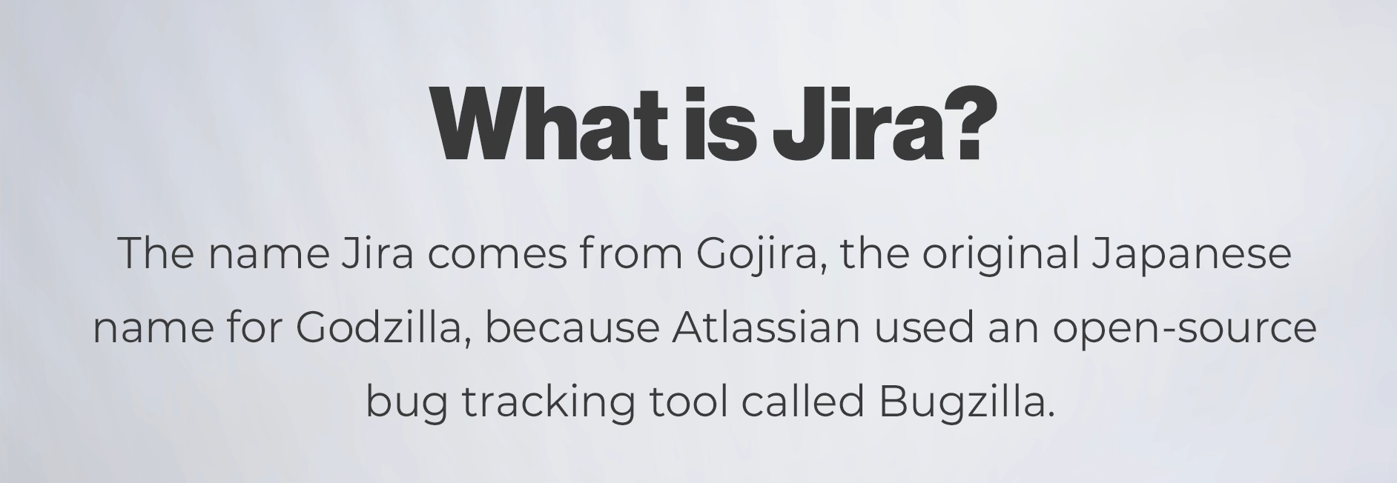

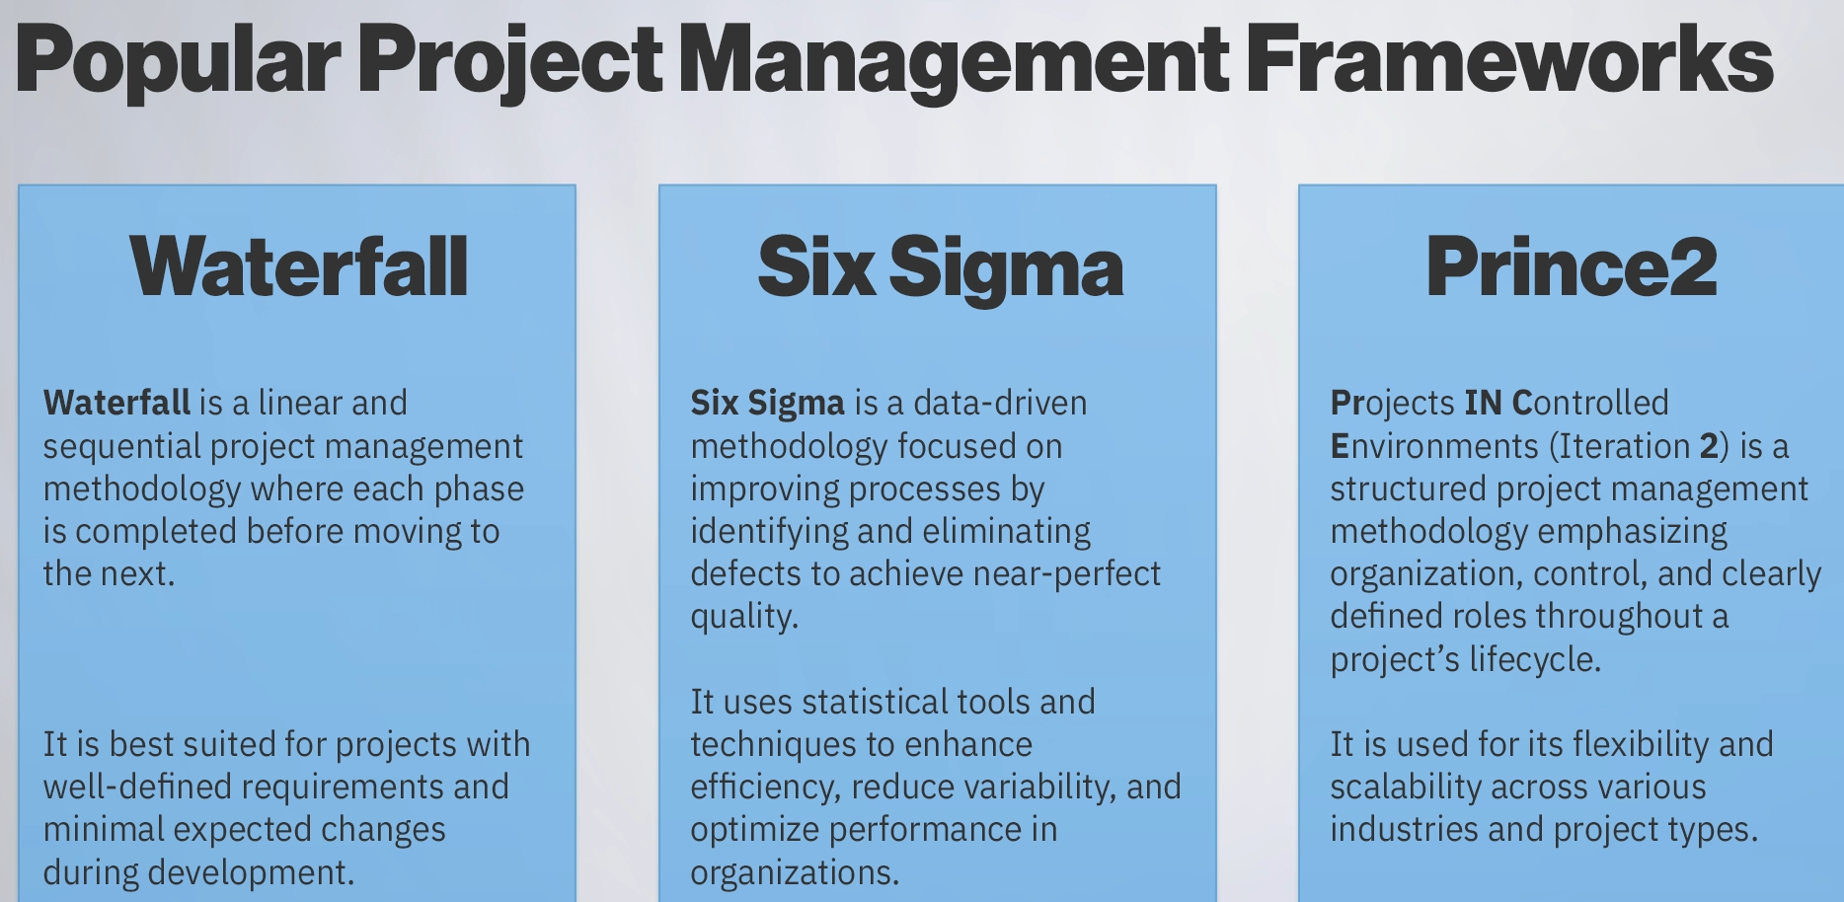

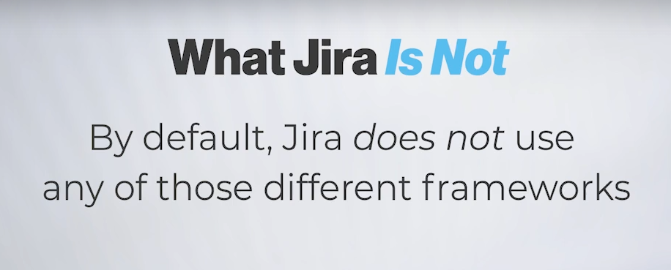

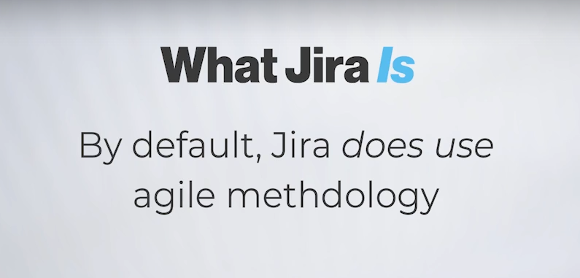

**I. What Jira Is (Definition and Background)**

* **Core Function:** Jira is an **agile project management and work tracking tool**.
  + *Extra Point (E.P.):* It's primarily used for tracking tasks, bugs, and overall progress, particularly in software development teams, but it's applicable to many types of team-based work.
* **Creator/Vendor:** Jira is developed and owned by the company **Atlassian**.
* **Name Origin:** The name "Jira" is a shortened form derived from **"Gojira,"** the Japanese name for Godzilla, which itself was a humorous reference to the older bug tracking tool, **Bugzilla** (developed by Mozilla).

**II. What Jira Is Designed For (The Agile Alignment)**

* **The Default Framework:** Jira is fundamentally and by default designed for the **Agile methodology** (or framework).
* **Agile Assumption:** When a team uses Jira, the tool automatically assumes that the team is following an **Agile workflow**.
  + *E.P.:* This means that core Jira features are built around Agile concepts like Sprints, Backlogs, Scrum Boards, and Kanban Boards.
* **Relevance of Agile:** Even though this course isn't a deep dive into Agile, understanding its basic concepts is essential because **Jira's tools and terminology revolve entirely around the Agile framework.**

**III. What Jira Is Not Designed For (Limitations)**

* **Limited Framework Compatibility (By Default):** Jira is **not designed** out-of-the-box for other project management methodologies, such as:
  + Waterfall
  + Six Sigma
  + Prince2
* **Difficulty with Alternatives:** Attempting to use a non-Agile framework like Waterfall with standard Jira will likely feel like "swimming upstream" due to the tool's inherent Agile structure.
  + *E.P.:* While some **apps or plugins** can be used to extend Jira's capabilities to *accommodate* other frameworks, the base product is optimized only for Agile.
* **Not a Universal PM Tool:** It is not a generic, framework-agnostic project management tool; it is a **specialized Agile tool**.

==================================================================================

1. **Understanding the basics of Agile:**

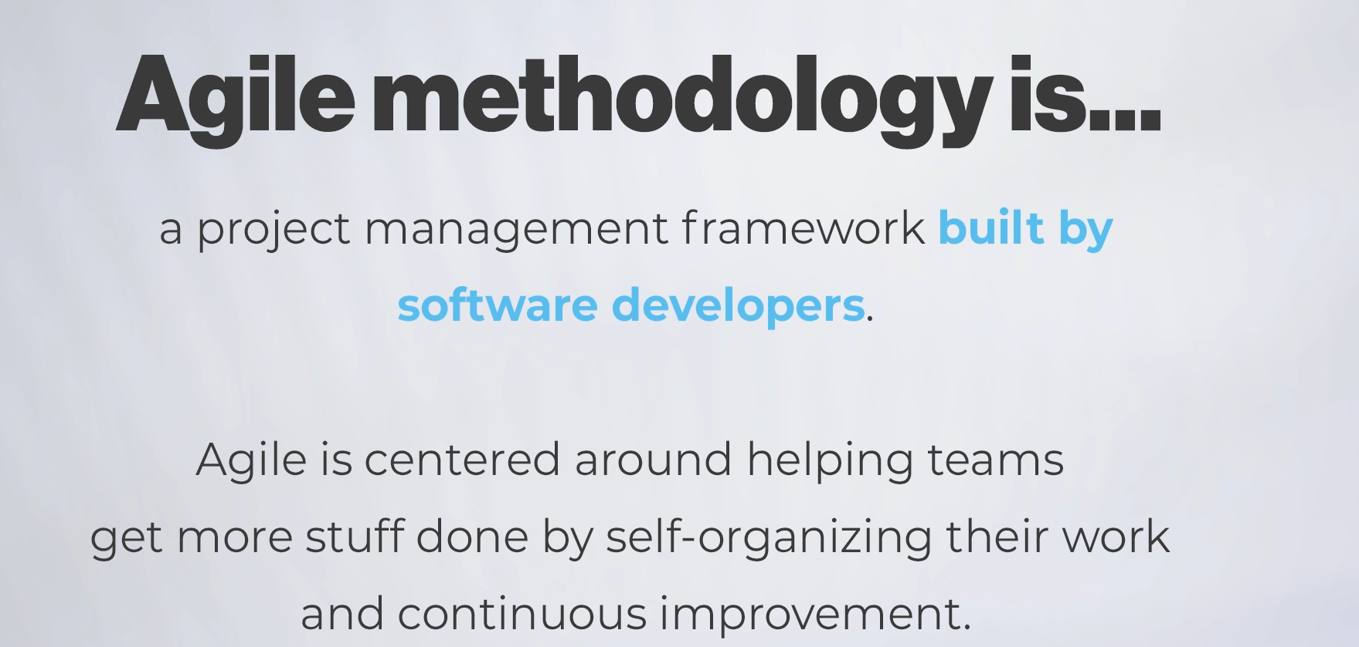

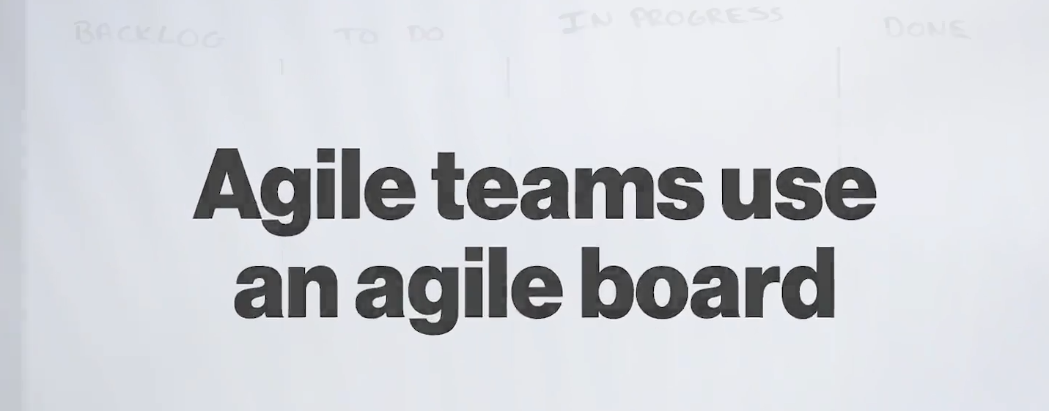

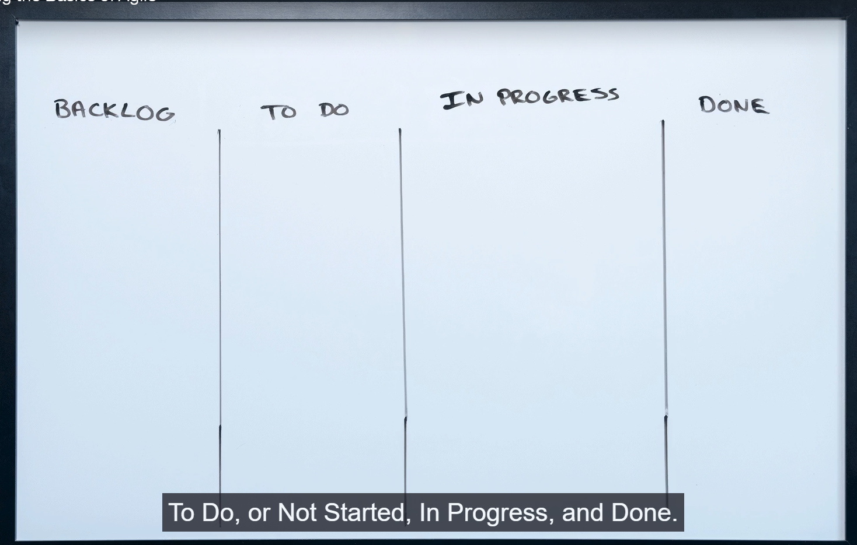

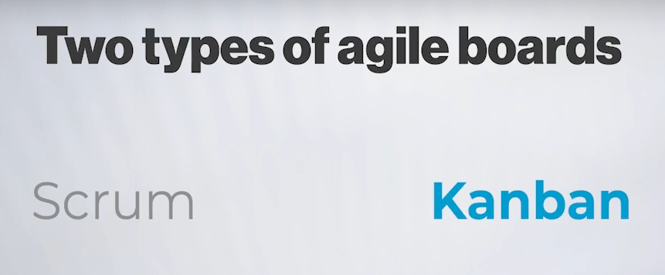

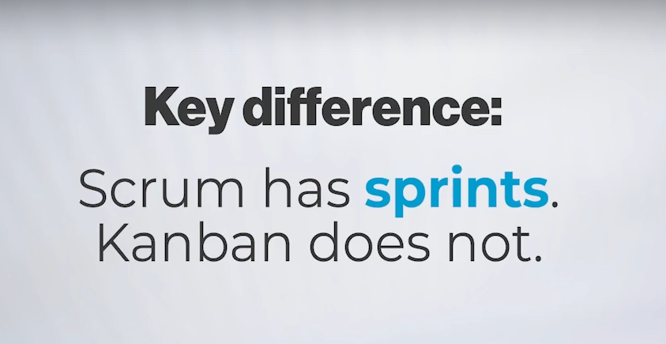

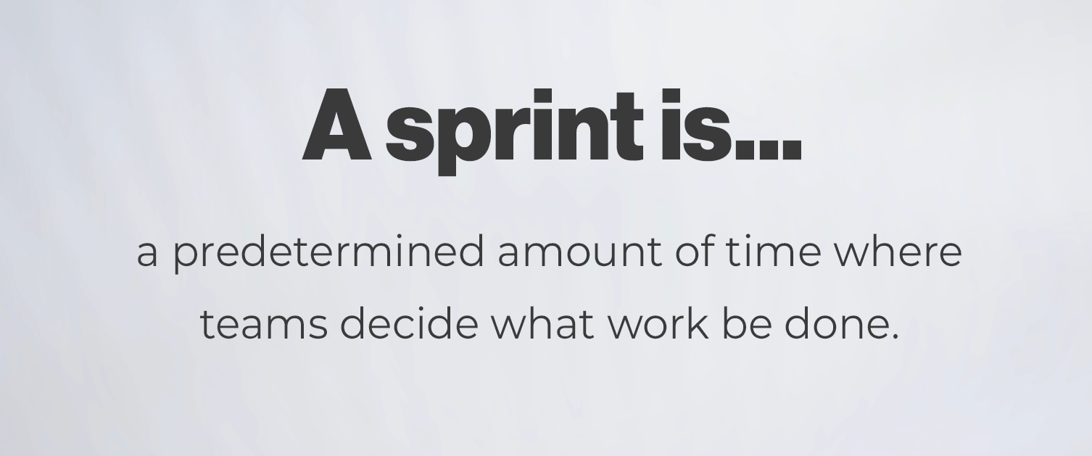

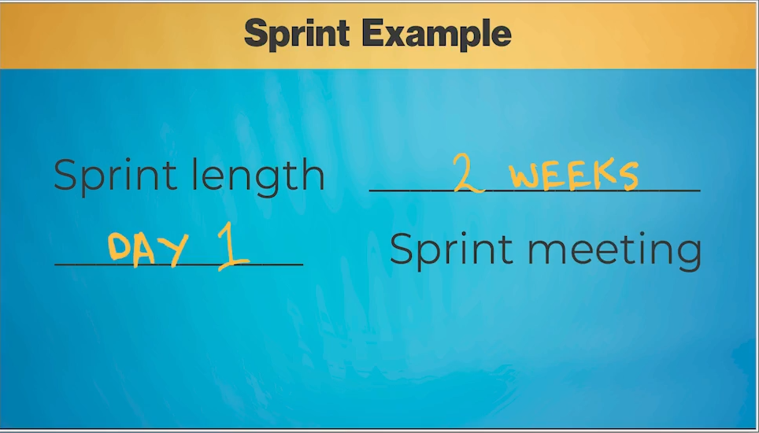

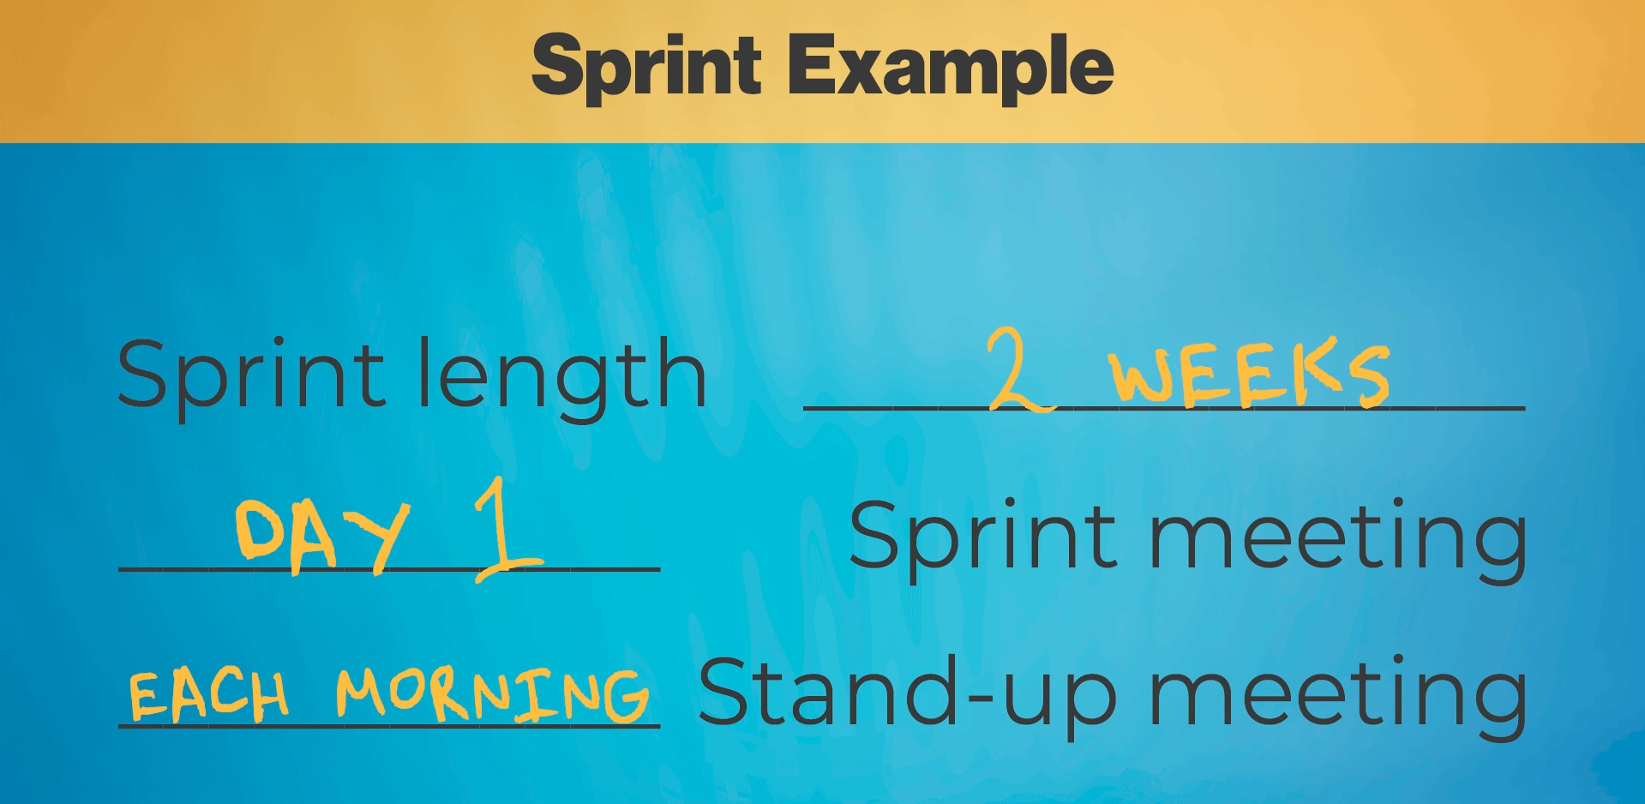

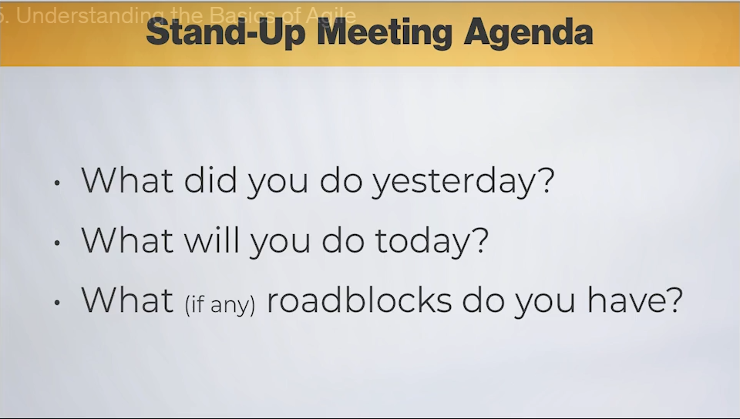

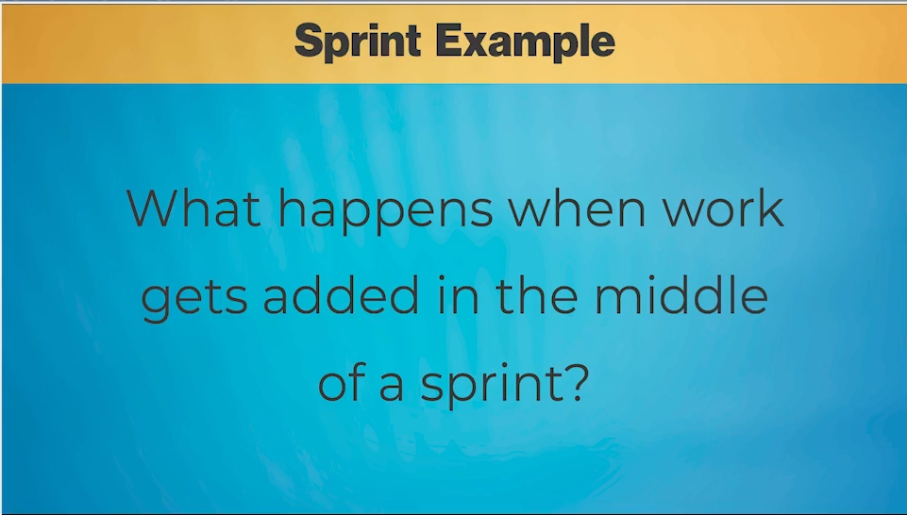

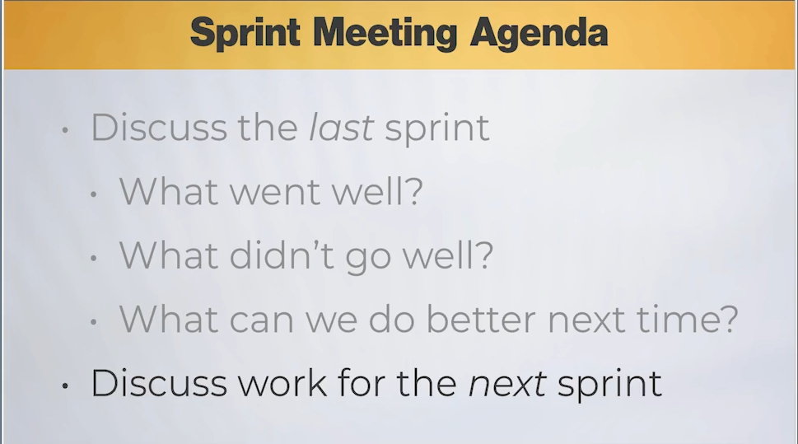

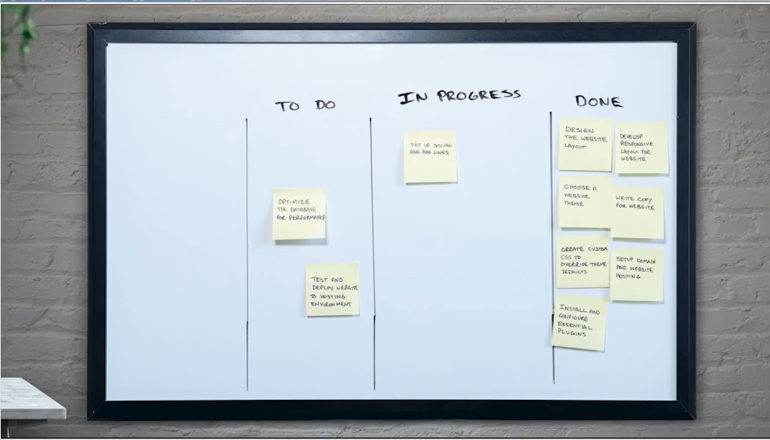

**I. Fundamentals of Agile**

* **Definition:** Agile is a set of **rules and practices** used globally by teams (developers, marketing, creative, etc.) to manage and complete work.
* **Origin:** It was founded by **software developers** in the early 2000s, which is why much of the terminology in Agile and Jira has a developer-centric focus.
* **Core Value:** Agile's popularity stems from its ability to help teams:
  + Adapt planning strategies *in advance*.
  + Maintain the flexibility to **change directions** and make quick decisions (i.e., be "agile").
  + Ensure **continuous improvement** through regular review.
* **Agile Team:** A team using the Agile methodology is simply referred to as an **Agile Team**.

**II. The Agile Board and Core Workflows**

* **Agile Board (or Lanes):** This is the fundamental tool for tracking work. In Jira, these are called **columns**.
  + They represent the sequential steps needed to complete a project, moving from left to right.
* **Basic Column Structure:** A simple Agile board generally includes:
  1. **Backlog:** The list of all future work that needs to be done.
  2. **To Do / Not Started:** Work selected for the immediate working period.
  3. **In Progress:** Work currently being actively performed.
  4. **Done:** Completed work.
* **Two Core Agile Frameworks:** These are the two primary ways work is structured on an Agile board: **Scrum** and **Kanban**.

**III. Scrum Workflow (The Time-Boxed Approach)**

* **Key Differentiating Feature:** Scrum is defined by the use of **Sprints**.
* **Sprint Definition:** A sprint is a **predetermined, fixed block of time** during which a team commits to finishing a specific amount of work.
  + *E.P.:* Common sprint lengths are **two weeks**, though one-week to one-month sprints are also used.
* **The Sprint Cycle:**
  1. **Preparation (Pre-Meeting):** Team members add all necessary tasks (called "tickets" or "issues") to the **Backlog**.
  2. **Sprint Planning Meeting (Start of Sprint):**
     + The team reviews the previous sprint (if any) to discuss **what went well** and **what didn't go well** (roadblocks).
     + The team agrees on the **highest priority tickets** from the Backlog to move into the **To Do** column for the current sprint.
  3. **Daily Stand-up Meeting:**
     + A short (approx. 15-minute) meeting held each morning.
     + Each team member quickly answers: "What did you do yesterday?", "What will you do today?", and "What, if any, roadblocks do you have?"
  4. **Work Execution:** Tickets move from **To Do** → **In Progress** → **Done**.
* **Handling New Work Mid-Sprint (Scope Change):**
  + New, unexpected work should generally be added to the **Backlog** for discussion in the next Sprint Planning Meeting.
  + *E.P.:* Adding items mid-sprint is discouraged because it changes the **scope** and threatens the team's commitment to finishing the original sprint work. If absolutely necessary, a pre-existing item must be removed to maintain the allocation of hours.

**IV. Kanban Workflow (The Continuous Flow Approach)**

* **Key Differentiating Feature:** Kanban **does not use Sprints**. Work is continuous.
* **Backlog Default:** By default, Jira's Kanban boards **do not have a visible Backlog**.
  + *E.P.:* New work is added directly to the **To Do / Not Started** column, ready to be pulled by a team member.
* **Workflow:**
  1. Work flows continuously from **To Do** → **In Progress** → **Done**.
  2. **Daily Stand-up** is still practiced to discuss status and roadblocks.
* **Focus on Completion:** The universal Agile rule applies: Focus on getting the current **In Progress** ticket to **Done** before starting a new one. This prevents accumulating partially finished work.
* **Done Column Management:** Since there are no sprints, tickets can be cleared from the **Done** column at any time. (Jira has specific features for this that will be covered later.)

===================================================================================

* 1. **Agile Terms:**

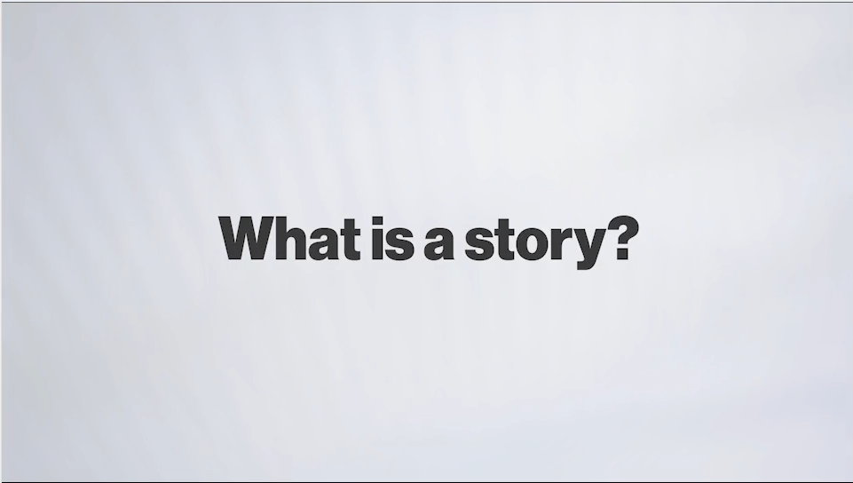

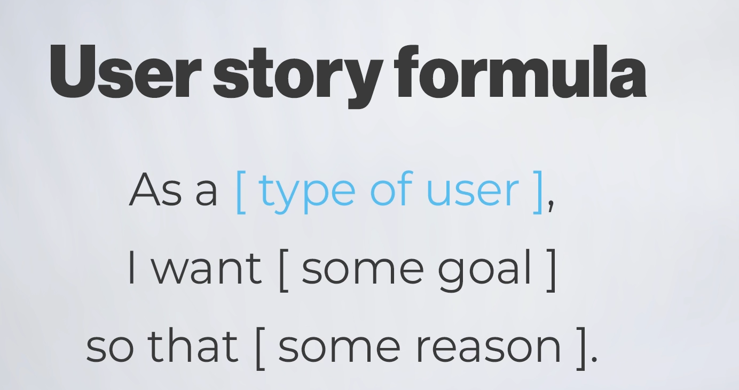

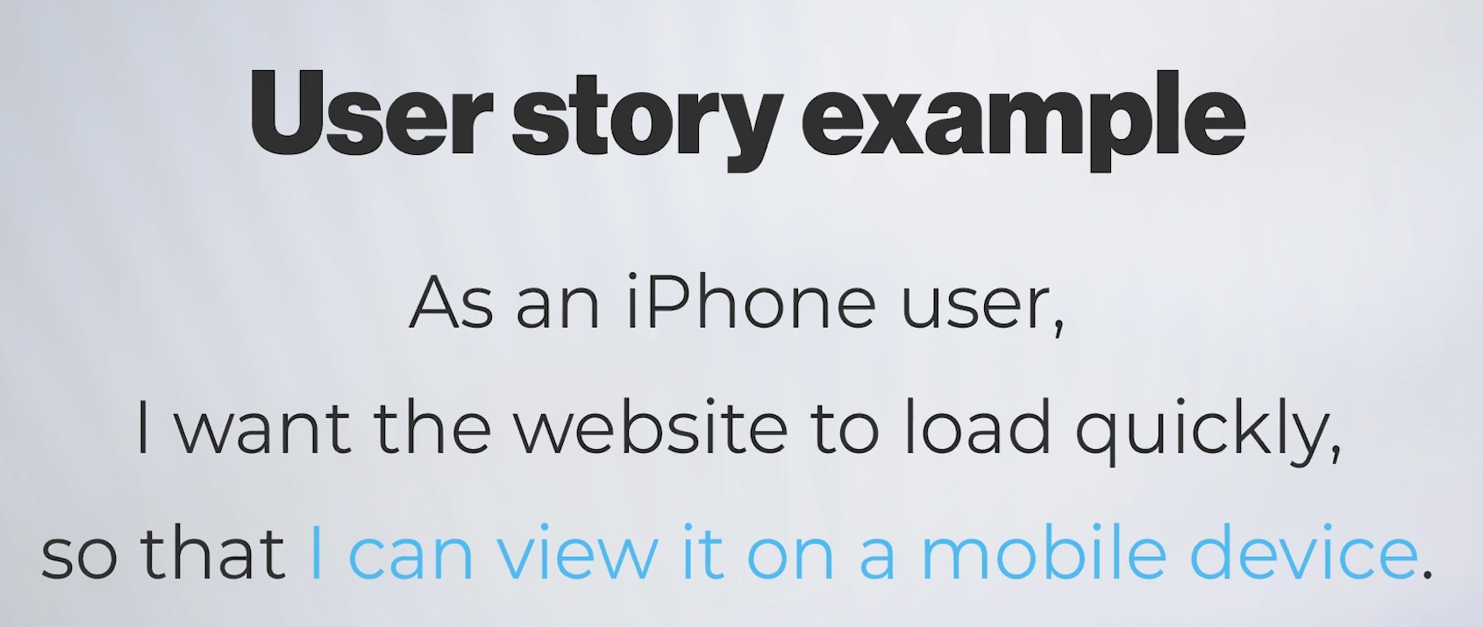

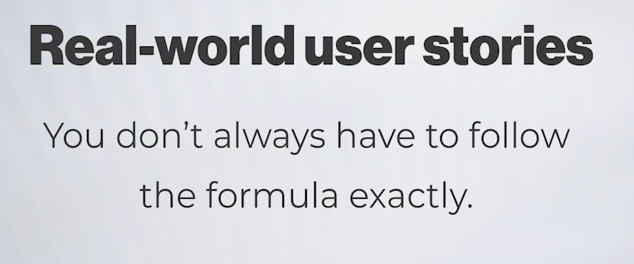



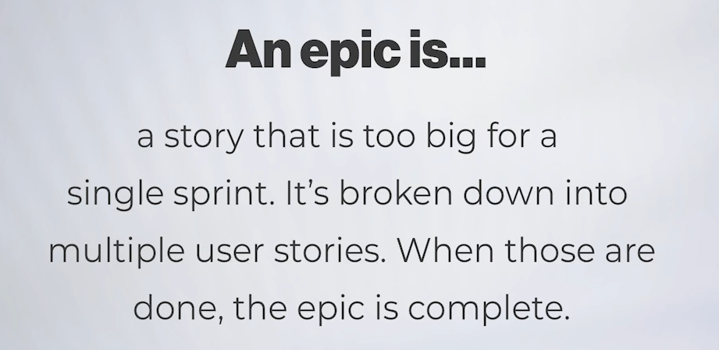

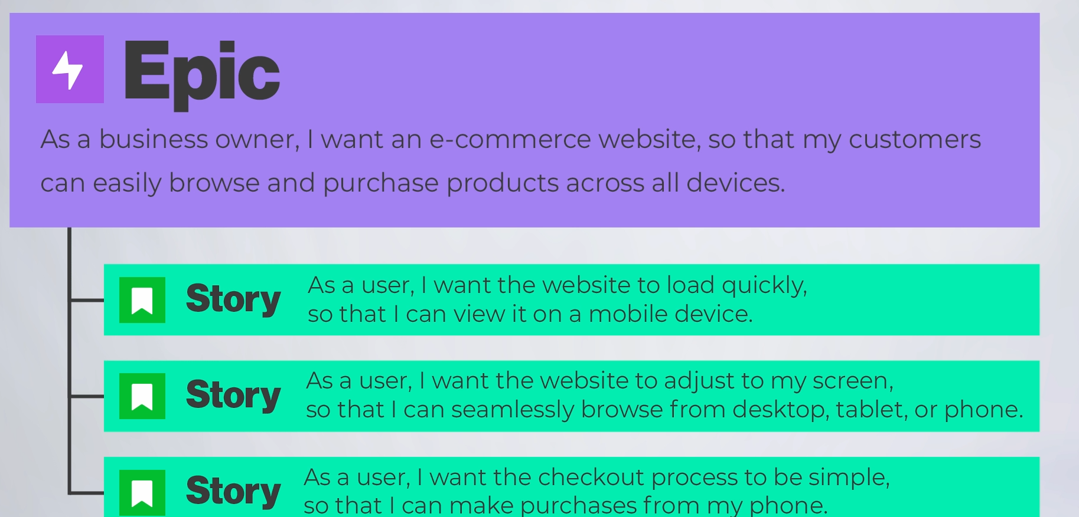

**I. Understanding "Story" in Jira**

* **Definition:** When you see the term **"Story"** in Jira, it is a direct reference to the Agile concept of **User Stories**.
* **User Story Formula:** The formal structure is designed to focus the work on the user's perspective and desired outcome:

**As a** [type of user], **I want** [some goal], **so that** [some reason/benefit].

* **Purpose of the Formula:** This format ensures the team focuses on the **end result** and the value delivered to the user, rather than just listing tasks.
  + *Example:* "As an iPhone user, I want the website to load quickly, so that I can view it on my mobile device."
* **Real-World Usage (E.P.):** While the formula is ideal, many teams skip the formal structure in Jira and simply use "Story" as the default work item to represent any smaller task or feature they need to get done.

**II. Understanding "Epic" in Jira**

* **Definition:** An **Epic** is essentially a **"big, massive-sized story."**
* **Purpose:** Epics are used to track very large bodies of work that are too big to be completed within a single sprint.
* **Hierarchical Relationship:** Epics act as **"parents"** to stories in a hierarchical structure.
  + **Epic ⊃ Multiple Stories**
  + *E.P.:* An Epic represents a major initiative or a massive feature (e.g., "Build the New Website," "Develop the Checkout System").
  + The Stories under it represent the smaller, achievable chunks of work (e.g., "Implement responsive navigation bar," "Set up payment gateway").
* **Organization Flexibility (E.P.):** The way Epics and Stories are broken down is flexible and depends entirely on what works best for the team. A team might decide if the checkout system is one Epic with many Stories, or one Story within a larger "New Website" Epic.

**III. The Distinction from "Projects"**

* **Common Confusion:** A common point of confusion for new Jira users is how Stories and Epics relate to **Jira Projects**.
* **Jira Projects are Different (E.P.):** In Jira, a **Project** is simply a container (like a folder) that holds all your team's work (Epics, Stories, Tasks, etc.). It’s a way to segment the work of one team or one major product.

===================================================================================

* 1. **Jira Terms:**

**I. The Shift from "Issues" to "Work Items"**

* **The Change:** Atlassian is replacing the long-standing term **"Issue"** with **"Work"** or **"Work Item"** in **Jira Cloud**.
* **Context:** This change was announced in March 2025. Due to the massive codebase (over 20 years of "Issue" terminology), the change will be gradual and may take years to fully implement across all versions.
* **Course Standard (E.P.):** Throughout this course, the instructor will use the term **"Work"** or **"Work Item"** to refer to what was previously known as an "Issue."
* **Functionality Remains the Same:** Regardless of the name ("Issue" or "Work Item"), the core purpose of this concept remains the same.

**II. Understanding the "Work Item" (The Heart of Jira)**

* **Definition:** A **Work Item** is the fundamental, single, trackable piece of work in Jira.
* **Data Container:** It is the container that holds all the fields and information you want to track, such as:
  + Due Dates
  + Description
  + Comments
  + Attachments (e.g., screenshots for bugs)
* **Analogy:** A Work Item is best thought of as a **"Post-it Note"** or **"Sticky Note"**. The note itself is the container for the information.
* **Types of Work Items:** Jira allows for different types of work, each customizable with its own set of fields:
  + **User Stories** (from the previous video)
  + **Bugs**
  + **Tasks**
  + *E.P.:* You can customize the fields based on the work type (e.g., Bugs require a "Screenshot" field, while Tasks require a "Due Date" field).

**III. Understanding the "Project"**

* **Jira's Definition vs. General Usage:** The term **Project** in Jira **does not** necessarily align with a single "project" you work on day-to-day.
* **Definition:** A **Jira Project** is simply a **container** that organizes and holds a collection of related **Work Items**.
* **Organizational Use:** Projects are often structured by:
  + **Team:** e.g., "Graphics Project," "Front-End Developer Project," "Back-End Developer Project."
  + **Product/Service:** e.g., "Mobile App," "Website."
* **Customization (E.P.):** The most powerful feature of Jira Projects is the ability to **customize the work types and fields allowed within that specific container.**
  + *Example:* The "Graphics Project" might need to track a *due date* on its Tasks, but the "Front-End Project" might need to track a *link to a code repository* on its Tasks. This allows teams to have distinct workflows while operating within the same Jira environment.

===================================================================================

* 1. **Versions of Jira:**

**I. Key Versions and Course Focus**

* **Version Consolidation (E.P.):** In 2024, Atlassian merged **Jira Software** and **Jira Work Management** into a single product simply called **Jira**. The old names may still be encountered.
* **Course Version:** The course uses the **most popular and latest version of Jira** (the merged product).
* **Core Focus Principle:** The course focuses on **core concepts and features** of Jira (the "get you from point A to point B" functionality), meaning the material will remain relevant even if you are using a different or older version.

**II. Licensing Models: Cloud vs. Data Center**

The version and features available to you largely depend on how your organization **licenses** Jira:

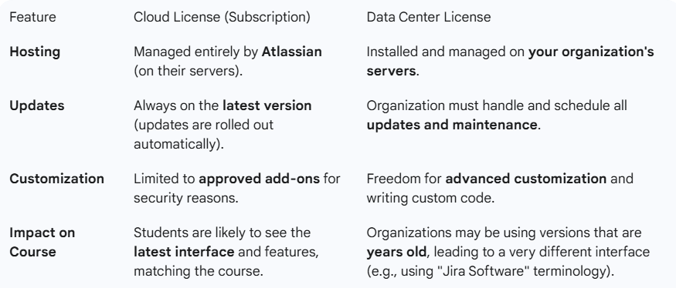

**III. Addressing Interface Discrepancies**

* **Ongoing Updates (E.P.):** Atlassian is currently rolling out a **brand-new interface** to all **Jira Cloud** licenses first. The instructor is in the process of updating the course to reflect these changes.
* **Terminology Lag:** Major terminology changes, like the shift from **"Issue"** (used since 2002) to **"Work"** or **"Work Item,"** can take many months or even years to fully propagate through all code and interfaces.
  + **Action:** If you see "Issue" on your screen and the instructor says "Work Item," remember they refer to the **exact same core concept**.
* **Third-Party Add-ons:** Jira has a marketplace with **over a thousand add-ons** (with extra costs) that can drastically change its appearance and functionality.
  + **Course Limitation:** This course **does not use any third-party add-ons**. If your company uses one, your Jira view may be different.

**IV. Conclusion of the Section**

* The course will proceed using the latest **Jira Cloud** version with **no extra add-ons**.
* Despite any visual differences, the core workflow principles being taught are universal to Jira.
* The class is now ready to move into the next section and begin exploring Jira firsthand.

***************************************************************************************************************************************************************************************************************************************************************************************

**Section 2: Jira for Users:**

1. **Getting familiar with Jira’s Interface:**

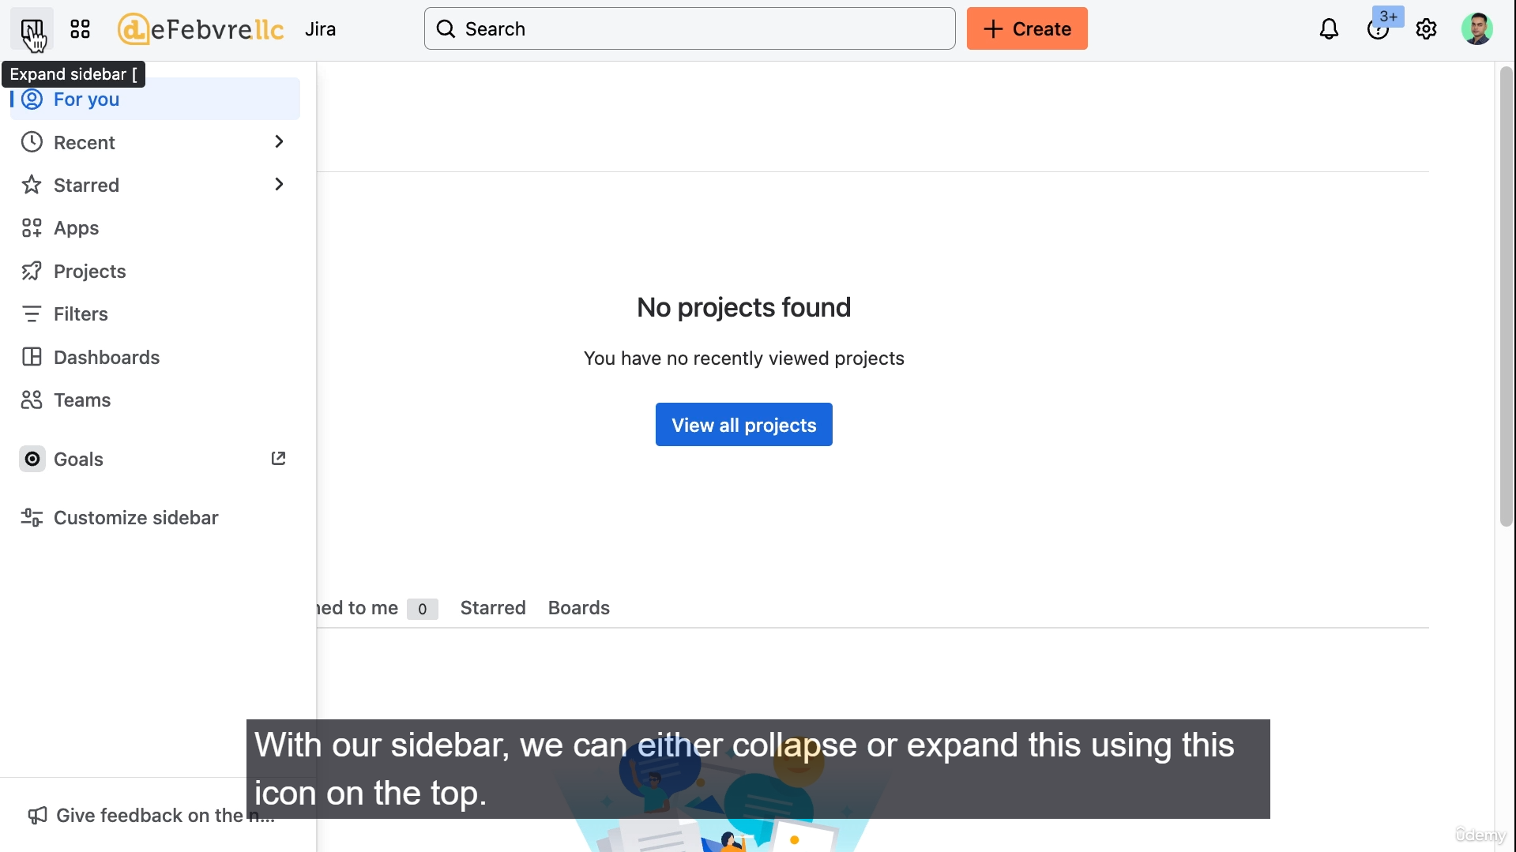

**I. The "Your Work" Home Screen**

* **Default Landing Page:** By default, when a user first logs in, they are taken to the **"Your Work"** page.
  + *E.P.:* This page is customizable and can be changed in the user's personal settings.
* **Content:** This area displays all the work items (formerly issues) the logged-in user has been actively working on.
  + New users will see very little, while active users (like the administrator shown) will see a densely populated list.

**II. Top Navigation Bar Components**

The top menu contains global navigation and tools, often accessible by keyboard shortcuts:

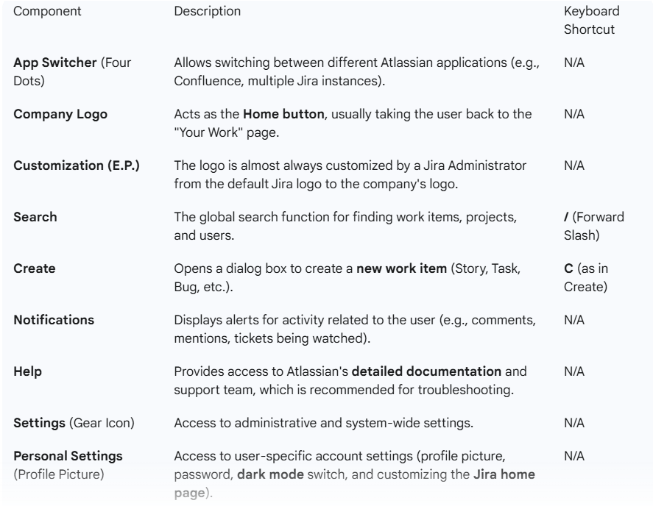

**III. Key Concepts to Remember**

* **Interface Differences:** The user's screen may differ from the course due to:
  1. The recent **interface change** (May 2025).
  2. The user running an **older Data Center version**.
  3. The administrator changing the **company logo**.
* **Permissions and Settings:** The number of options visible in the **Settings** menu is directly tied to the user's **permissions**. An administrative user will see many more options than a standard user.
* **Terminology Note (E.P.):** Atlassian is changing **"Product Settings"** to **"App Settings"** to align with the "App Switcher" terminology.
* **Time-Saving Tip:** Users are encouraged to practice the global keyboard shortcuts (**/** for search and **C** for create) to speed up their work in Jira.

===================================================================================

1. **First look at Jira’s Sidebar Features:**

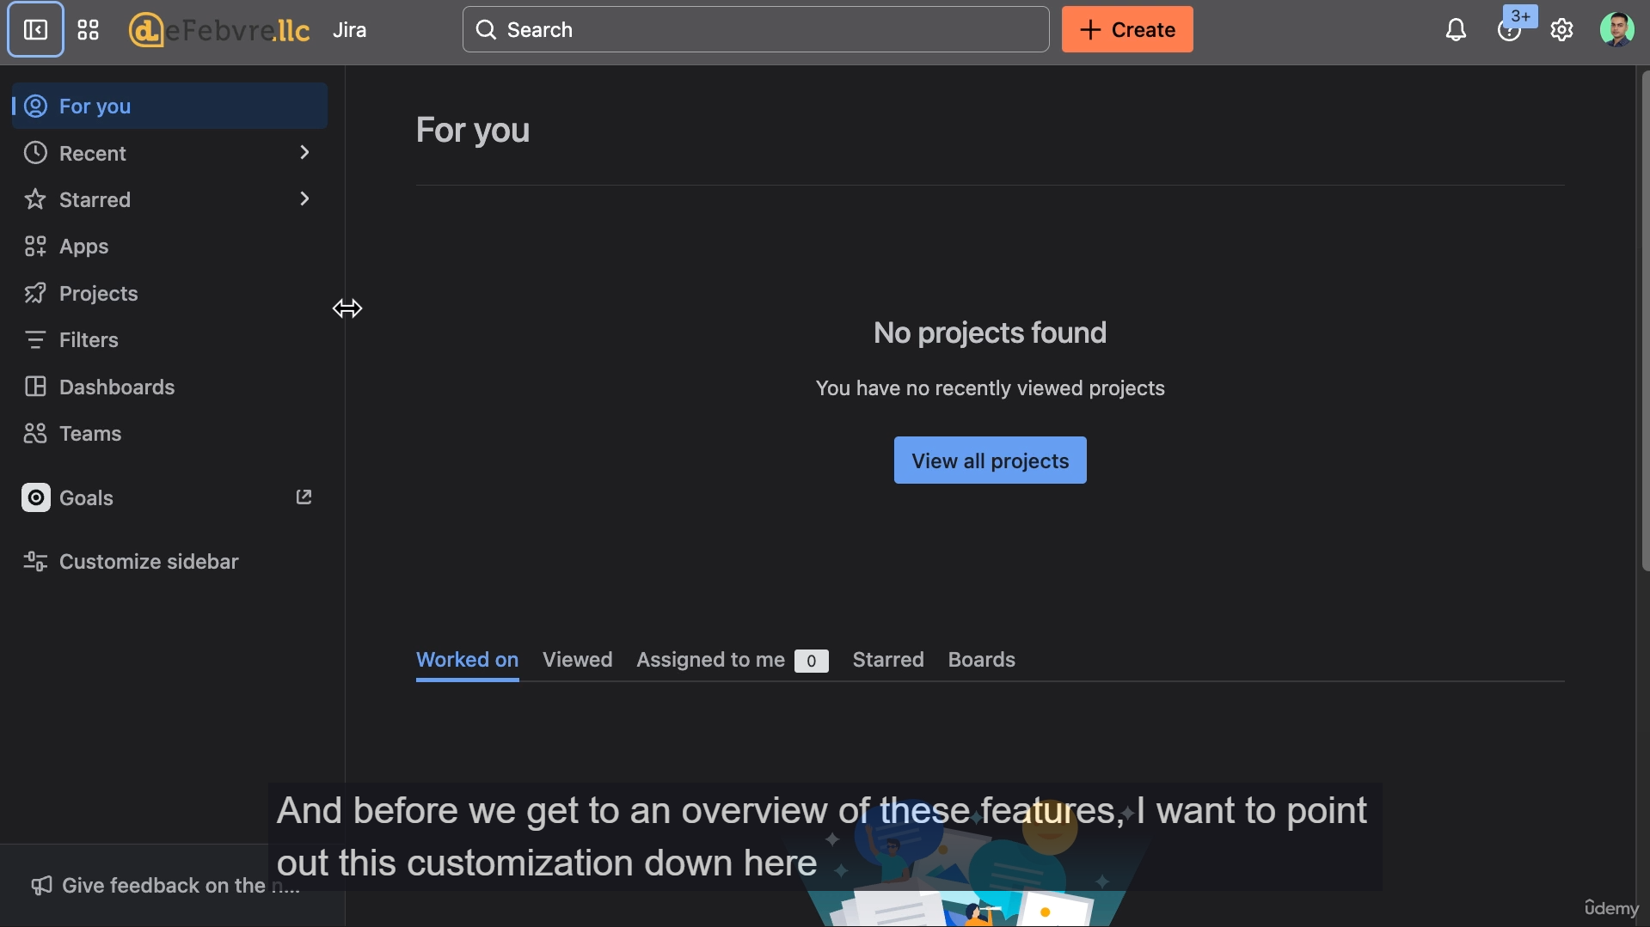

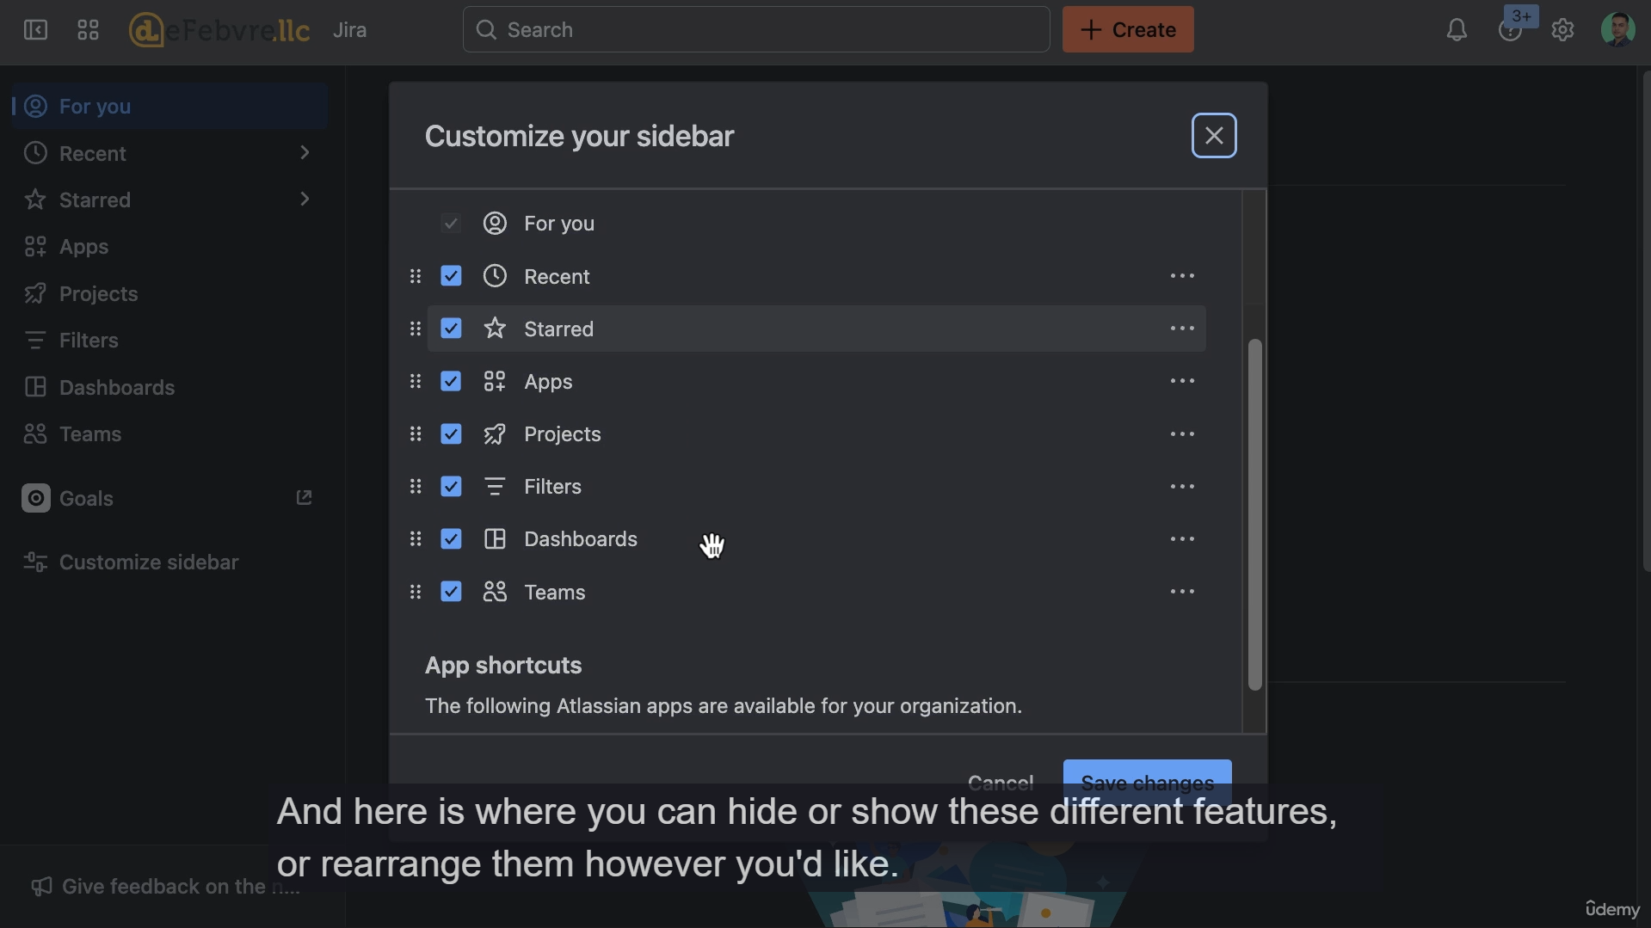

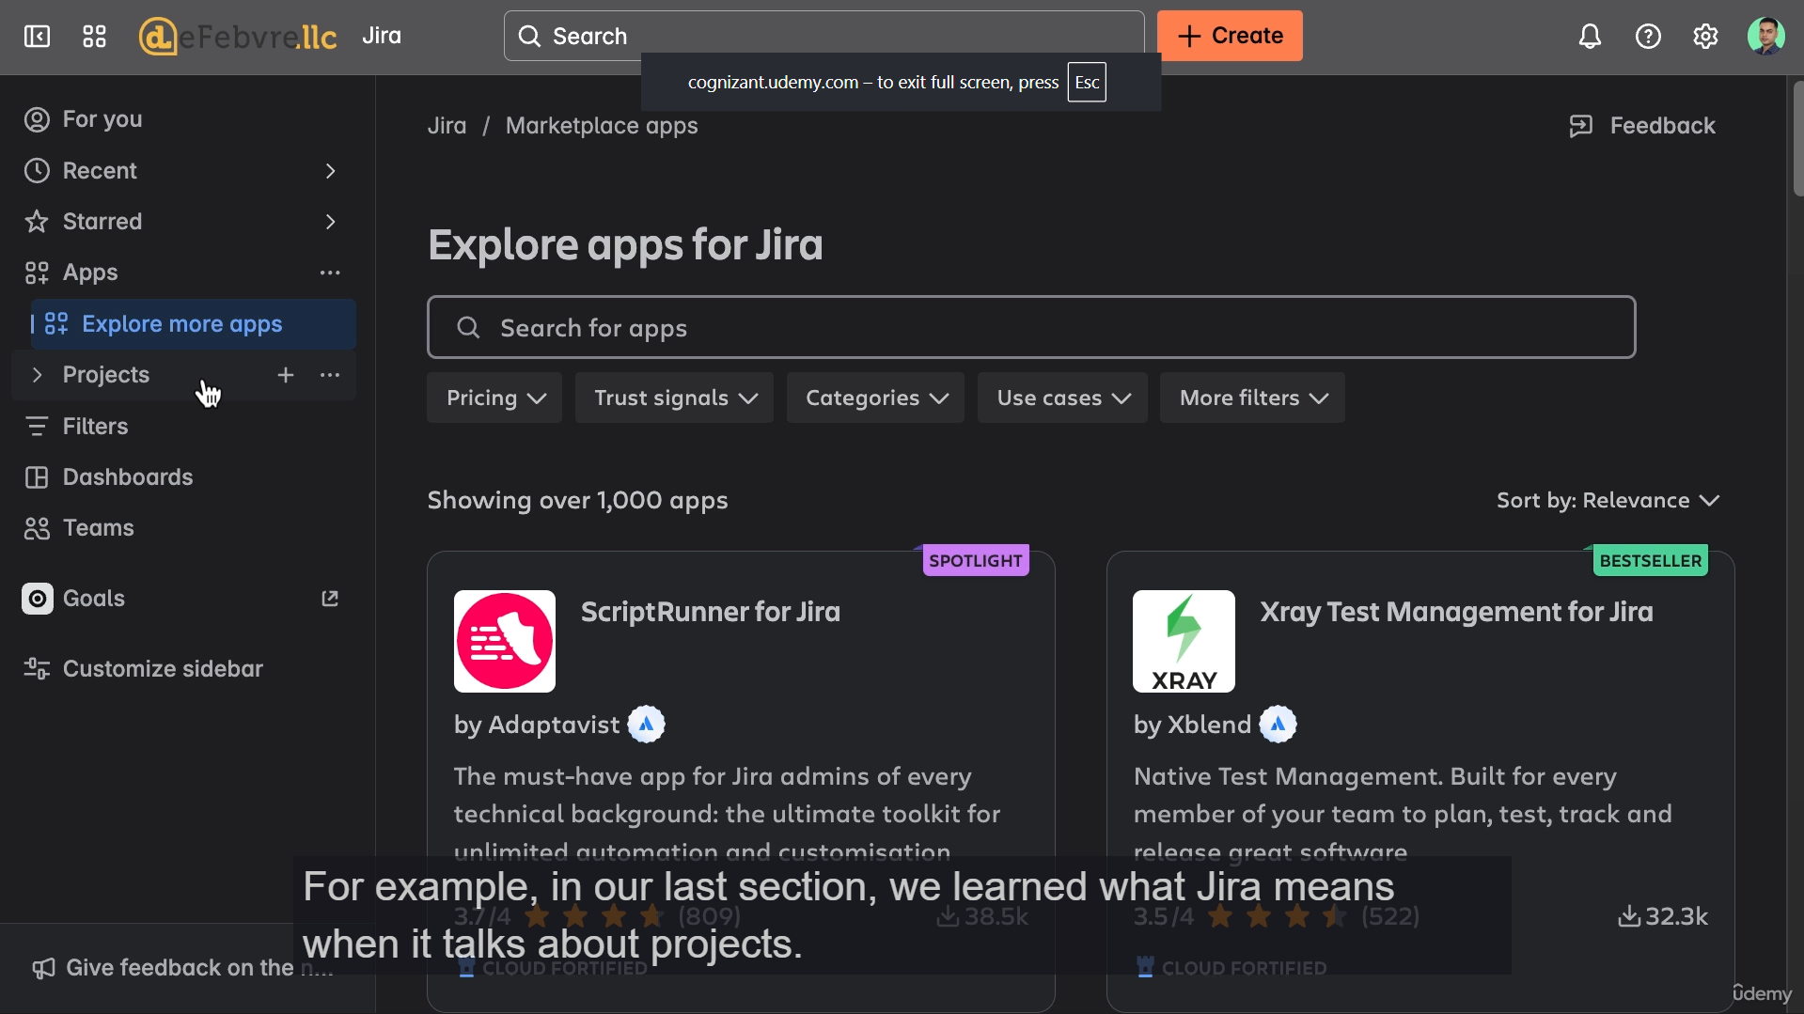

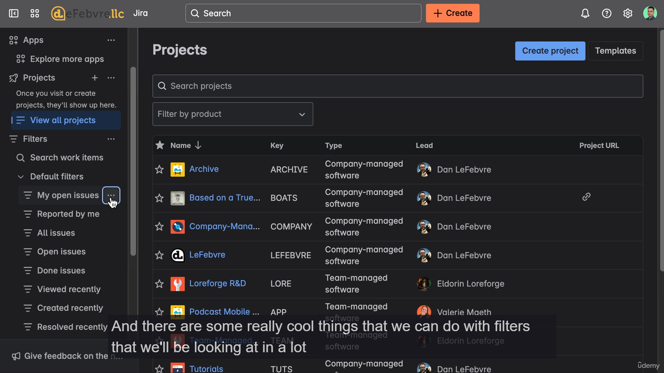



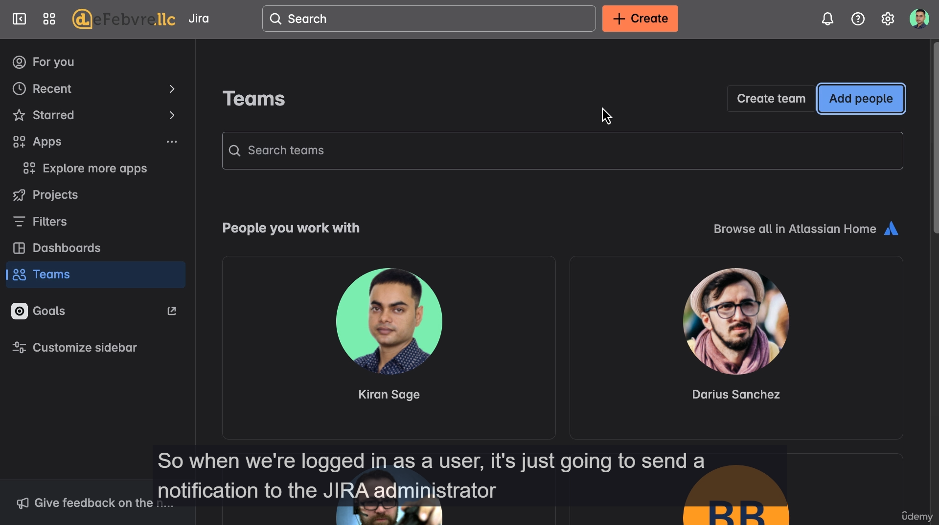

**I. Sidebar Mechanics and Customization**

* **Responsive Design:** On mobile or small browser windows (responsive design), the sidebar is **collapsed** by default and cannot be permanently pinned open.
* **Pinning:** On a wider desktop view, the sidebar is typically **pinned open** by default. It can be manually expanded or collapsed using the dedicated icon (or the [ keyboard shortcut, as learned previously).
* **Customization:** Users can **customize the sidebar** (rearrange, hide, or show features) using the menu at the bottom of the sidebar. The instructor will maintain the default configuration throughout the course.

**II. Core Sidebar Features**

The sidebar contains global quick-access links to core Jira functionalities:

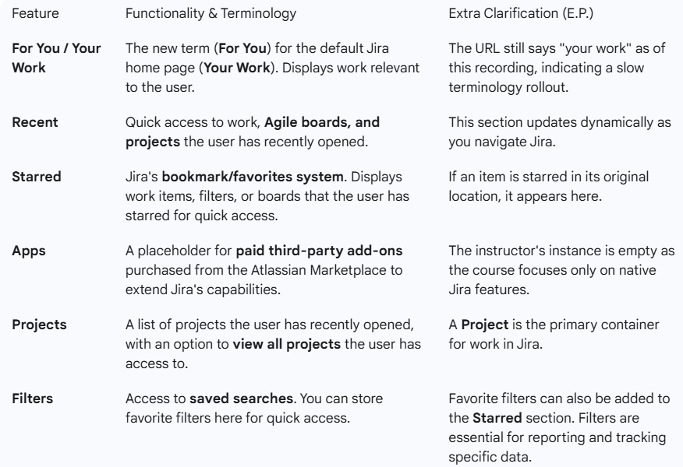

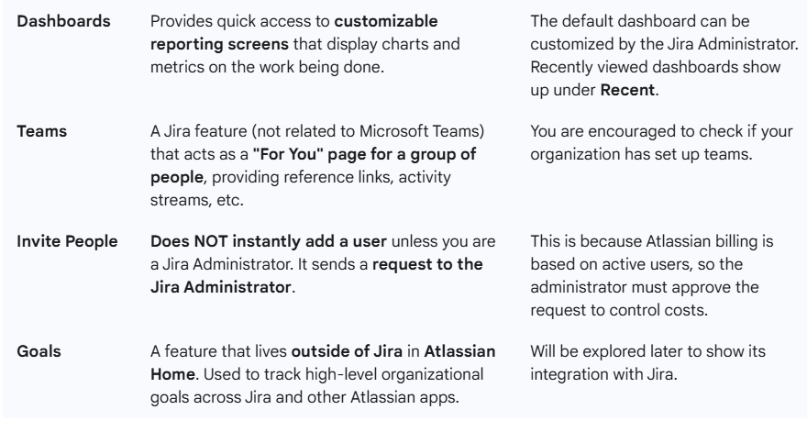

**III. Final Review and Next Steps**

* **Review:** The last two videos provided a comprehensive high-level view of the entire Jira user interface.
* **Practice:** Users are encouraged to click around the interface to get accustomed to the layout and navigation.
* **Navigation Tip:** Clicking the **company logo** in the top-left corner will always take you back to the Jira home page (**Your Work**).
* **Next Topic:** The next video will cover the fundamental structural concepts of Jira Projects: **Team-managed** vs. **Company-managed** projects.

===================================================================================

1. **Team Managed VS Company Managed Projects:**

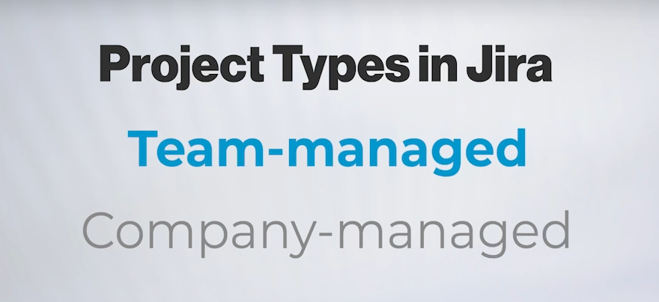

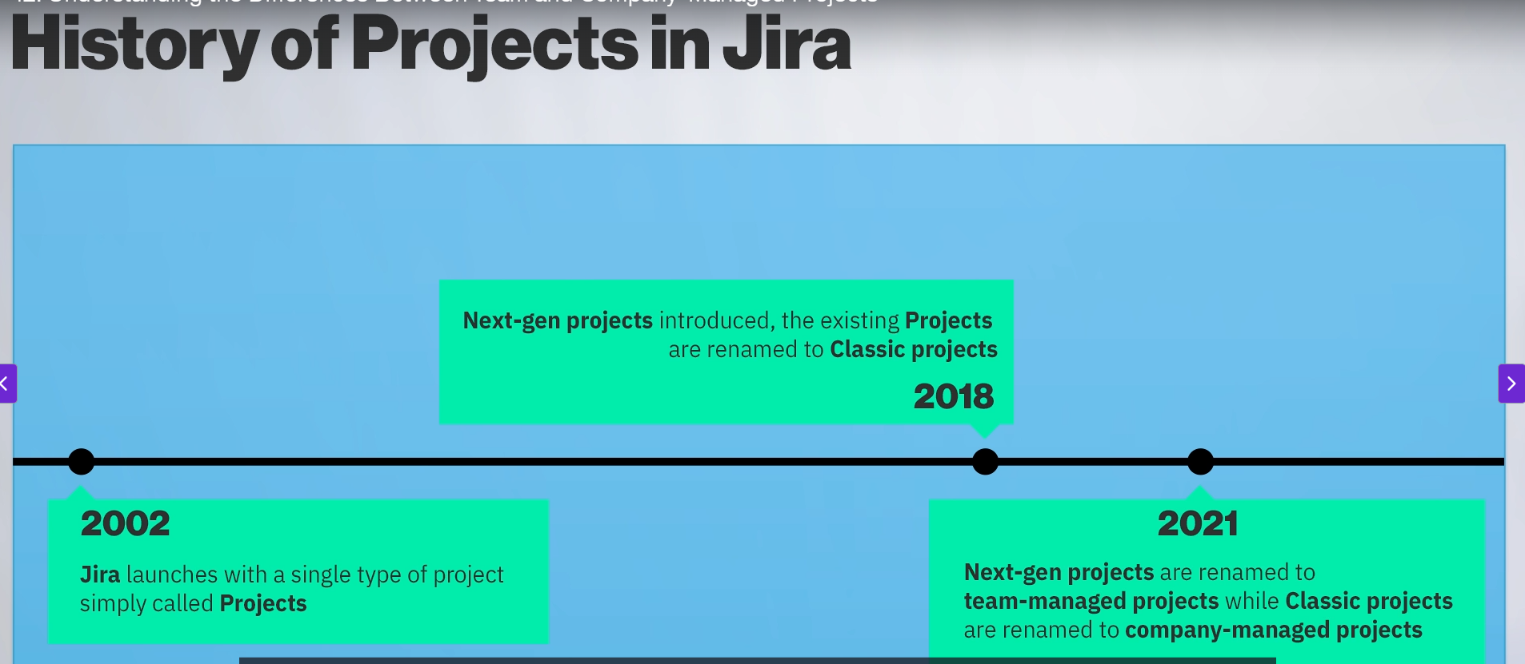

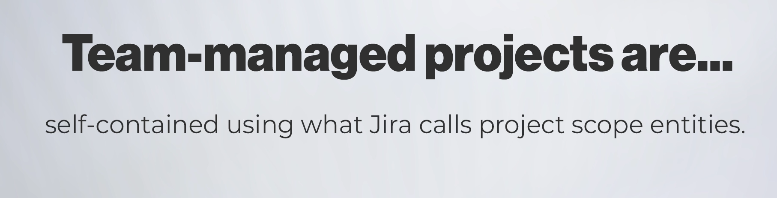

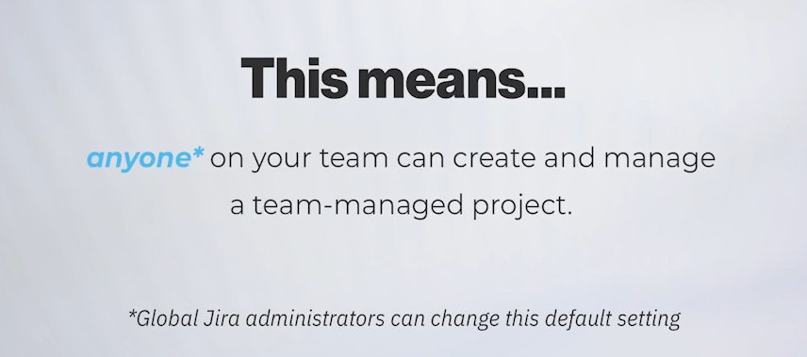

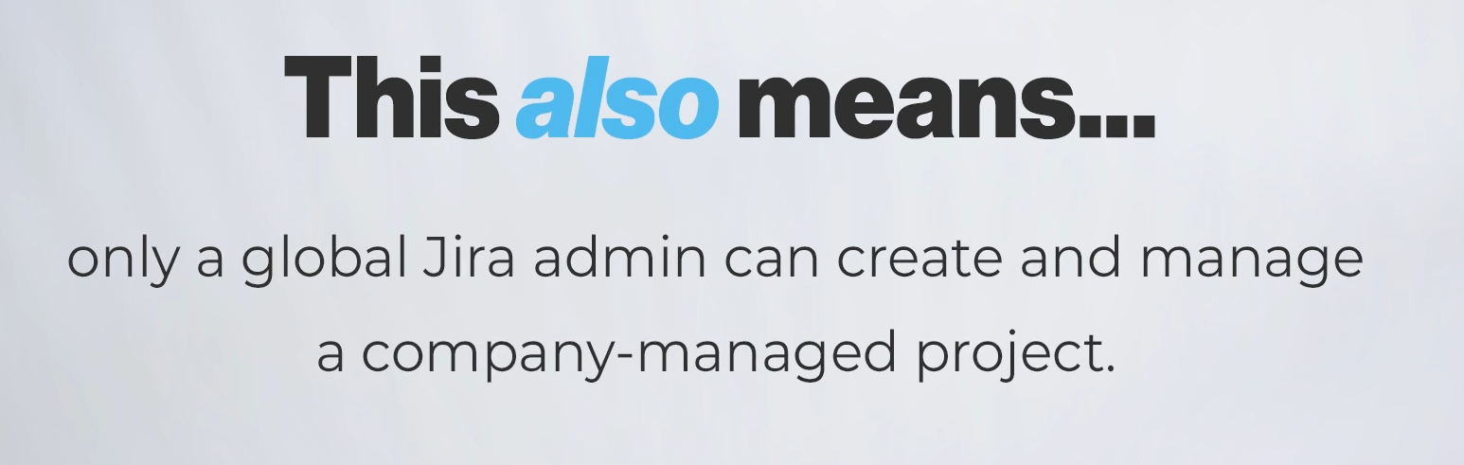

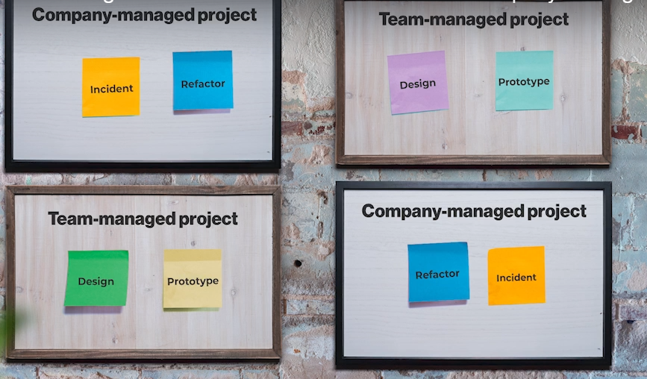

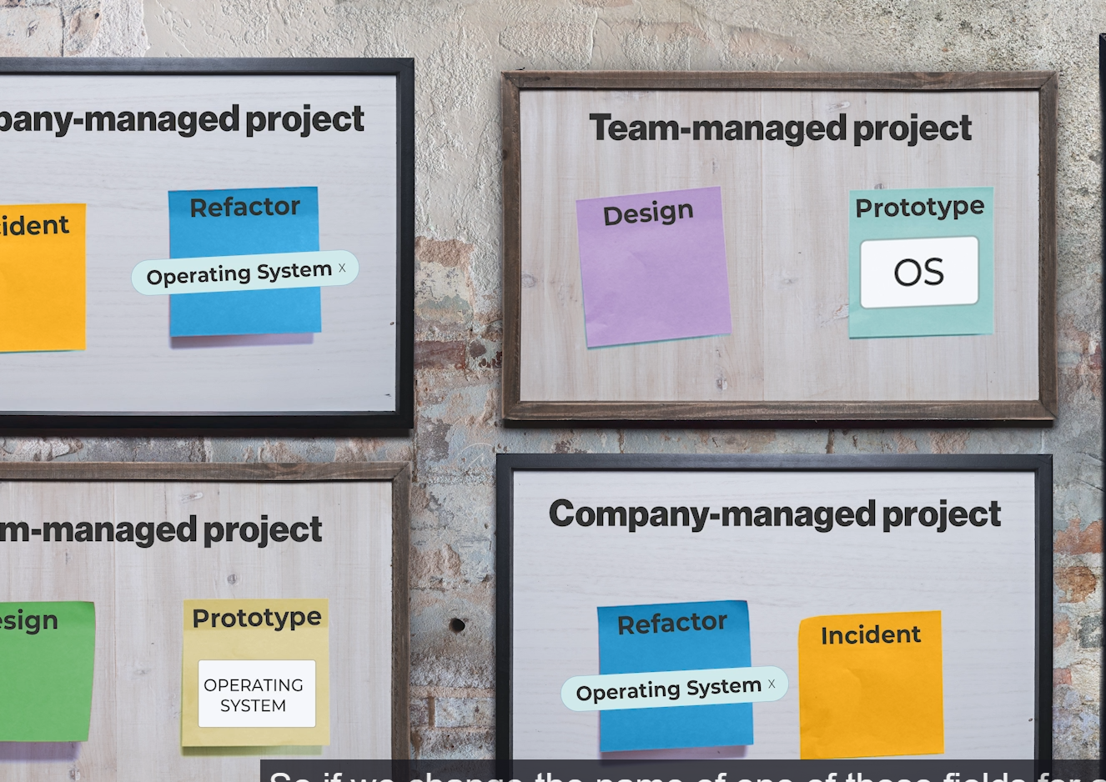

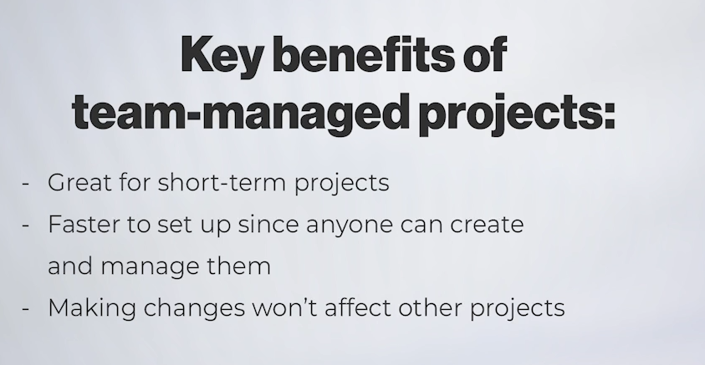

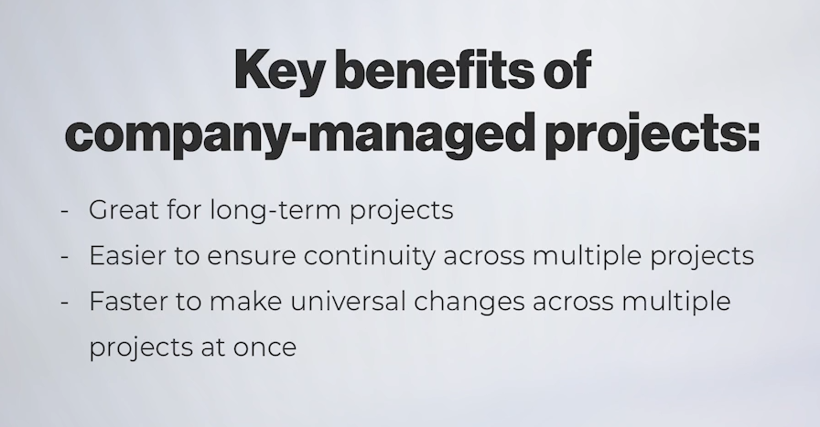

**I. Historical Terminology (E.P. for Context)**

* **2002 - 2018:** The single project type was simply called **"Project."**
* **2018:** Atlassian introduced a new project type called **"Next-Gen Projects."** The original project type was renamed **"Classic Projects."**
* **2021:** The names were simplified to reflect their purpose:
  + **Next-Gen Projects** → **Team-Managed Projects**
  + **Classic Projects** → **Company-Managed Projects**

**II. Team-Managed Projects (Self-Contained & Flexible)**

* **Concept Analogy:** A **self-contained book** (everything needed is inside).
* **Scope:** Uses **Project-Scoped Entities**. Everything within the project (workflows, fields, work types, etc.) is confined to that project only.
* **Creation/Management:** Can be created and managed by **anyone on the team** (or anyone with default Jira user permissions).
  + *E.P.:* No special **Global Jira Administrative Permissions** are required for management, making them fast and autonomous.
* **Pros:**
  + **Autonomy:** Teams can quickly customize their work types, fields, and workflows without needing a Jira Administrator.
  + **Safety:** Changes made to a team-managed project **do not affect any other project** in the Jira instance.
  + **Best for:** **Short-term projects** or new teams needing a quick, dedicated space.
* **Key Example:** If you rename a field (e.g., "OS" to "Operating System") in one team-managed project, it only updates in that project because it's a unique field entity, even if another team-managed project has a field named "OS."

**III. Company-Managed Projects (Shared & Consistent)**

* **Concept Analogy:** An **entire library of books** (entities are shared across the whole system).
* **Scope:** Entities are **Shared** and live in a central **Global Administration Area**. The project references these central entities.
* **Creation/Management:** Must be created and managed by the **Global Jira Administrator**.
* **Pros:**
  + **Consistency:** Ensures continuity across the organization by standardizing work types, fields, and workflows across multiple projects.
  + **Efficiency:** Administrators can make a single change to a shared entity, and that change immediately propagates to **all company-managed projects** using it.
  + **Best for:** **Long-term projects** or large programs where consistency and standardized reporting are required across the company.
* **Key Example:** If a Jira Administrator renames a shared field in the central area (e.g., "OS" to "Operating System"), it instantly updates in **every company-managed project** that uses that shared field.

**IV. Moving Forward**

* **Next Step:** The course will start by demonstrating how to create a **Team-Managed Project** because they are simpler to set up and do not require elevated Global Jira Administrative Permissions.

===================================================================================

1. **Creating a Team managed Project:**

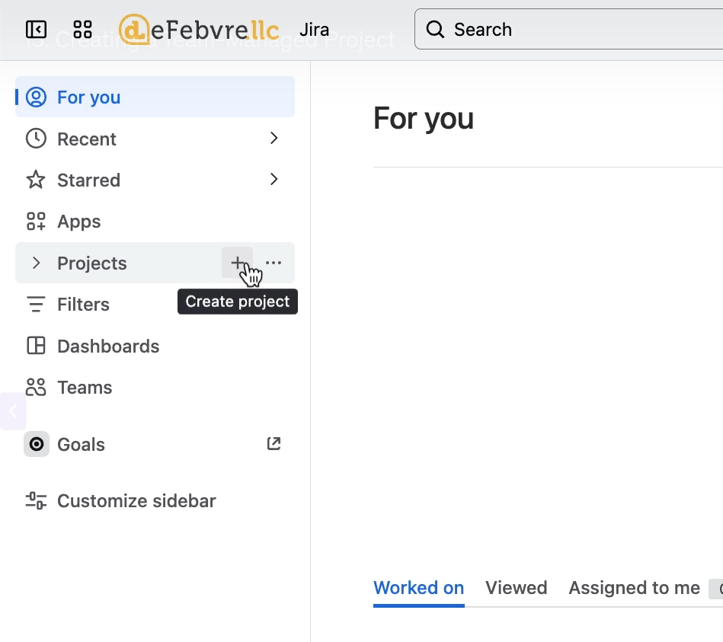

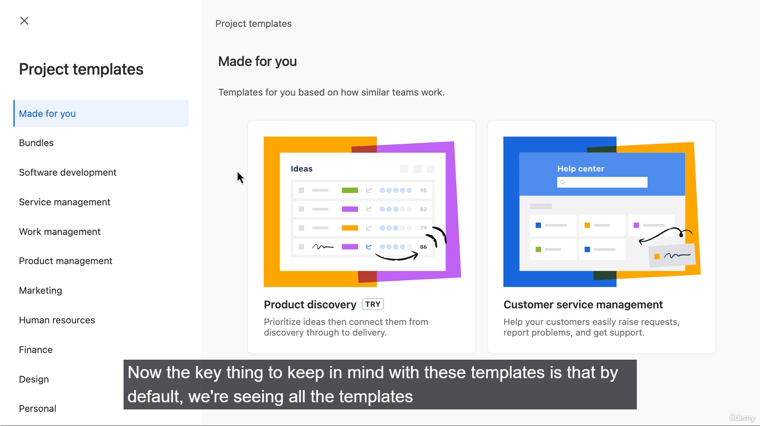

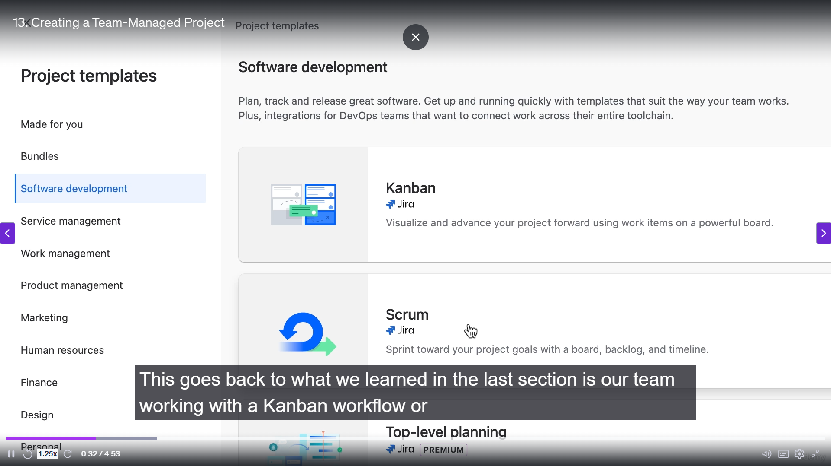

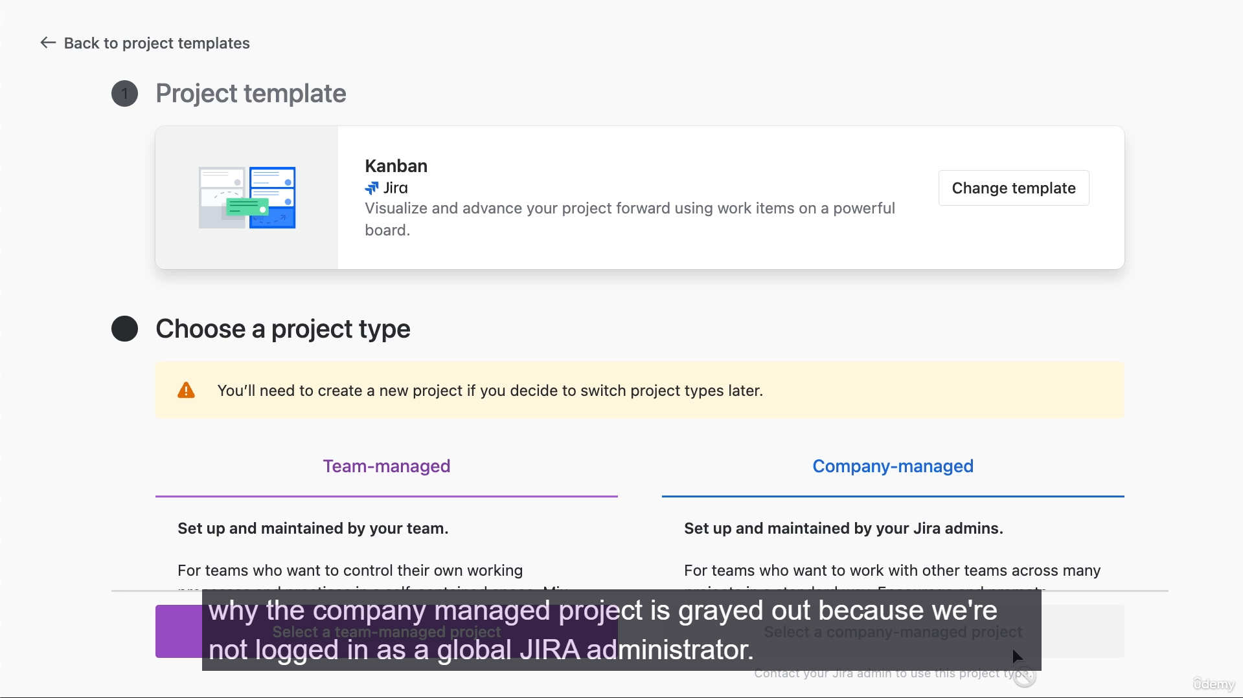

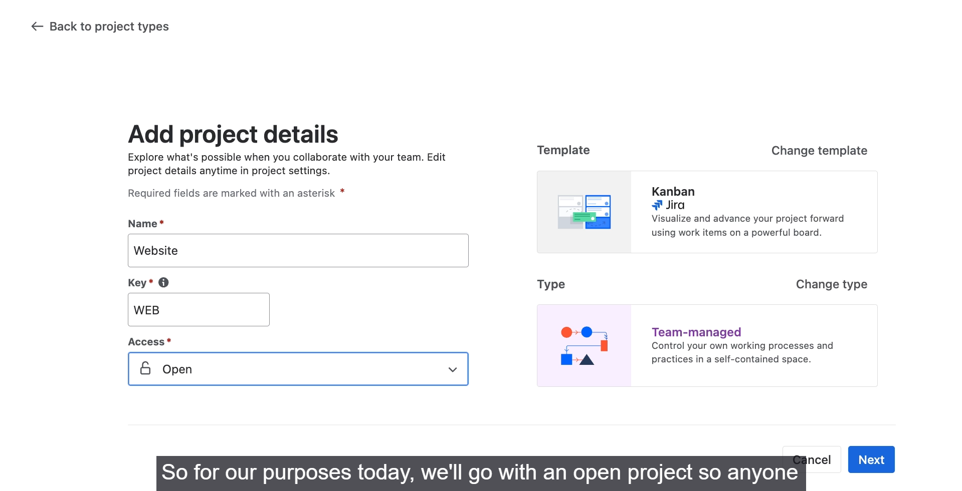

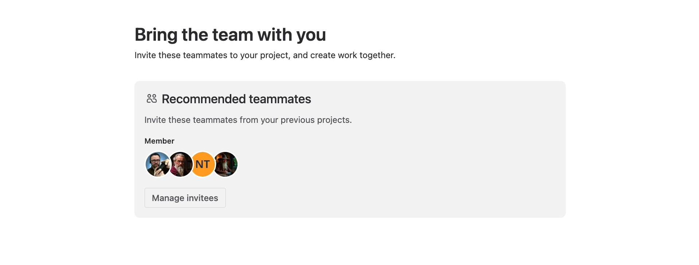

**Steps to Create a Team-Managed Project**

1. **Access Project Creation:**
   * Navigate to the **sidebar** and click on **Projects**.
   * Click the **plus icon (+)** to create a new project, which takes you to the project templates.
2. **Select a Template:**
   * Review the available templates, keeping in mind that the list shows all templates, including those for different Jira versions (e.g., Jira Premium, Jira Service Management) that might require a trial or a different license.
   * For this example, the user selects the **Kanban** template under **Software development**.
3. **Choose Project Type:**
   * After selecting the template, choose between **Team-managed project** or **Company-managed project**.
   * The user selects **Team-managed project** because they are logged in as an end-user, not a global Jira administrator (the latter is required to create a Company-managed project).
4. **Name and Key the Project:**
   * **Name:** Give the project a name (e.g., "**Website Project**").
   * **Project Key:** Enter a unique key (e.g., **WP**). The key is crucial as it's used in the URLs for all work items within the project and must be unique across all Jira projects in the installation.
5. **Set Access Level:**
   * Choose one of the three access levels:
     + **Private:** Locks down the project; people must be invited manually (a global Jira administrator can always view it).
     + **Limited:** Anyone in the Jira installation can **see** the project but cannot make changes (read-only).
     + **Open:** Makes the project accessible to everyone in the Jira installation, allowing them to **create and edit** work items.
   * The user selects **Open** for ease of use, noting it can be changed later.
6. **Finalize Creation:**
   * Click **Next** to create the project.
   * The user is given an option to connect another Atlassian app but chooses to **skip** this step.
   * The new team-managed project is then successfully created.

**======================================================================**

1. **Creating Work in team managed Project:**

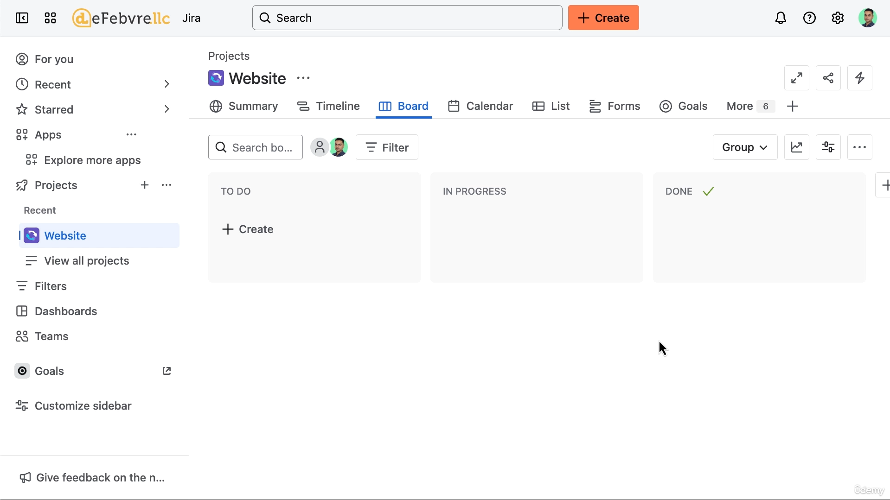**’**

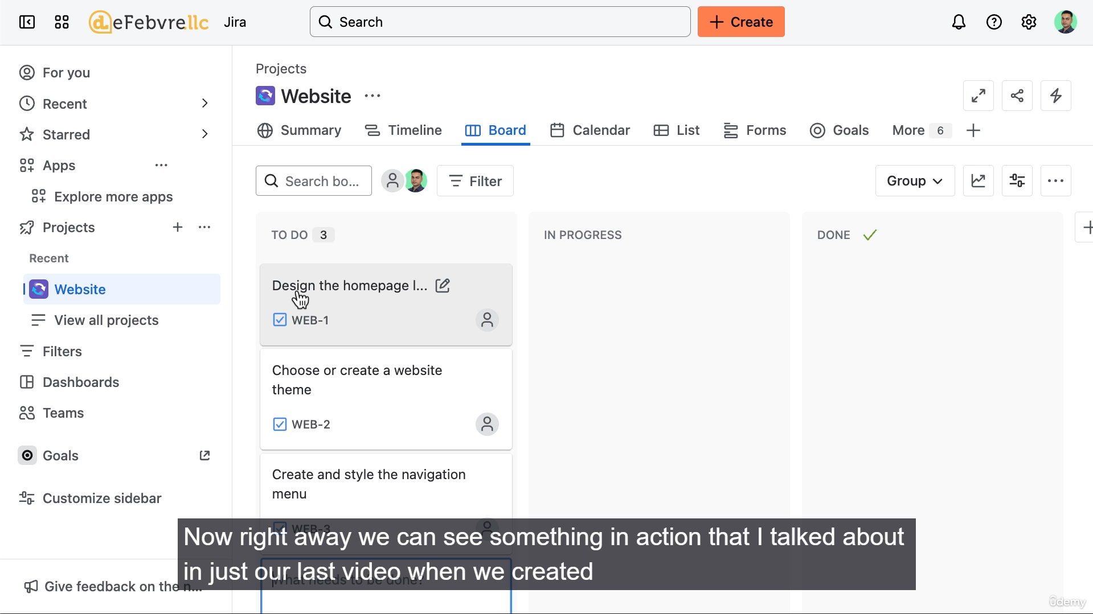

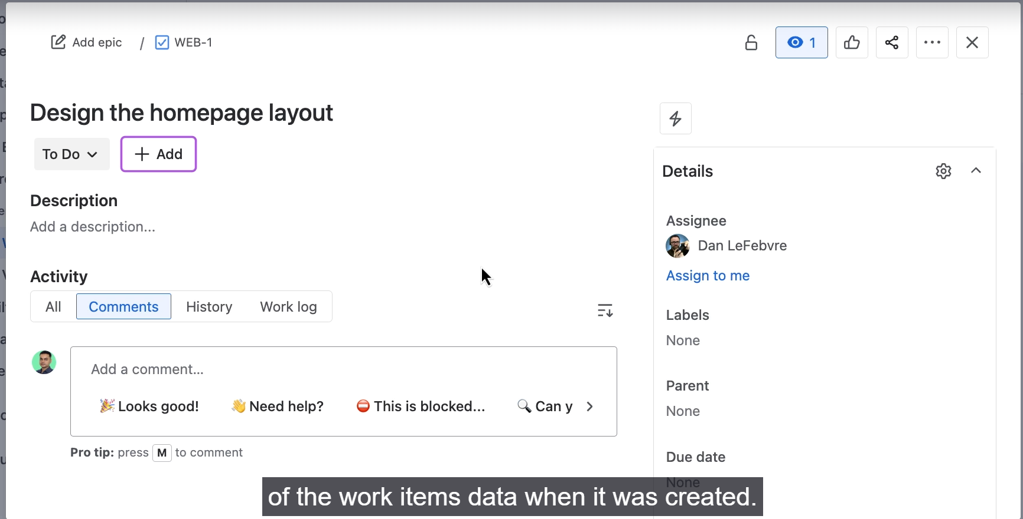

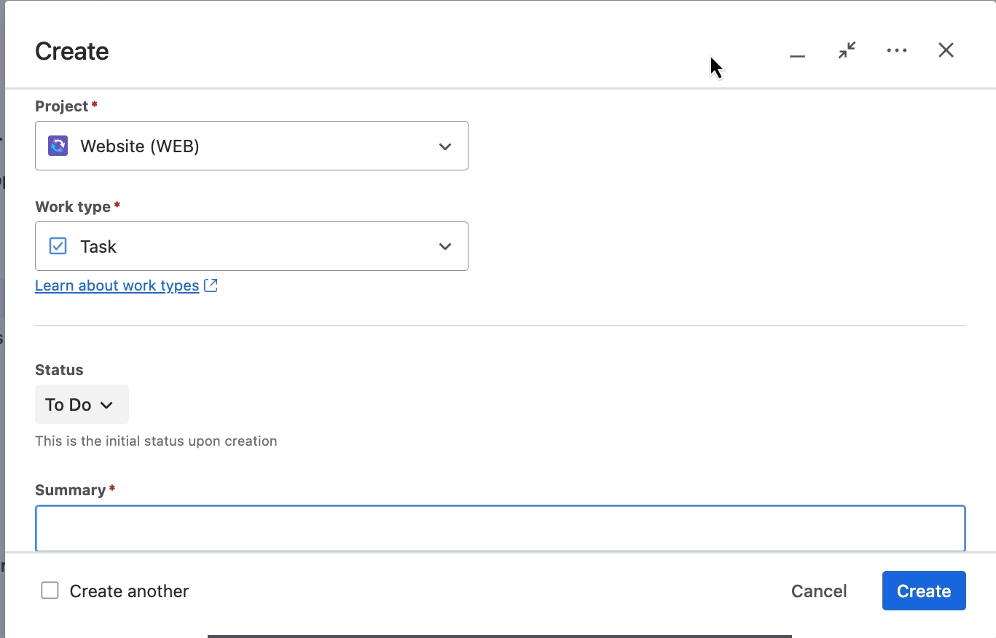

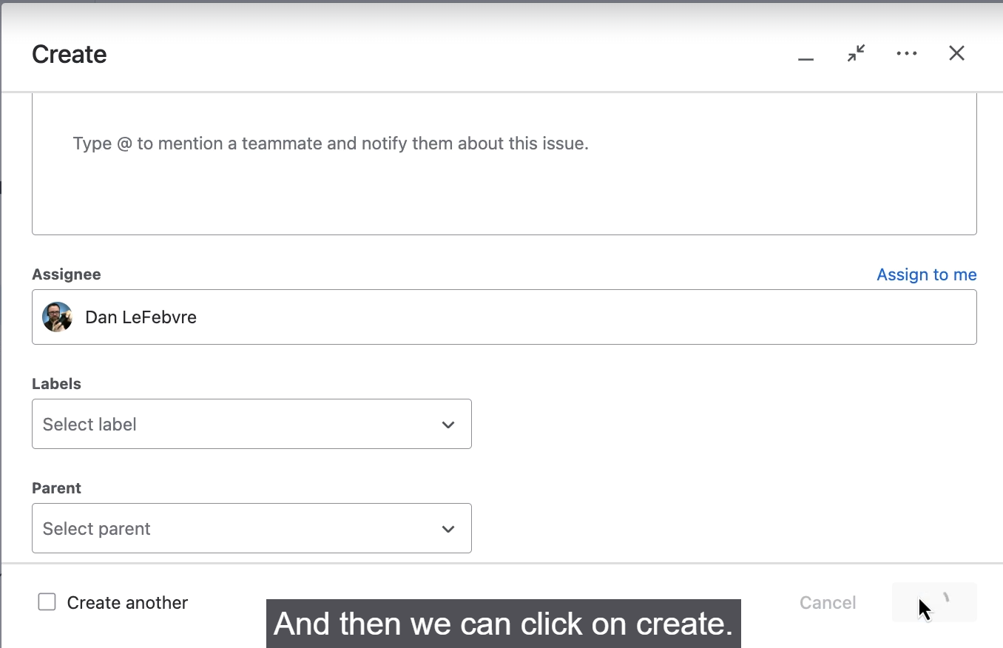

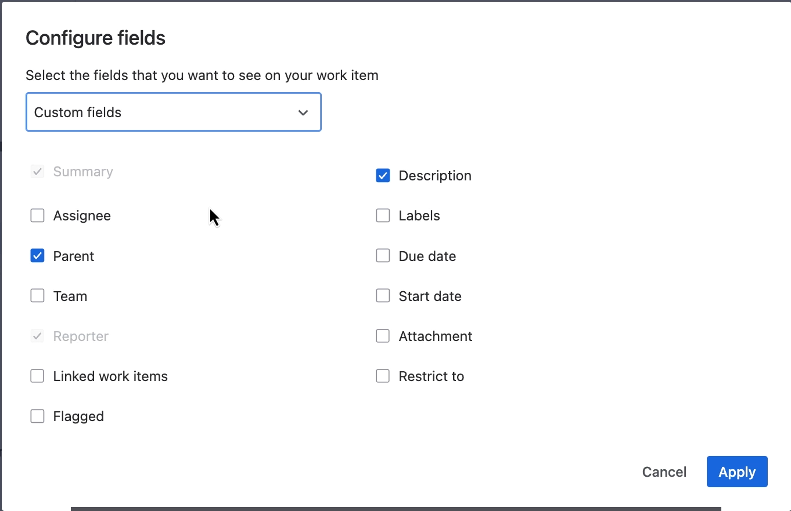

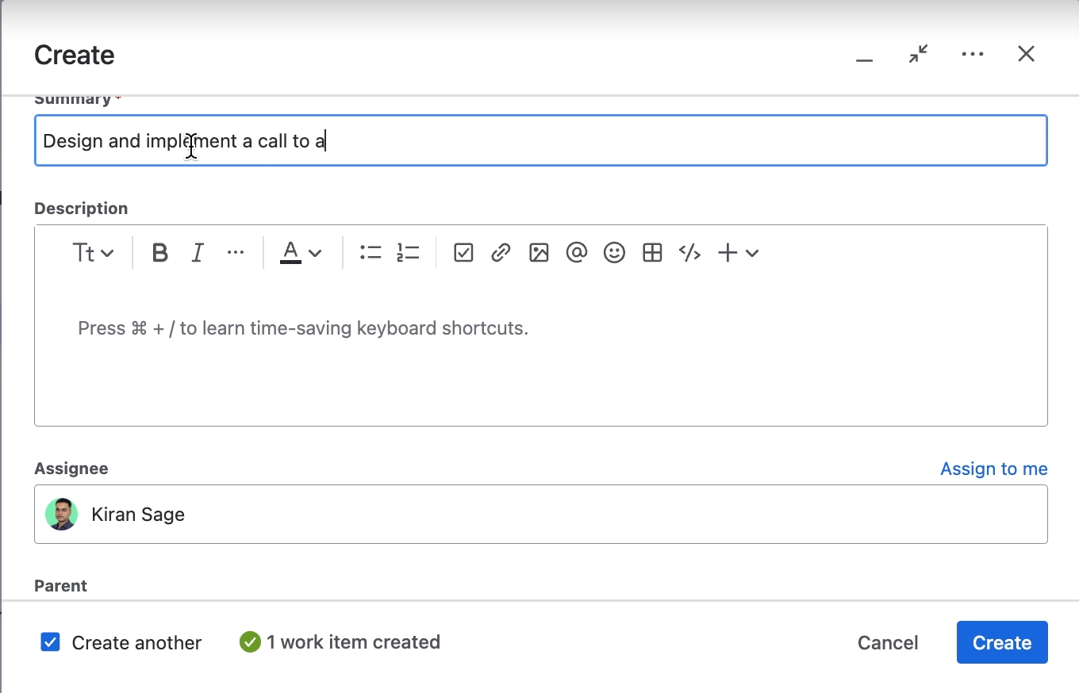

**Methods for Creating Work Items**

**1. Quick Creation (Directly on the Board)**

This is the fastest method, ideal for adding multiple items rapidly.

* **Location:** In the "To Do" column on the project board.
* **Process:** Click the "Create" button directly on the board, type the summary, and press **Enter**.
* **Resulting Data:**
  + **Project Key:** The new work item is assigned a sequential key (e.g., WEB-1, WEB-2) based on the project key.
  + **Fields:** Only the **Summary** field is populated. All other fields are left empty.
  + **Assignee:** The work item is created as **Unassigned** by default in Jira.
* **Tip:** You can click the unassigned icon to immediately assign the work item to a user, like Dan, directly from the board.

**2. Full Creation Screen (Using the "Create" Button)**

This method allows you to fill out more fields at the time of creation.

* **Access:** Click the global **Create** button in the top navigation bar, or use the keyboard shortcut **C**.
* **Key Concept: The Dividing Line:** The fields in the creation screen are organized hierarchically:
  + **Above the line:** **Project** and **Work Type** (Issue Type).
  + **Below the line:** All other fields.
* **Dynamic Fields:** All fields **below the line** change based on the **Project** and **Work Type** selected above the line.
  + *Example:* Switching the project changes the available work types, and switching the work type changes the available custom fields (like "Release date" or "Category").
* **Required Fields:**
  + The **Summary** field is always required (marked with a red asterisk) because Jira needs it to display work items on the board and in other views.
  + The **Reporter** field is also required but is automatically filled with the name of the currently logged-in user (e.g., Kieran).
* **Data Entry:** You can fill out fields like **Summary**, **Description**, and **Assignee** *before* creation, ensuring the work item is assigned immediately upon creation.

**Tips for Faster Work Item Creation**

**1. Configure Fields for Your User Account**

You can customize which fields appear on the full "Create" screen for your user account (e.g., Kieran) to reduce clutter.

* **Access:** Click the **three dots** in the top right of the "Create" screen.
* **Action:** Select **Configure fields** > **Custom**.
* **Customization:** Uncheck unnecessary fields to hide them and keep only the ones you frequently use (e.g., Summary, Description, Assignee, Parent).
* **Effect:** This setting is *personal* and only affects the screen for your user, speeding up your individual workflow without impacting the team.

**2. Use the "Create another" Checkbox**

This feature is ideal when creating multiple similar work items consecutively.

* **Location:** Bottom left of the "Create" screen.
* **Functionality:**
  + Keeps the "Create" screen open after you click "Create."
  + Jira **remembers** certain field values (like **Project**, **Work Type**, and **Assignee**) from the last work item, so you only have to enter a new **Summary**.
  + This eliminates the need to re-open the screen and re-select the same project/assignee repeatedly.

==================================================================================

1. **Navigating team managed Project:**

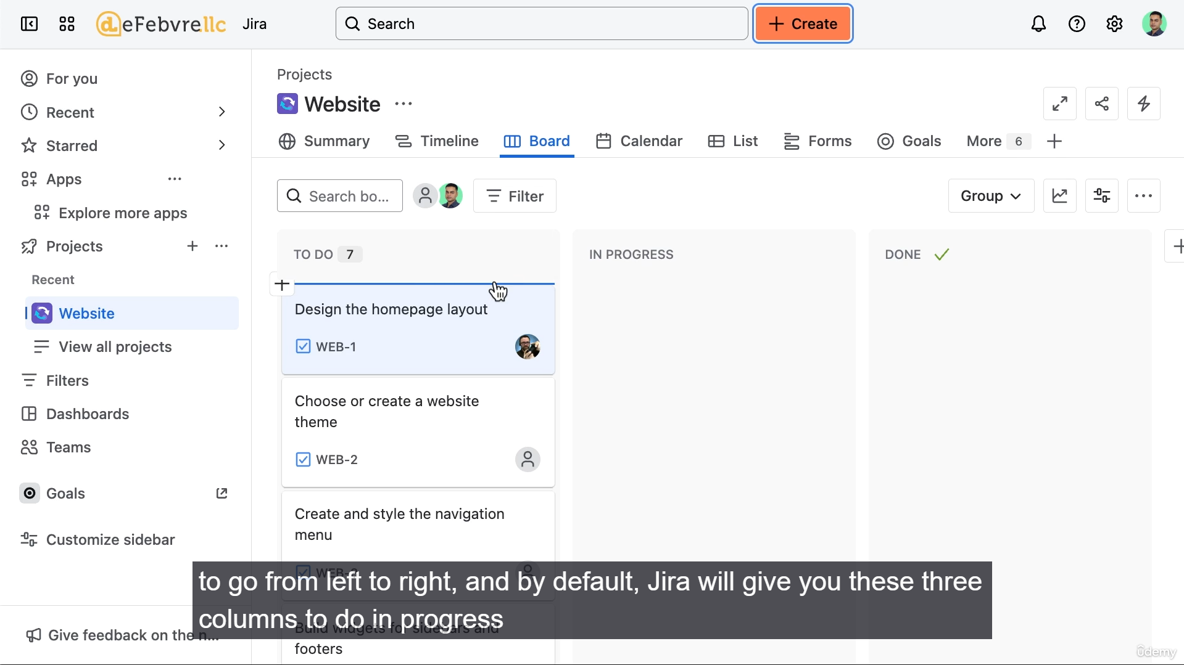

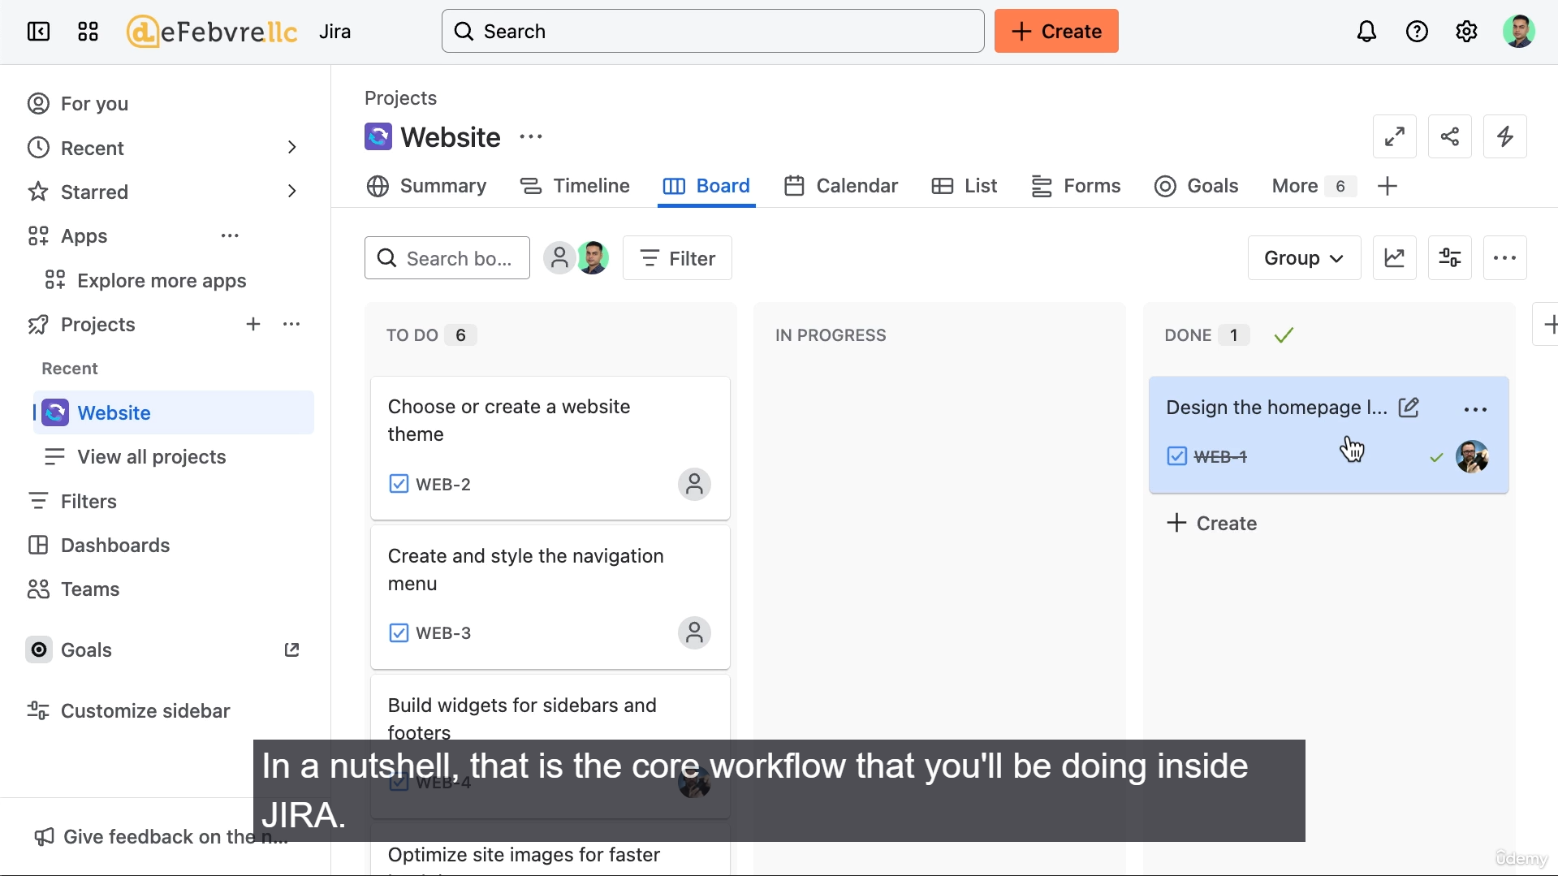

**1. Jira Interface Navigation**

* **Global Navigation (Top Menu):** The top menu remains constant across Jira and is used for **global navigation** (i.e., navigating between different sections of Jira outside the current project).
* **Project Navigation (Tab-Style Menu):** Once inside a team-managed project, a **tab-style menu** (or a vertical sidebar in older interfaces) is used for **internal navigation** between the project's features (Summary, Timeline, Agile Board, etc.).
* **Consistency:** While the visual look of the interface may change (referencing an update around May 2025), the **core features** (Board, Timeline, etc.) remain the same.

1. **The Agile Board and Core Workflow**

* **Default Landing Page:** The default landing page for a new team-managed project is the **Agile Board**.
* **Board Components:** The board is where the work items are displayed and managed.
* **Default Columns:** By default, Jira sets up three columns:
  1. **To Do**
  2. **In Progress**
  3. **Done**
* **Core Workflow:** The fundamental workflow in a Jira Agile Board is moving work items from **left to right** until they reach the "Done" column.
  1. *Example:* A user drags a task from "To Do" to "In Progress," and then finally drags it to "Done" when the work is complete.
* **Agile Assumption:** Jira assumes the user is following an Agile methodology, which dictates the left-to-right progression of the workflow.

1. **Customizing team managed Project:**

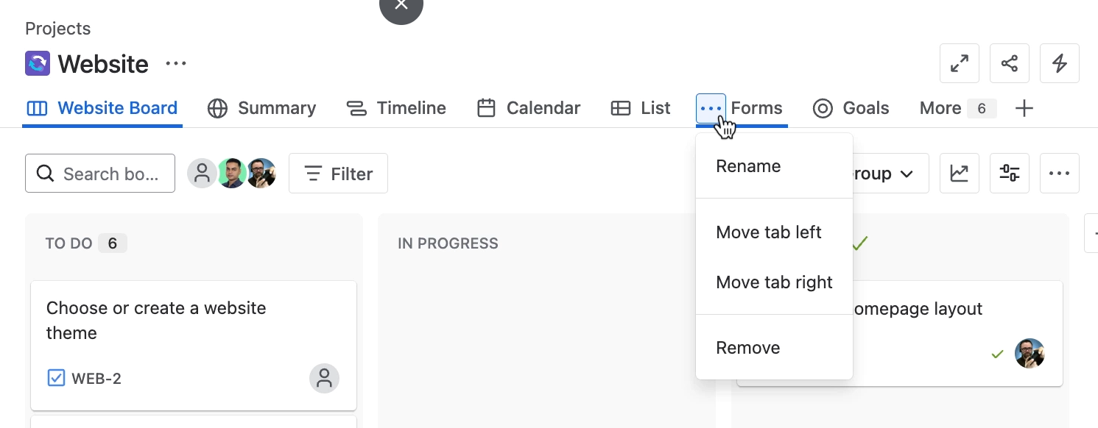

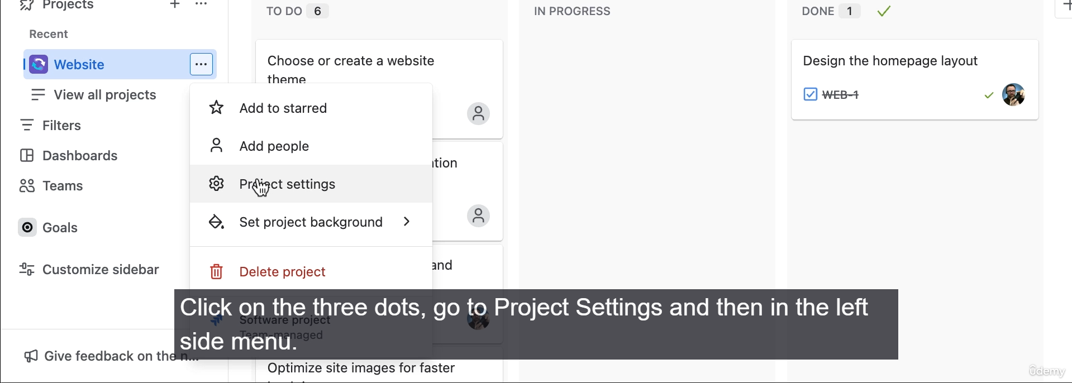

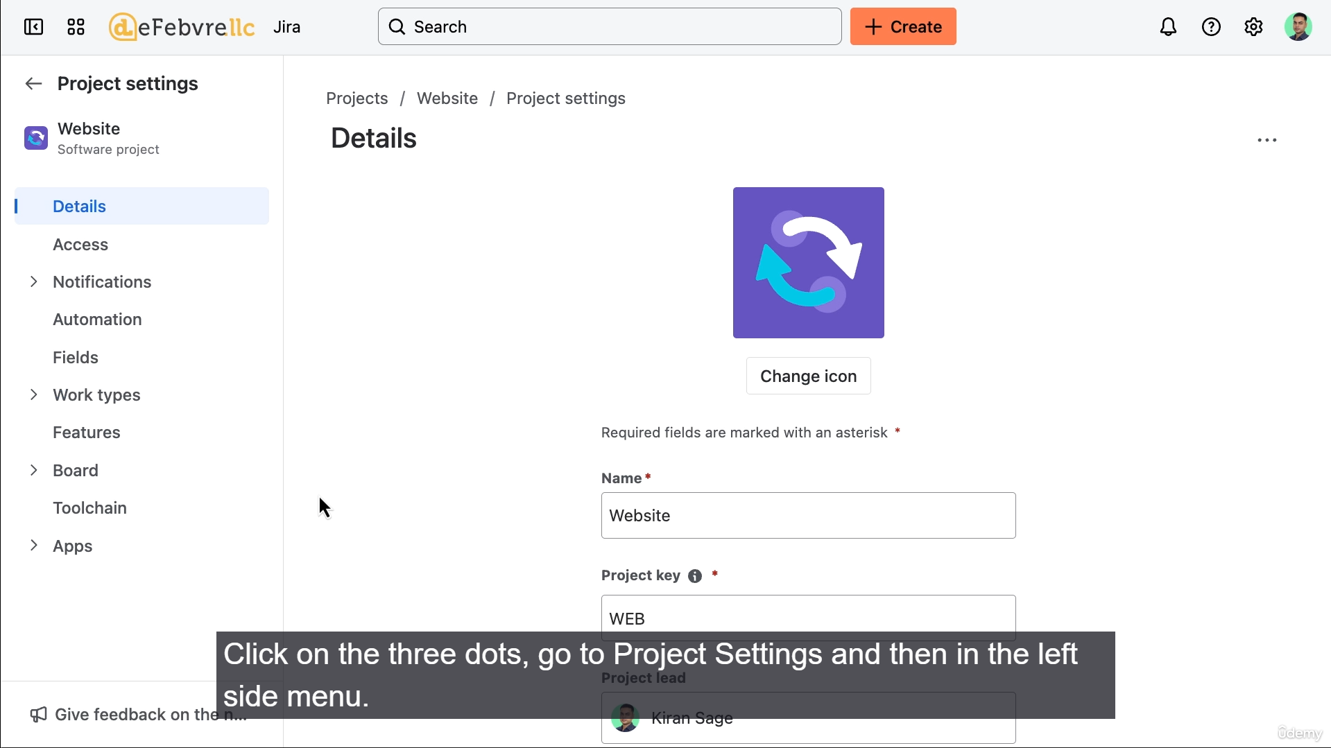

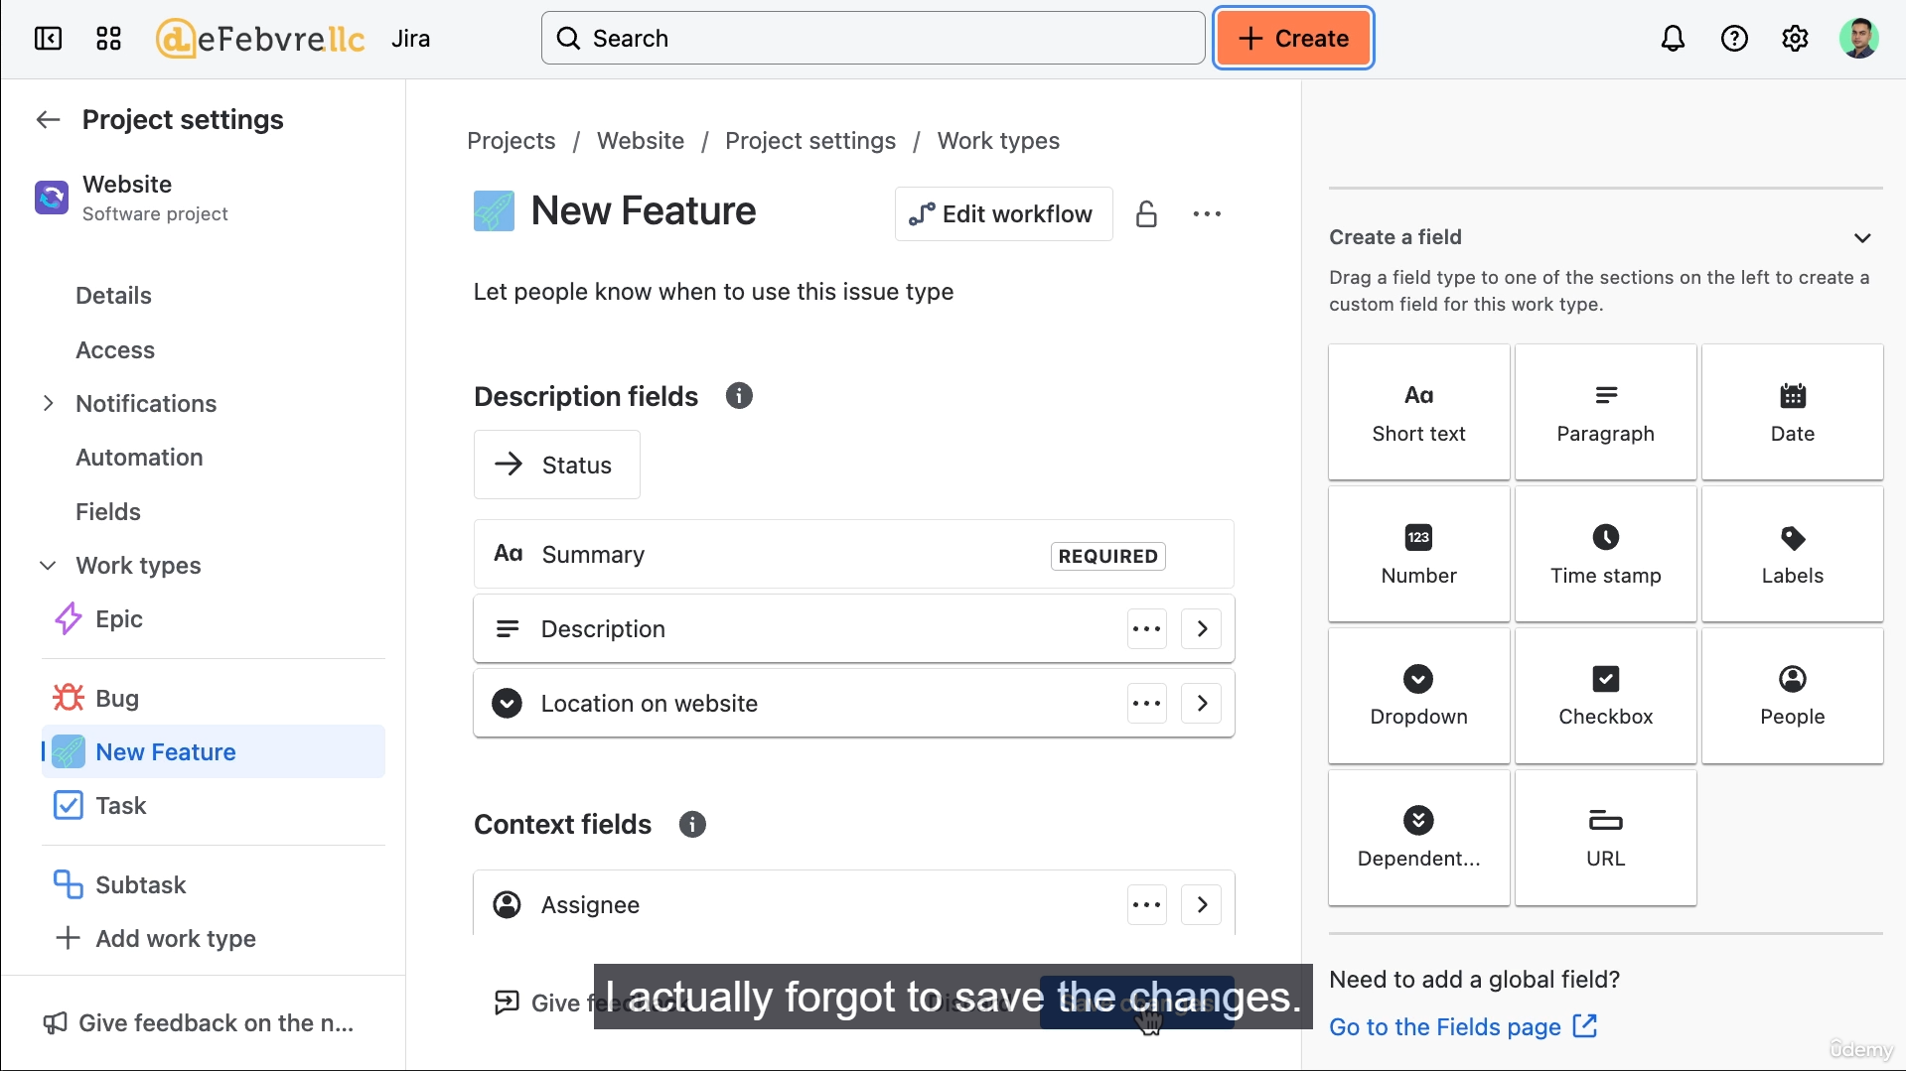

**1. Customizing Project Navigation**

The project administrator can reorganize and rename the tabs used for internal project navigation.

* **Reorganizing Tabs:** Tabs (e.g., Board, Timeline, Forms) can be dragged and dropped to reorder them.
* **Renaming Tabs:** Tabs can be renamed (e.g., renaming "Board" to "Website Board").
* **Setting the Default View:** You can set a specific tab (like the Board or Timeline) as the **default landing page** for the project. When users click on the project name, they will land on this page.
  + *Note:* Not all tabs (like "Forms") can be set as the default view.
* **Hiding Tabs:** Unused tabs can be removed from the navigation. They can be brought back at any time.
* **Impact:** Changes to the project navigation apply to **everyone** who uses the project, unlike the issue field visibility settings, which are per-user.

**2. Customizing Work Types and Fields**

This is done by accessing the **Project Settings**.

**A. Adding a New Work Type (Issue Type)**

1. **Navigate to Settings:** Click the three dots on the project navigation, then go to **Project Settings**.
2. **Access Work Types:** In the left sidebar, click on **Work Types**.
3. **Add New Work Type:** Click to add a new work type.
   * You can select a **suggested** work type (e.g., **Bug**).
   * You can **create a custom** work type (e.g., **New Feature**).
4. **Customization:**
   * **Name:** Give it a name (e.g., "New Feature").
   * **Icon:** Choose a preset icon or upload a **custom icon**.
5. **Result:** The new work type becomes available in the "Create work item" screen.

**B. Creating a Custom Field**

You can add custom fields to track specific information for a work type.

1. **Access Field Settings:** While in Project Settings, select the desired **Work Type** (e.g., "New Feature").
2. **Add Field:** Click to add a new field. You can use suggested fields or create a custom one.
3. **Create Custom Field:**
   * Select the field type (e.g., **Dropdown**).
   * **Name** the field (e.g., "Location on Website").
   * Set **Options** (e.g., "Header," "Body," "Footer").
   * Optionally, set a **Default Value**.
4. **Save Changes:** **Crucially, remember to click the save button** as changes are not saved automatically.
5. **Reorganize Fields:** You can click and drag fields within the work type's settings to change their display order (e.g., moving the custom field below the description).
6. **Field Visibility Check:** If a new field isn't visible on the "Create" screen, check your personal user settings, as you may have previously hidden custom fields in the "Configure Fields" menu (as shown in a prior video). The new field must be checked/made visible in your personal configuration to appear.

**=======================================================================**

1. **Overview of team managed Project settings:**

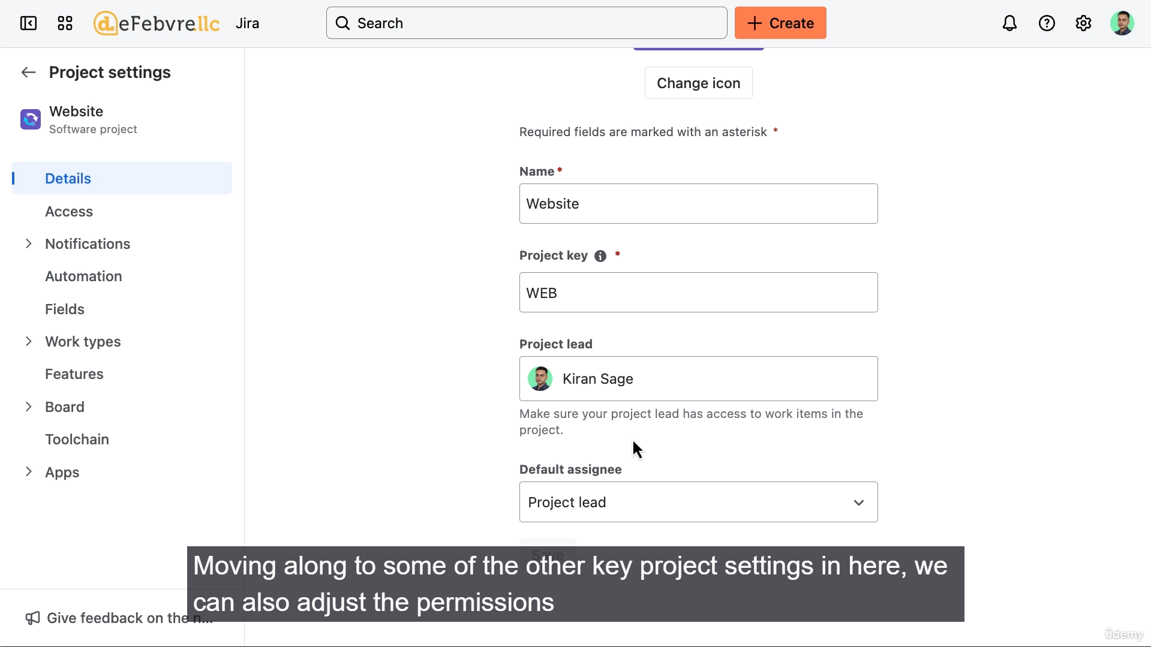

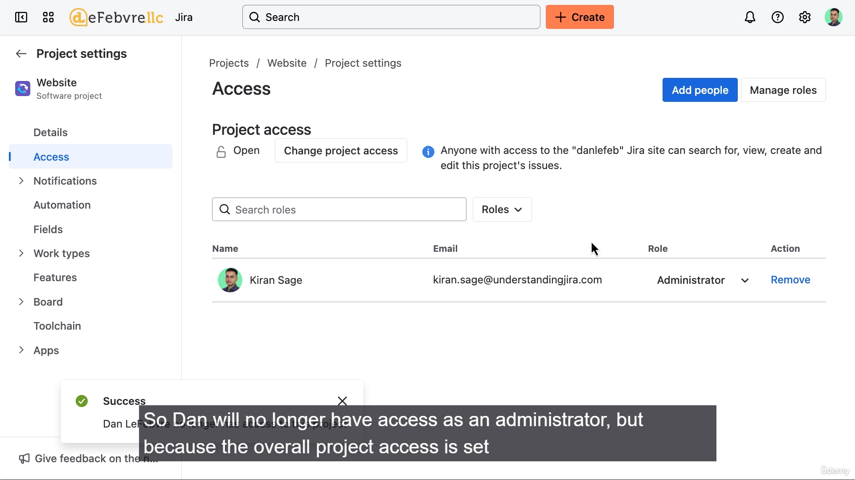

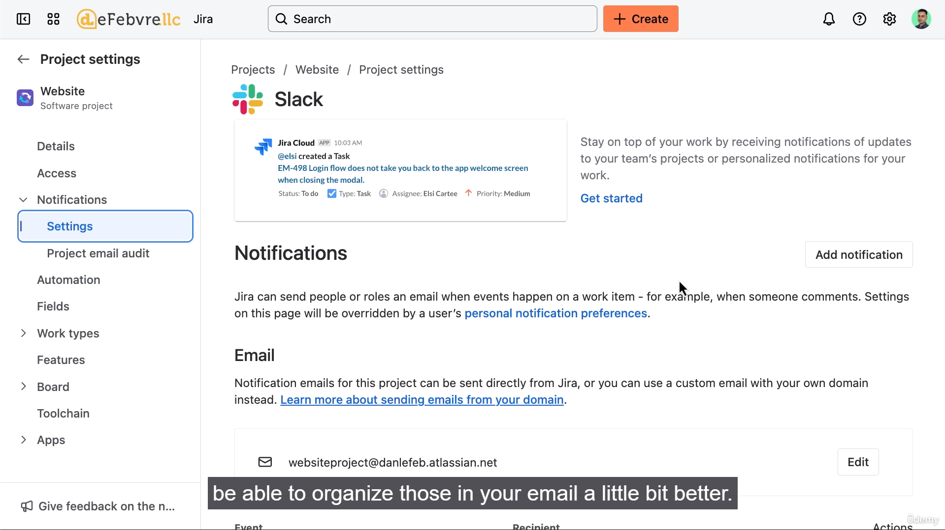

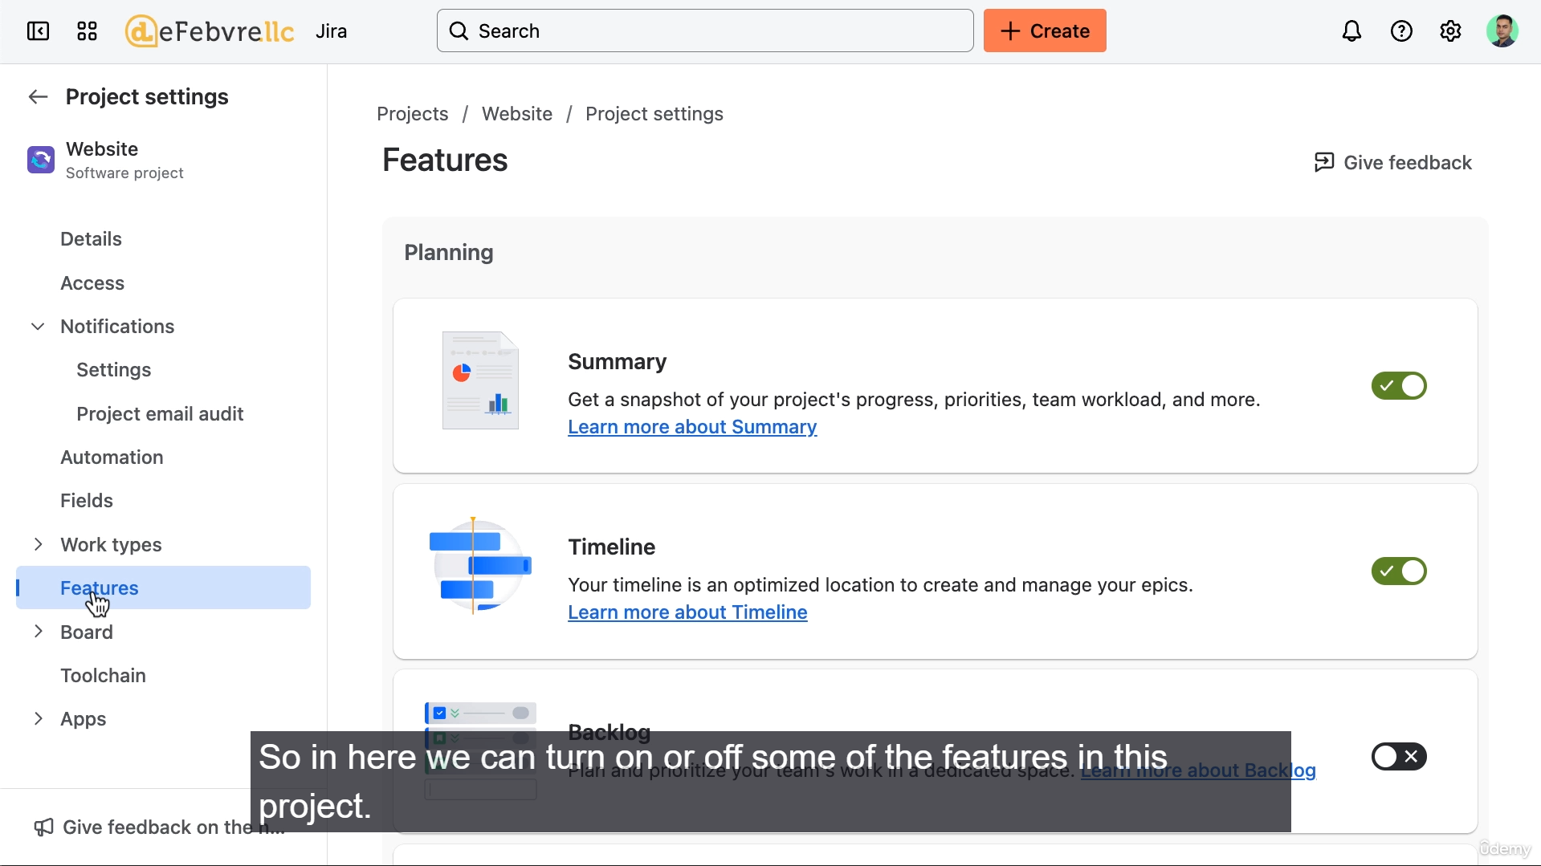

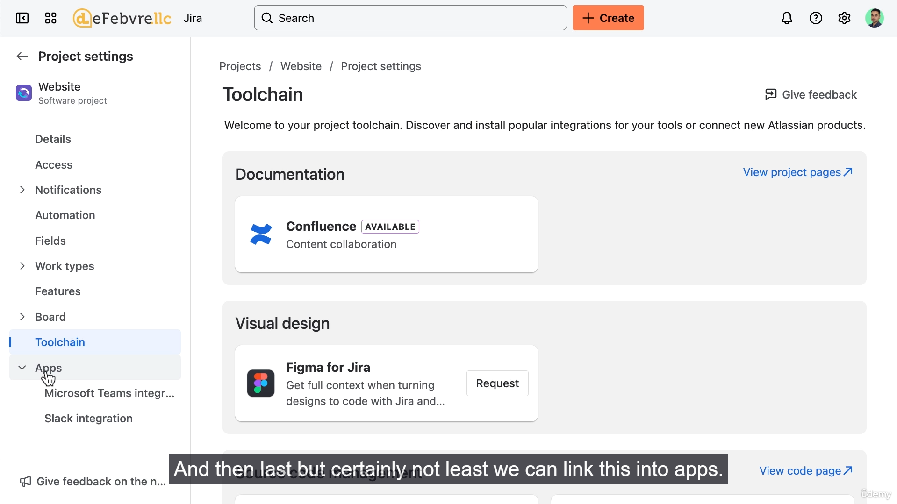

The video provides a tour of the Project Settings for a team-managed project, highlighting how a project administrator can configure essential project-level details, access, notifications, features, and integrations.

**1. Project Details (Details)**

* **Project Name and Key:** These are the details set during project creation, which can be modified here.
* **Default Assignee:** This setting determines who is automatically assigned new work items.
  + **Default:** "Unassigned." This explains why the work items created earlier were initially unassigned.
  + **Change Option:** The only alternative is to set it to the **Project Lead**.
* **Project Lead:** The person who acts as the primary point of contact for the team and is responsible for project oversight.
  + *Note:* Jira automatically sets the creator (Kieran) as the Project Lead by default.

**2. Access and Permissions (Access)**

This section controls who can see and interact with the project.

* **Project Access Level:** You can change the access level set during project creation:
  + **Open:** Anyone in the Jira installation can view, create, and edit work items.
  + **Limited:** Anyone can view and comment, but cannot edit or create new work items (read-only access).
  + **Private:** Only Jira administrators and specifically added people can see the project.
* **Adding/Removing People:** You can manually add specific users (e.g., Dan) and assign them a role, such as **Administrator** or **Member**.

**3. Notifications**

This controls how and when users are alerted about activity within the project.

* **Notification Settings:** You can configure who gets notified (assignee, reporter, watchers) when a work item is created, updated, or assigned.
* **Custom Email Address:** You can set a custom email address for notifications (e.g., website-project@jira.com). This is helpful for users who want to set up email filters based on the project.
* **Email Audit:** This log shows any errors related to email notifications (e.g., bounced or blocked emails) to help troubleshoot issues for users not receiving alerts.

**4. Work Types, Fields, and Features**

This area allows for in-depth customization of the project's working structure.

* **Fields and Work Types:** This is where you can manage custom work types (like "New Feature") and custom fields (like "Location on Website") created in the previous video, including deleting duplicates and troubleshooting visibility issues.
  + *Self-Correction Example:* The user demonstrates the need to re-verify the work item creation process after making changes to ensure the customizations (like the new custom field) are correctly visible and working for users.
* **Features:** You can enable or disable built-in Jira features for the project.
  + The features initially available are based on the project template (e.g., a Kanban template has Kanban features enabled by default).
  + You can manually turn on features associated with other methodologies (e.g., turning on **Backlog** and **Sprints** to essentially convert a Kanban project into a Scrum project).
  + Disabling features (e.g., turning off **Summary**) removes them from the project navigation.

**5. Board Settings (Agile Board)**

* This section allows customization of the project's single Agile Board, including columns and statuses.
* **Key Difference (Team-Managed vs. Company-Managed):** The video notes that team-managed projects have **only one** board, whereas company-managed projects can have multiple agile boards.

**6. Integrations and Apps**

* **Integrations:** You can link the project with other Atlassian tools (like **Confluence**) or request integration with external tools (like **Figma**).
  + *Note:* Requesting new integrations that affect billing will send a request to the global Jira administrator for approval.
* **Apps:** Connect to third-party apps like **Microsoft Teams** or **Slack** for notifications and enhanced functionality.

**Core Concept Recap**

The video re-emphasizes that since this is a **team-managed project**, all configurations—work types, fields, and workflow—are **Project Scope entities**. This means they live *only* within this specific project and do not affect or share settings with any other project in the Jira installation.

**======================================================================**

1. **Unravelling the features in company managed projects:**

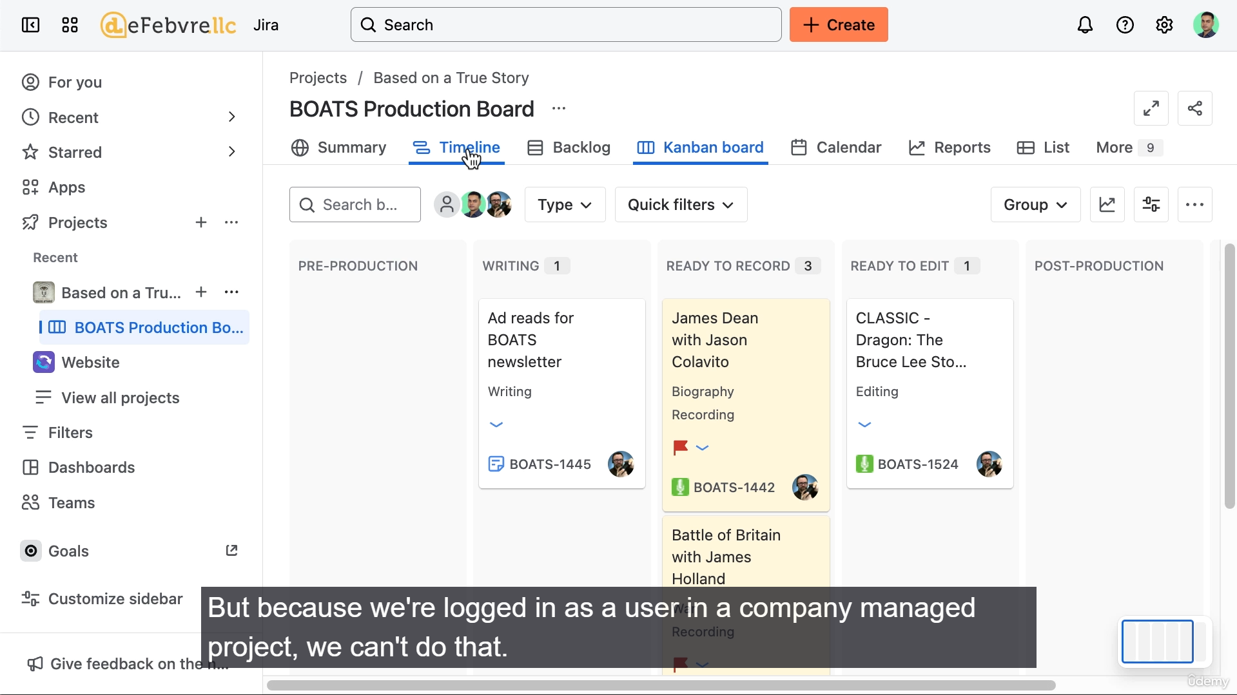

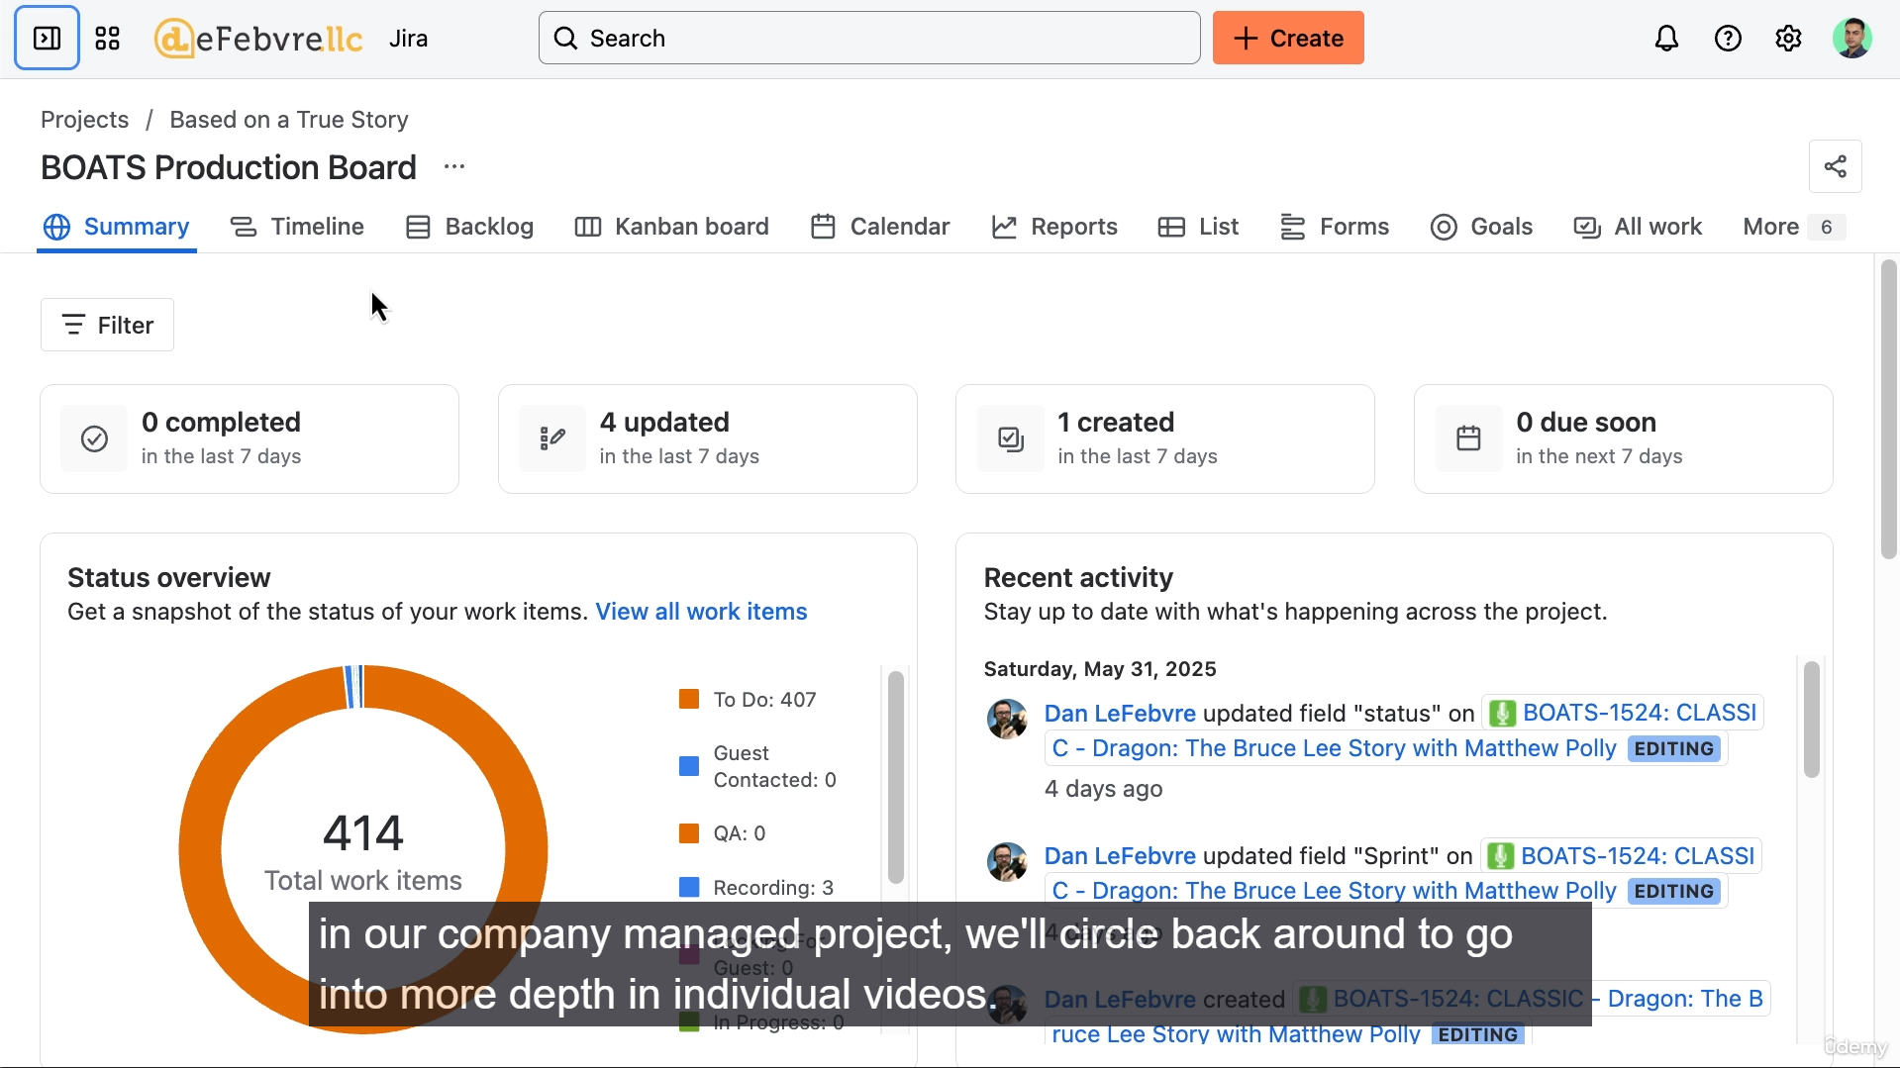

* Query successful

Try again without apps

The user is being introduced to the features and navigation of a **Company-Managed Project** in Jira, contrasting it with the previously covered Team-Managed Project.

Here is a summary of the key points about Company-Managed Projects from the video:

**Key Differences from Team-Managed Projects (for a standard user):**

* **Project Creation:** A standard user (not a Jira Administrator) **cannot create** Company-Managed Projects. This ability is reserved for Jira Administrators.
* **Navigation Customization:** A standard user **cannot rearrange or customize** the navigation tabs (like dragging them or seeing the "three little dots" for options). Customization is done by the Jira Administrator.
* **Board Options:** Company-Managed Projects allow for the option of different agile boards, such as **Kanban** or **Scrum** boards, which is a difference from Team-Managed Projects.
* **Permissions:** Permissions are more granular and complex, meaning certain actions (like managing forms) are restricted to users with specific roles, such as Project Administrator, within the company-managed project.
* **Features:** Company-Managed Projects tend to offer more advanced features and deeper customization, which are often configured and standardized by a Jira Administrator across the organization.

**Project Navigation Views (Tabs) Overview:**

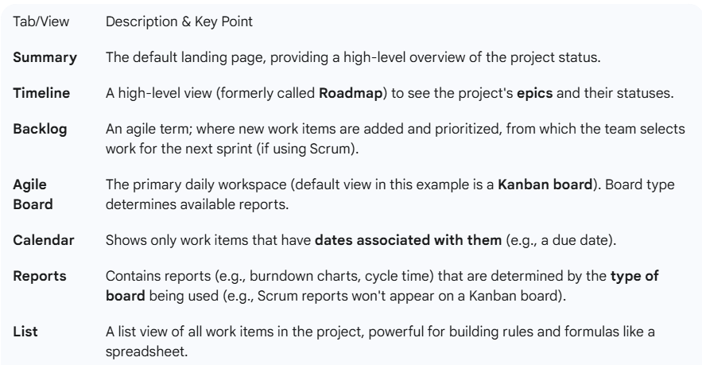

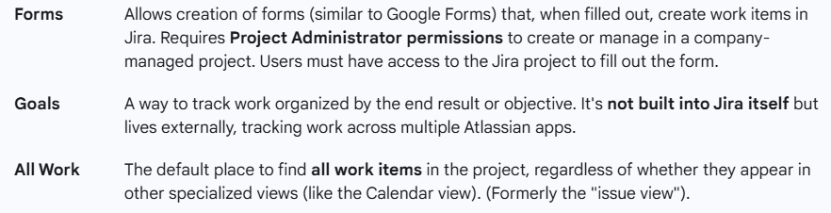

**"More" Menu Items (Different Features, Not just views of work):**

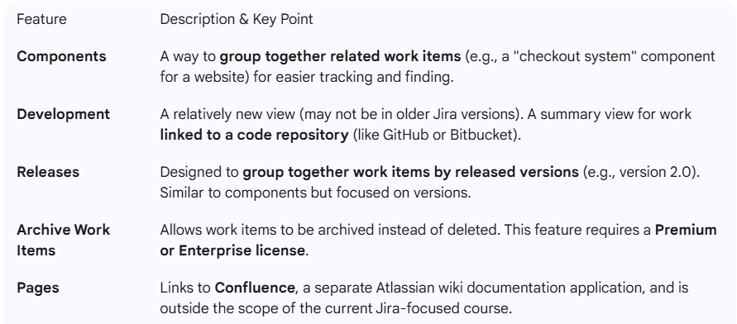

**======================================================================**

1. **Understanding Kanban Agile Boards:**

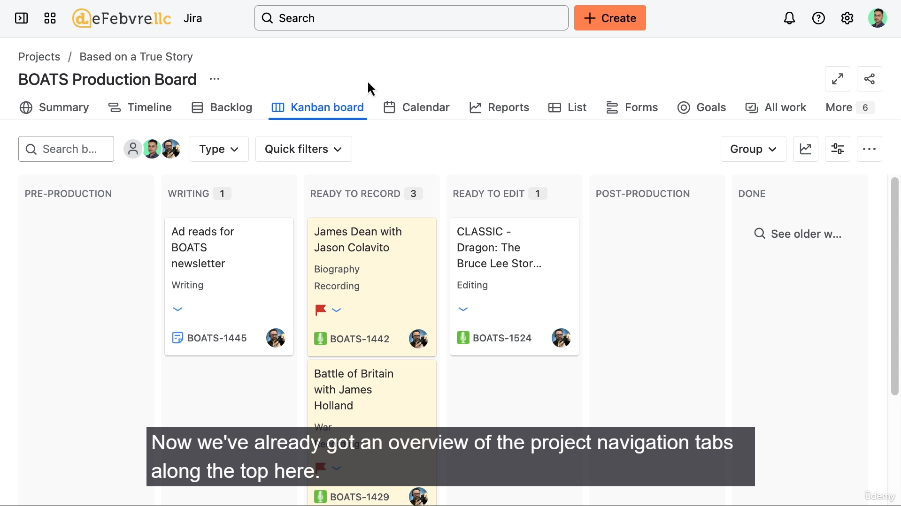

**Kanban Agile Board Layout and Features**

The Kanban Agile Board is the **primary day-to-day workspace** in Jira. The video highlights several features, particularly focusing on the filtering and customization available to a standard user, and contrasts this with the limitations imposed by user permissions.

**1. Board Navigation and Identification**

* **Breadcrumb:** Located at the top left, it shows the path to the board: All projects > [Project Name] > [Board Name].
* **Board Name:** Set by a Project or Jira Administrator.
* **Project Navigation Tabs:** The standard project tabs (Summary, Timeline, Backlog, etc.) are still present above the board-specific tools.

**2. Filtering and Quick Tools (Above the Board)**

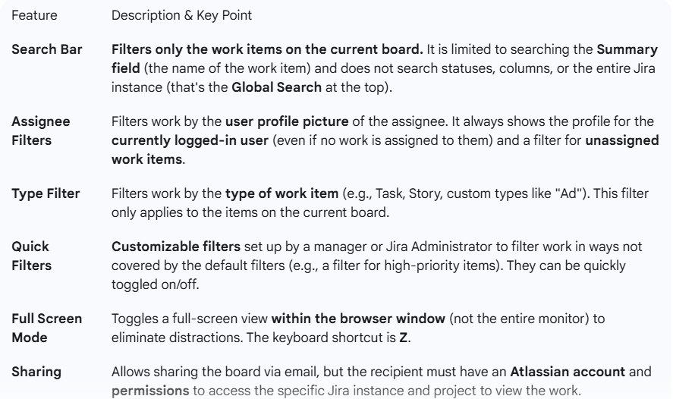

**3. Board Customization Tools (Below Project Navigation Tabs)**

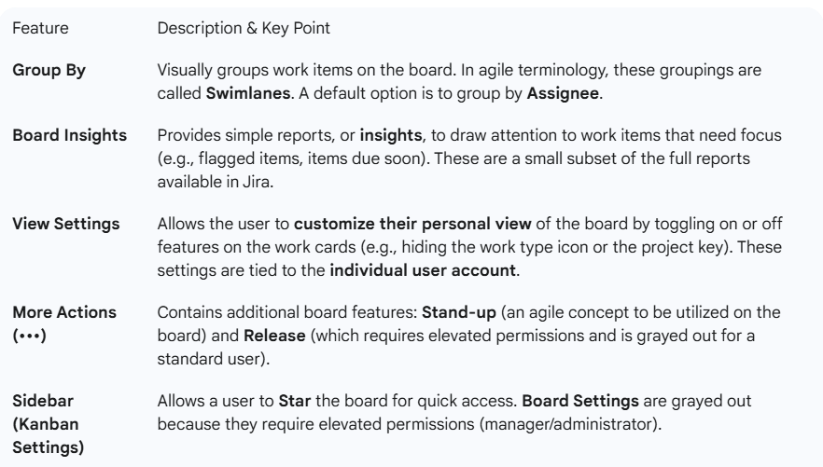

**4. The Board Itself**

* **Functionality:** The core functionality is the ability to **click and drag** work items from one column to another.
* **Status Update:** Dragging a work item to a new column automatically **updates the status** of that work item (e.g., moving a card from "Writing" to "Recording" updates the card's status field).

**======================================================================**

1. **Understanding Scrum Agile Boards:**

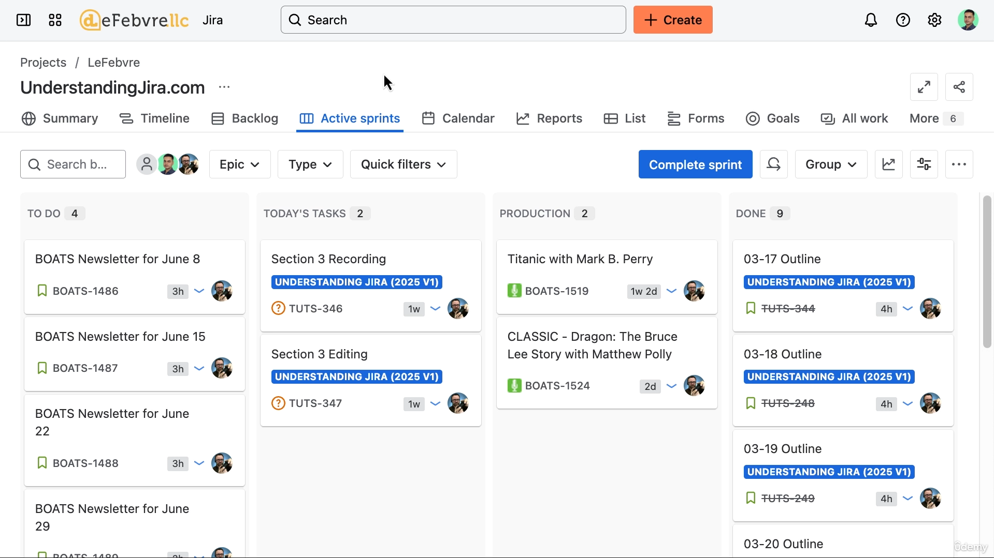

**Scrum Agile Board Layout and Features**

The Scrum Agile Board shares many elements with the Kanban board but is adapted to the **Scrum workflow**, specifically by integrating sprints and epics.

**1. Board Navigation and Identification**

* **Access:** Can be accessed via the **Recent Projects** section (since Company-Managed Projects can have multiple boards) or through the project in the main sidebar.
* **Breadcrumb:** Identical to the Kanban board (All projects > [Project Name] > [Board Name]).
* **Board Settings:** A user **cannot customize** the board name or other settings; this is reserved for the Manager or Administrator with elevated permissions.
* **Project Navigation Tabs:** The standard project tabs (Summary, Timeline, Backlog, etc.) are present above the board-specific tools.

**2. Filtering and Quick Tools (Above the Board)**

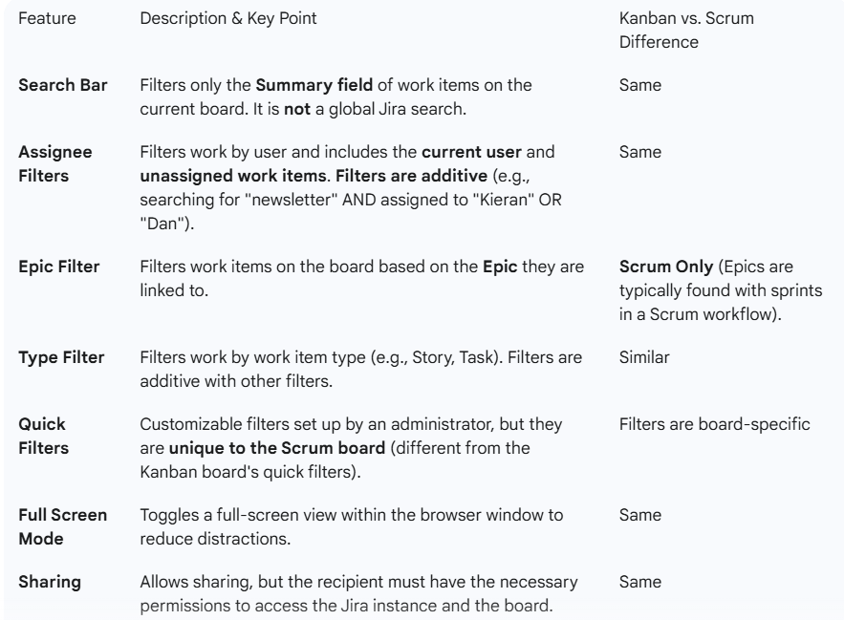

1. **Scrum-Specific Tools (Below Project Navigation Tabs):**

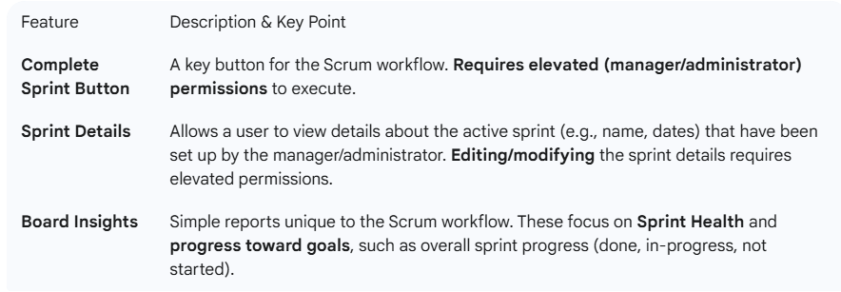

**4. General Board Tools:**

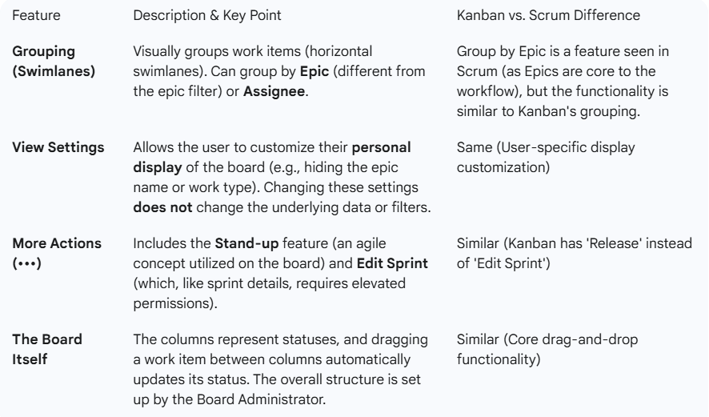

**=======================================================================**

1. **Comparing scrum and kanban boards:**

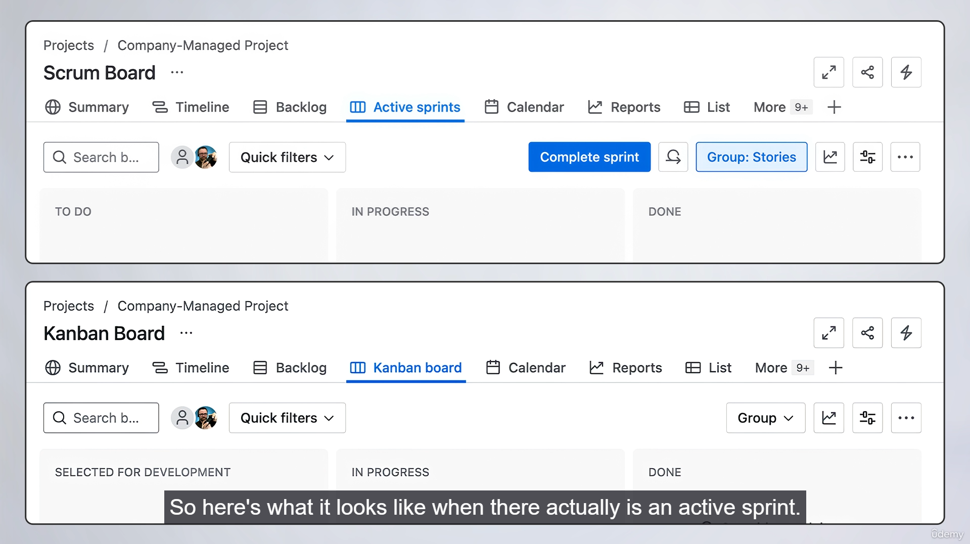

**Scrum VS Kanban:**

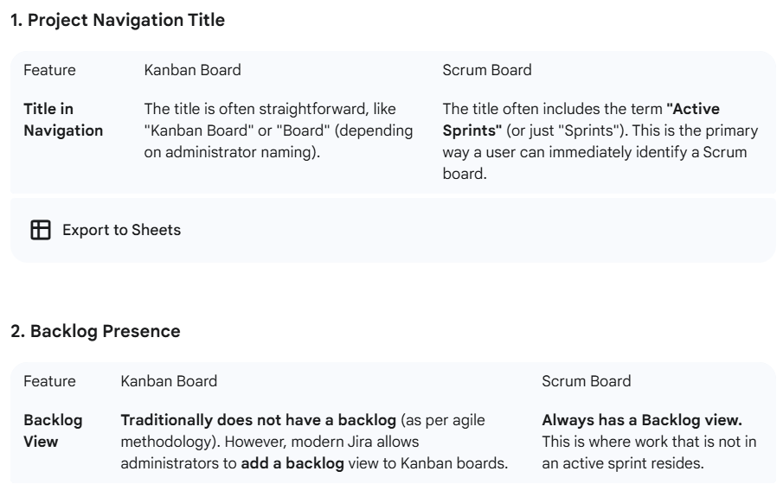

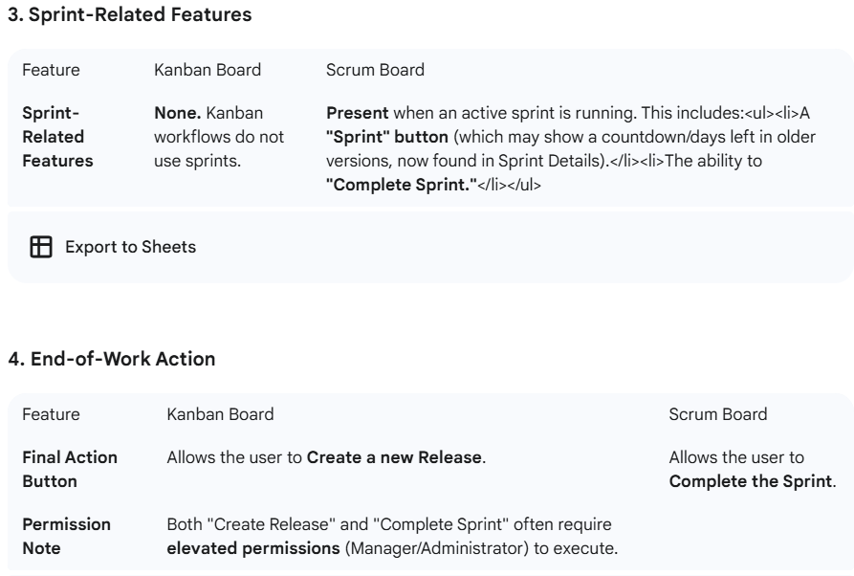

**Summary of Similarities**

* **Breadcrumb and Project Name:** The structure and location of the board's name and project name are the same.
* **Default Filters:** Both boards feature the same filters (Search, Assignee, Work Type, Quick Filters, etc.) available to the user.
* **Board Naming:** The board name is displayed in the same location on both boards, although it can be customized by a Jira Administrator.

**======================================================================**

1. **Adding work to company managed projects:**

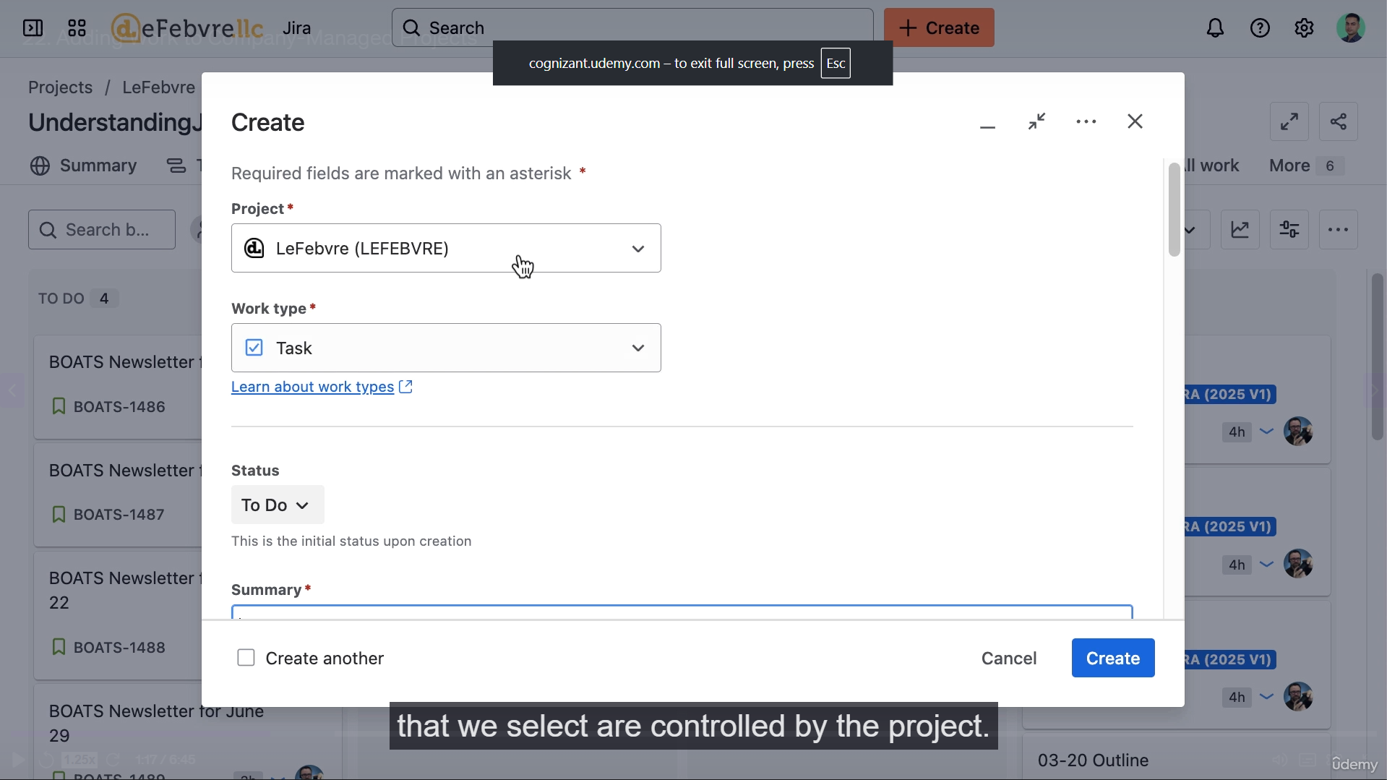

**Creating New Work Items in a Company-Managed Project**

The process of creating a new work item is initiated using the **"Create"** button at the top of the Jira interface, or by using the keyboard shortcut **C**.

**1. The "Create" Screen Layout**

The "Create" screen is divided by a horizontal line:

* **Above the line:** Controls the context and display of fields:
  + **Project:** Selects the project where the work item will be created. This dictates the available work types.
  + **Work Type:** Selects the specific type of work item (e.g., Task, Story, custom types like "Episode"). This selection dictates which fields are displayed below the line.
* **Below the line:** Contains the **fields** associated with the selected work type in the chosen project.

**2. Key Considerations for Work Item Creation**

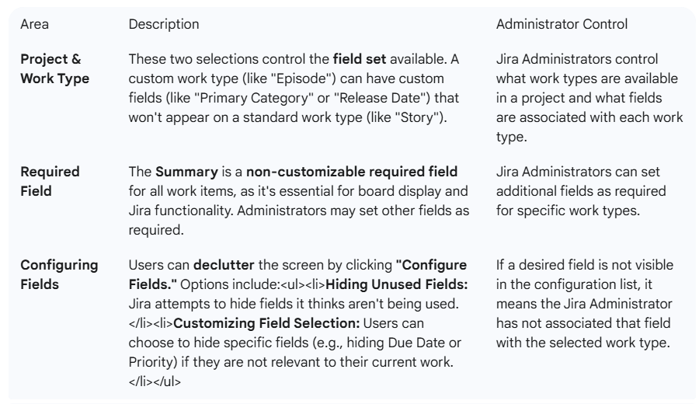

**3. Work Item Placement and Next Steps**

* **Initial Placement:** By default, new work items are created in the project's **Backlog** (especially in a Scrum project with an active sprint). They are not immediately visible on the active board/sprint view.
* **Next Workflow Step:** Once created, the work item has its own unique layout for managing its details. The next step is to get familiar with this **work item layout**.

**=======================================================================**

1. **Viewing and editing work items:**

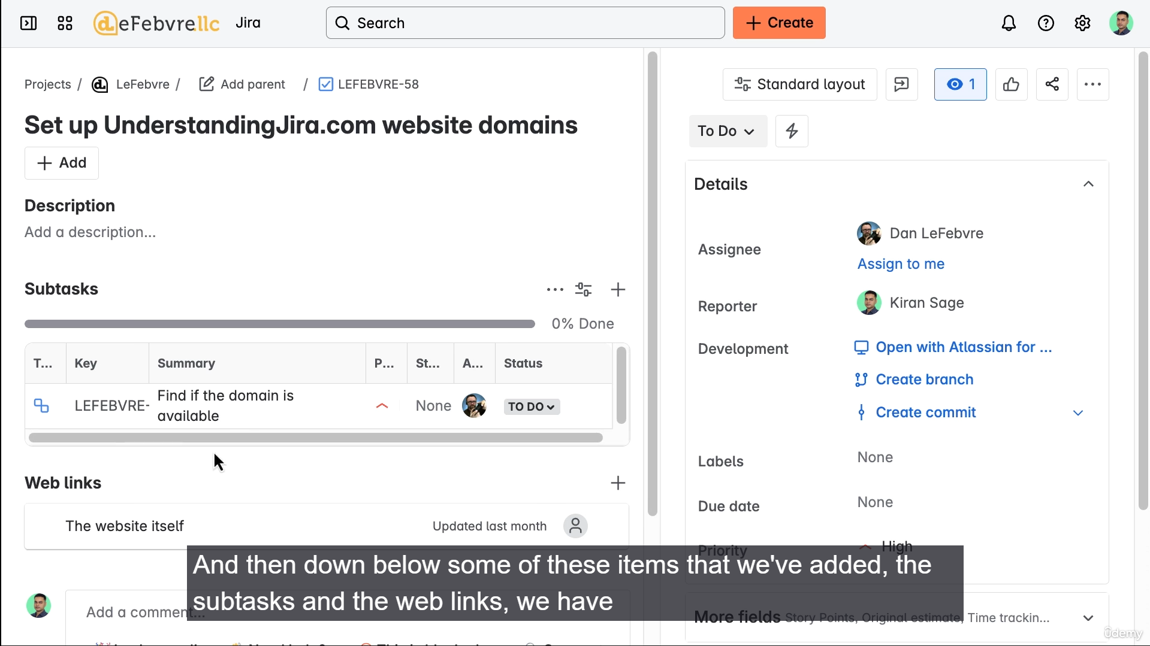

**Work Item Layout and Features in Jira**

A work item is the core component for tracking work in Jira. The default view is structured to provide all relevant information, communication, and history.

**1. Header and Context**

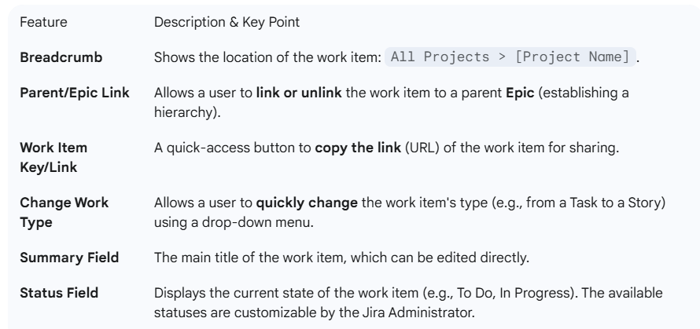

**2. Primary Work Area (Left Column)**

This area contains the description, attachments, and activity history.

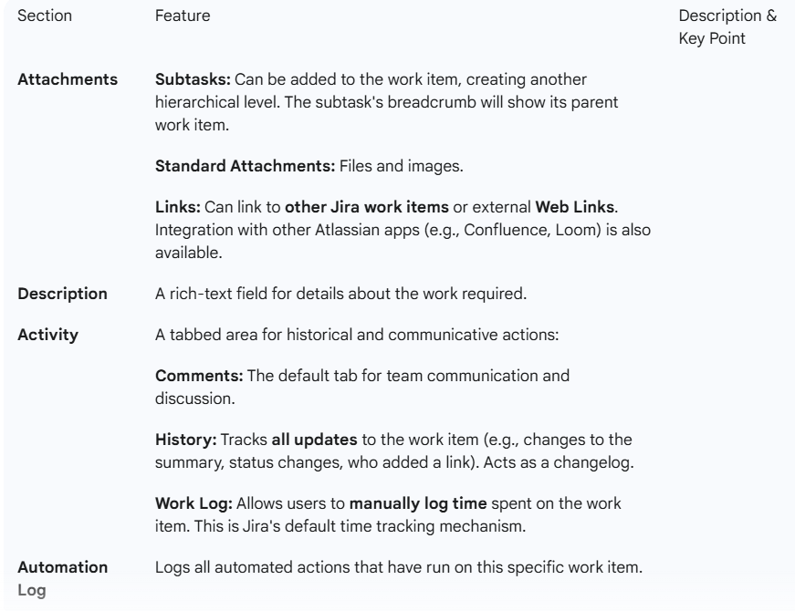

**3. Sidebar (Right Column)**

This column contains administrative and action-oriented tools.

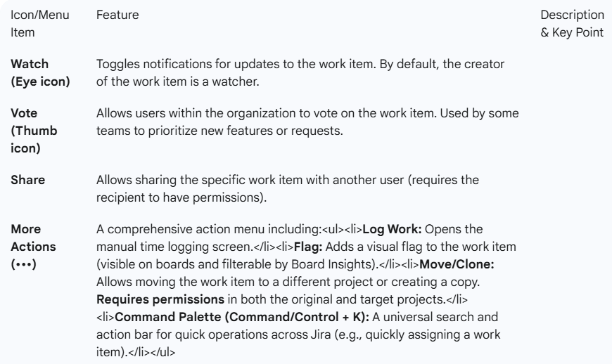

**4. Other Fields and Customization**

* **Field Pinning:** Users can **pin frequently used fields** (e.g., Assignee, Due Date) to the top of the details area for a better personal workflow. This setting is user-specific.
* **Layout View:** The user can switch the entire work item layout between:
  + **Standard View:** The default, multi-column layout.
  + **Discussion View:** Focuses the main content on comments and the work log.
  + The sidebar can also be **collapsed** to focus on the main content area.

**======================================================================**

1. **Using the Calendar View:**

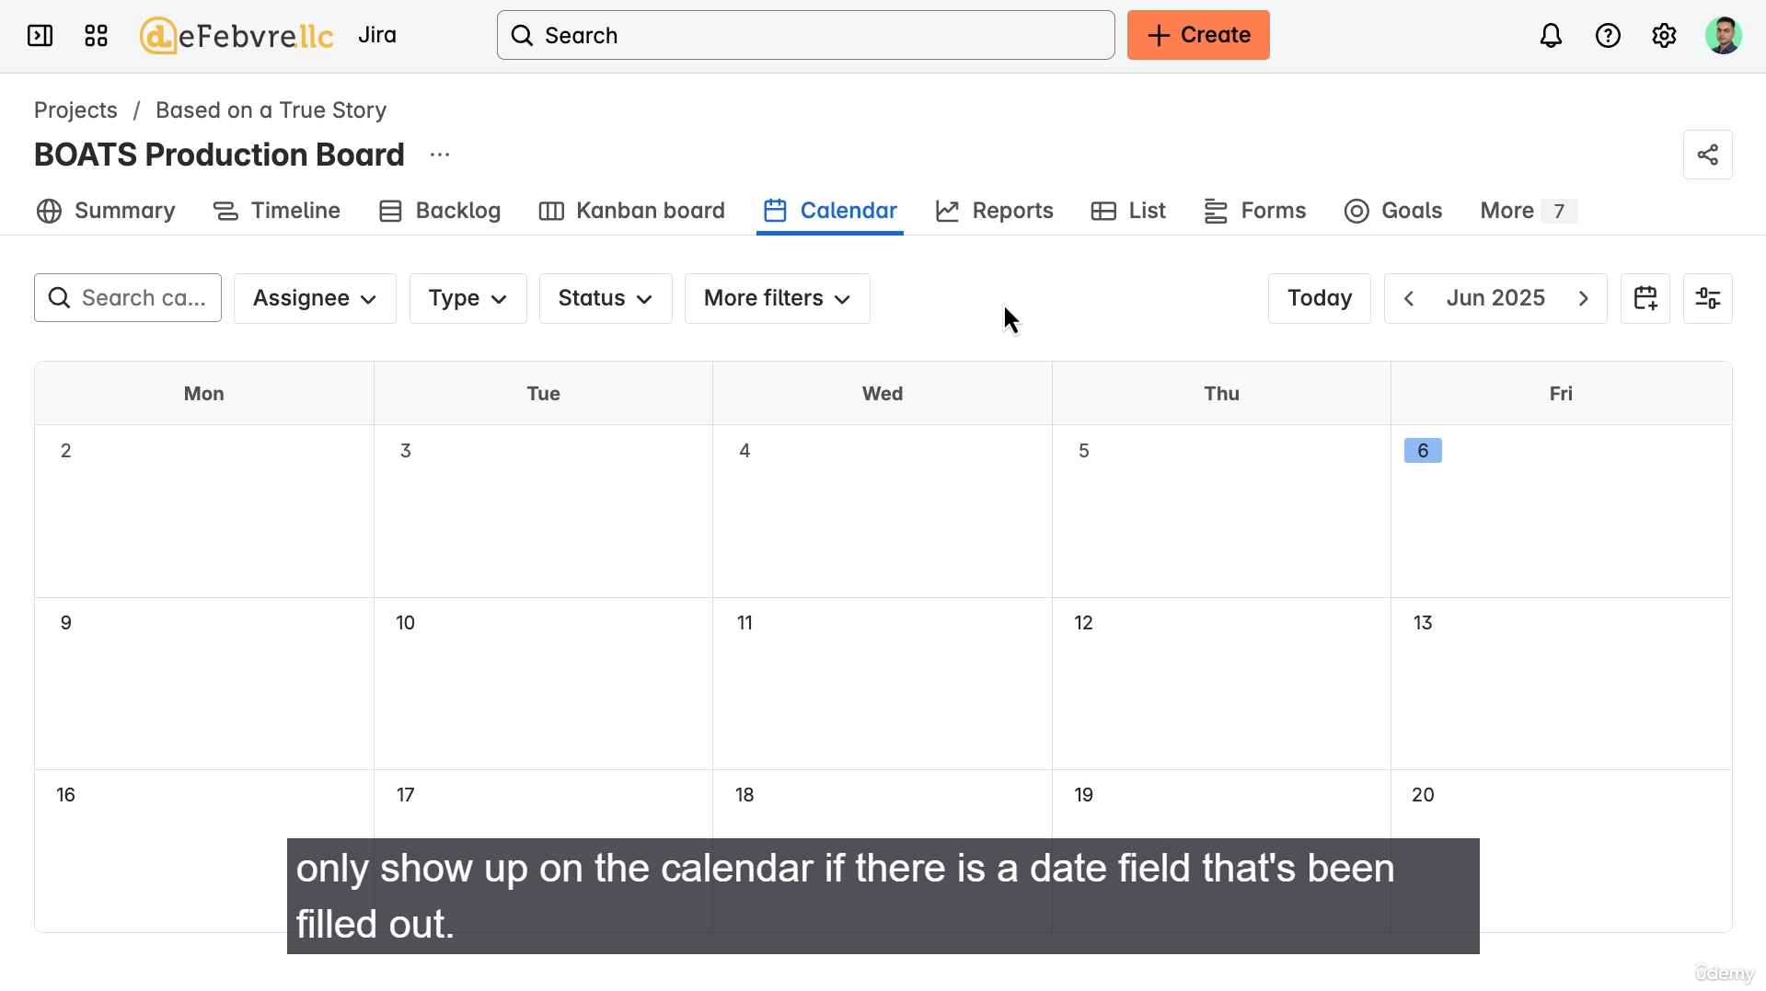

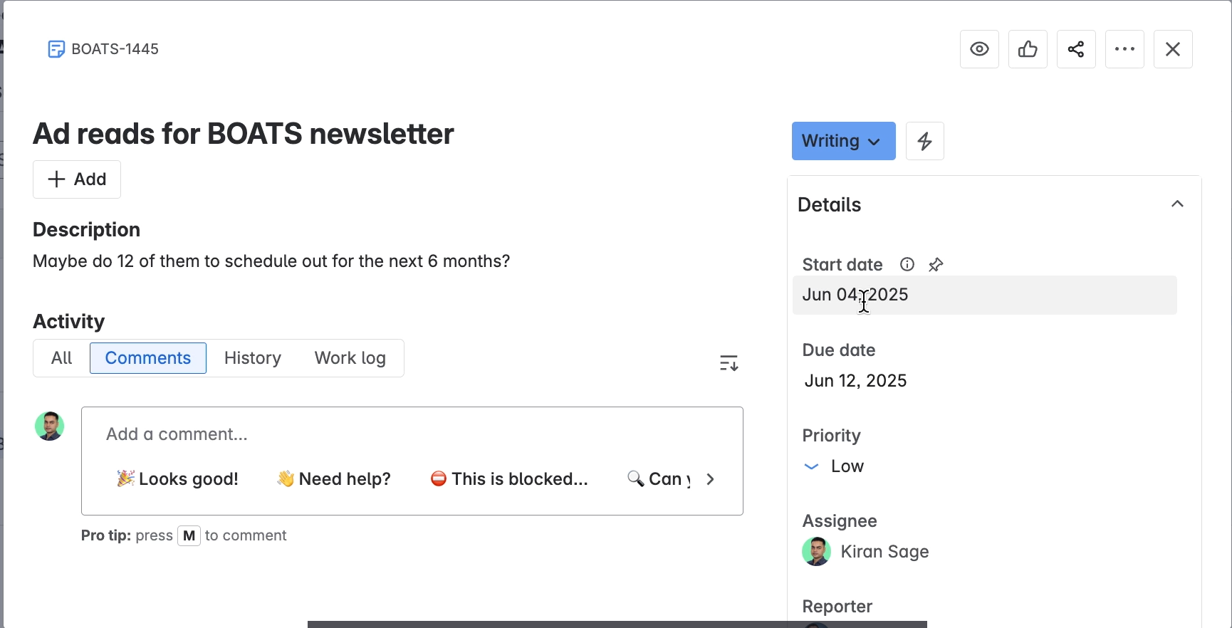

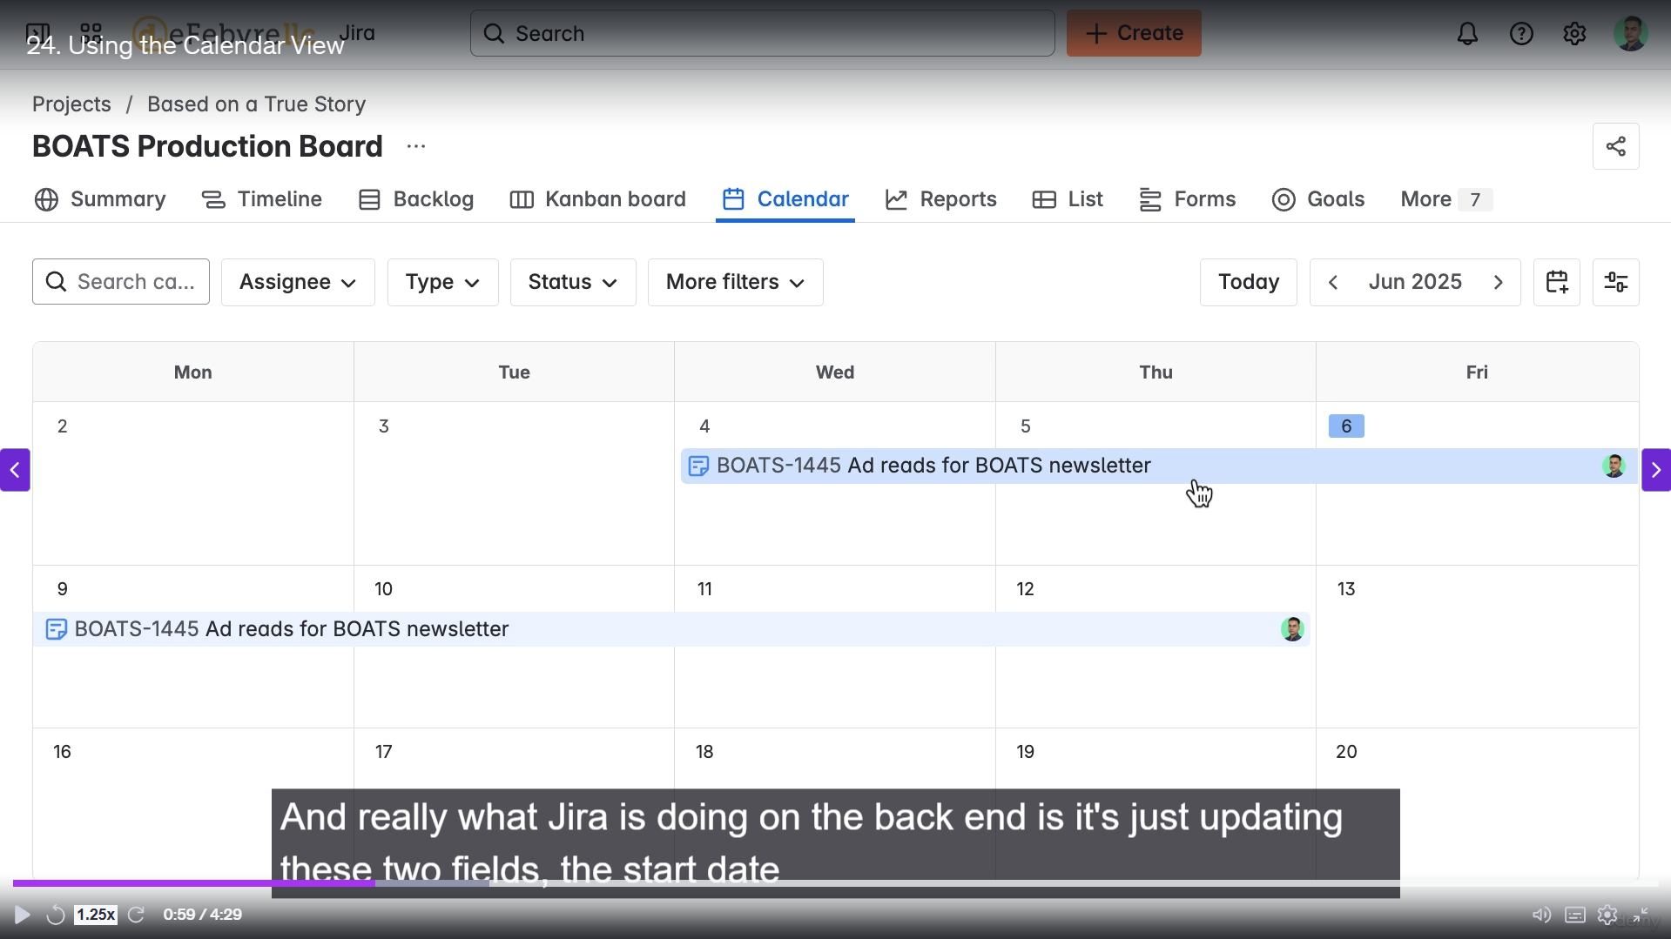

**Key Features of the Calendar View:**

The most crucial aspect of the Jira calendar view is its reliance on date fields.

**1. Work Item Visibility**

* **Date-Driven:** Work items **will only appear** on the calendar if they have a date field populated, such as the **Due Date** or a custom date field.
* **Start and Due Dates:** The calendar directly visualizes the duration of a work item, typically determined by its **Start Date** and **Due Date** fields.
  + Dates can be set by dragging the work item directly on the calendar interface.
  + Dragging a work item on the calendar will automatically update the corresponding date fields (Start Date and Due Date) on the work item itself.
* **Removal:** If the date fields are removed from a work item, it will immediately disappear from the calendar view, but the work item itself is **not deleted**.

**2. Finding Unscheduled Items**

* **Unscheduled Items Icon:** A specific icon is available on the calendar view that allows users to quickly find all **unscheduled work items** (those without a due date).
* **Scheduling:** Users can open an unscheduled item from this list, add a date, and the item will then appear on the calendar.

**3. Filters and View Settings**

The calendar view includes several options for filtering and customizing the display.

* **Filters:** Similar to the Agile Boards, filters are available to narrow down the displayed work items:
  + **Search Bar:** Filters by the **Summary field** of the work items.
  + **Assignee, Type, Status:** Allows filtering by the work item's assigned user, type (e.g., Task, Story), or current status.
  + **Clear Filters:** Used to remove all active filters to view the full set of scheduled work items.
* **View Settings:** These allow for display customization:
  + **Sprints:** If using a Scrum workflow, the calendar can display the **duration of active Sprints** to help align due dates with sprint goals.
  + **Calendar Traditionals:** Users can adjust common calendar settings, such as **which day the week starts** and whether to **display weekends**

**=======================================================================**

1. **Getting reports in Jira:**

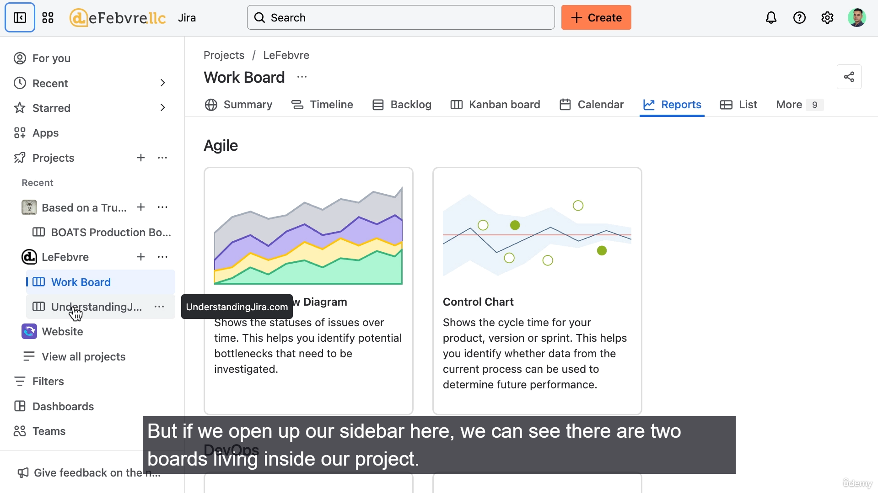

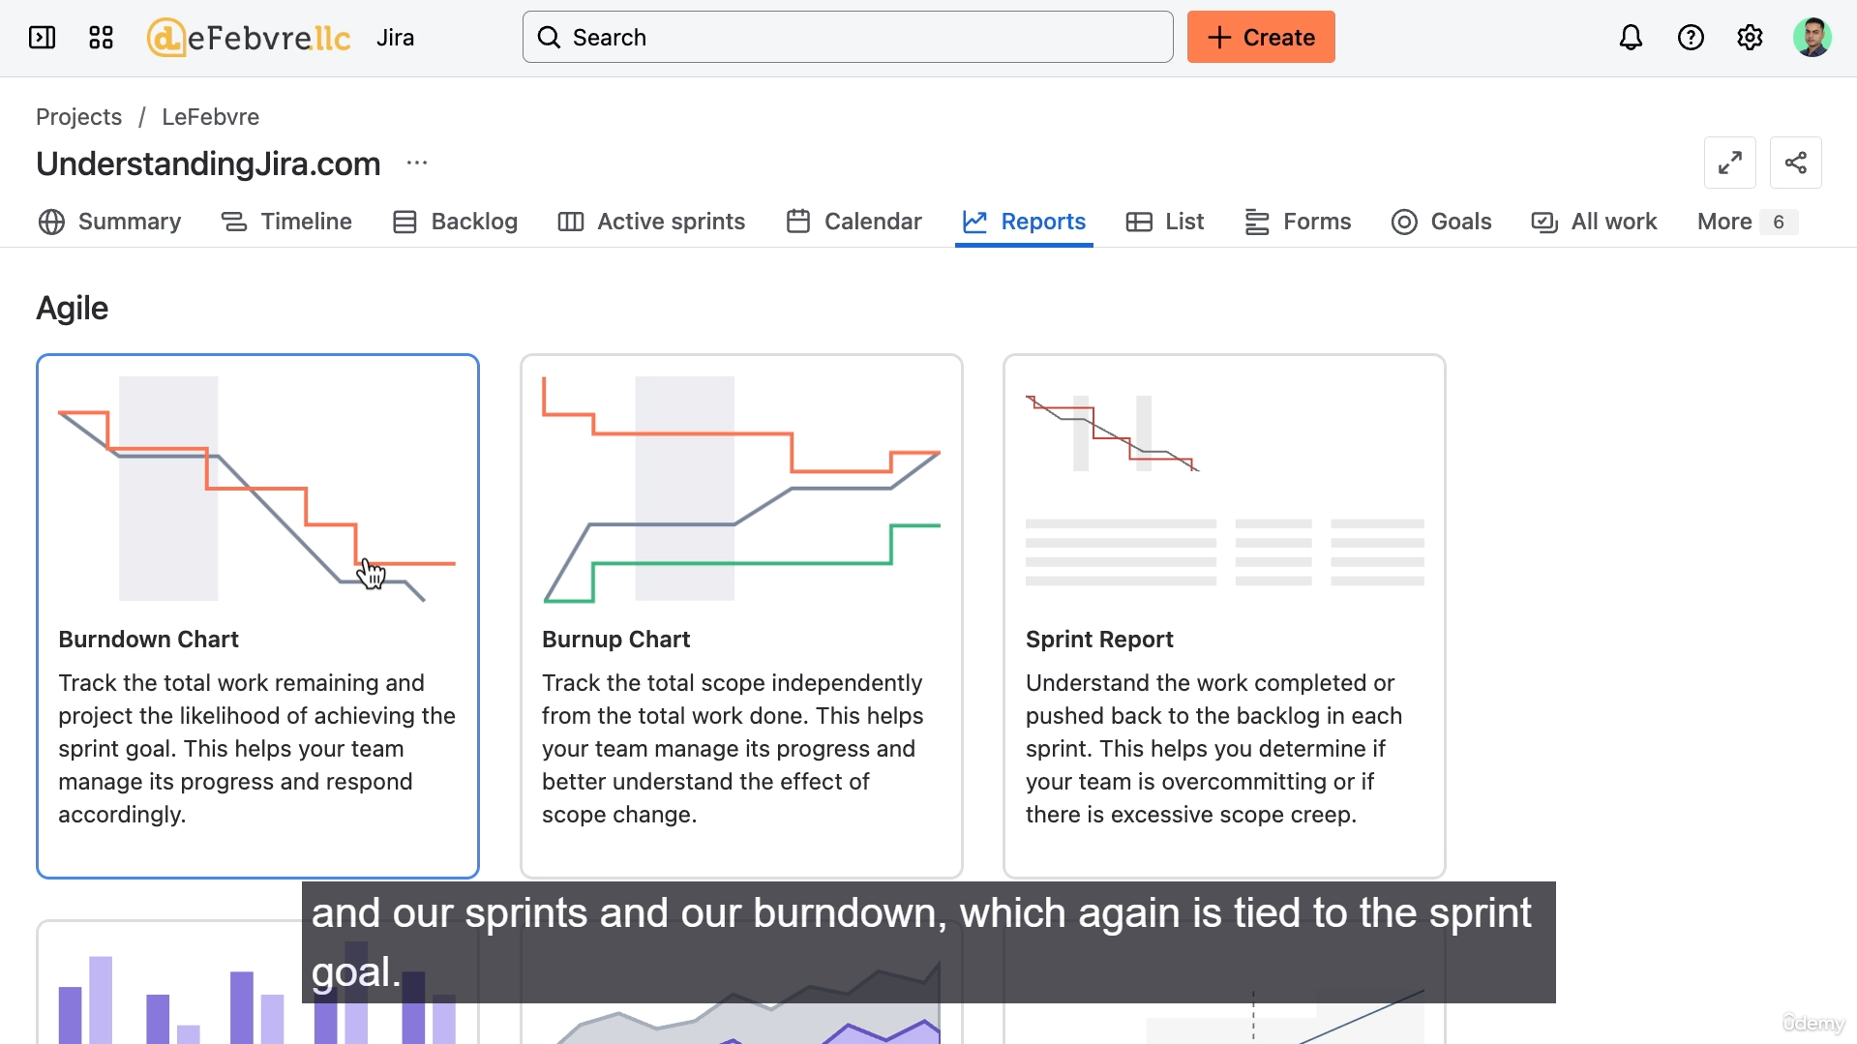

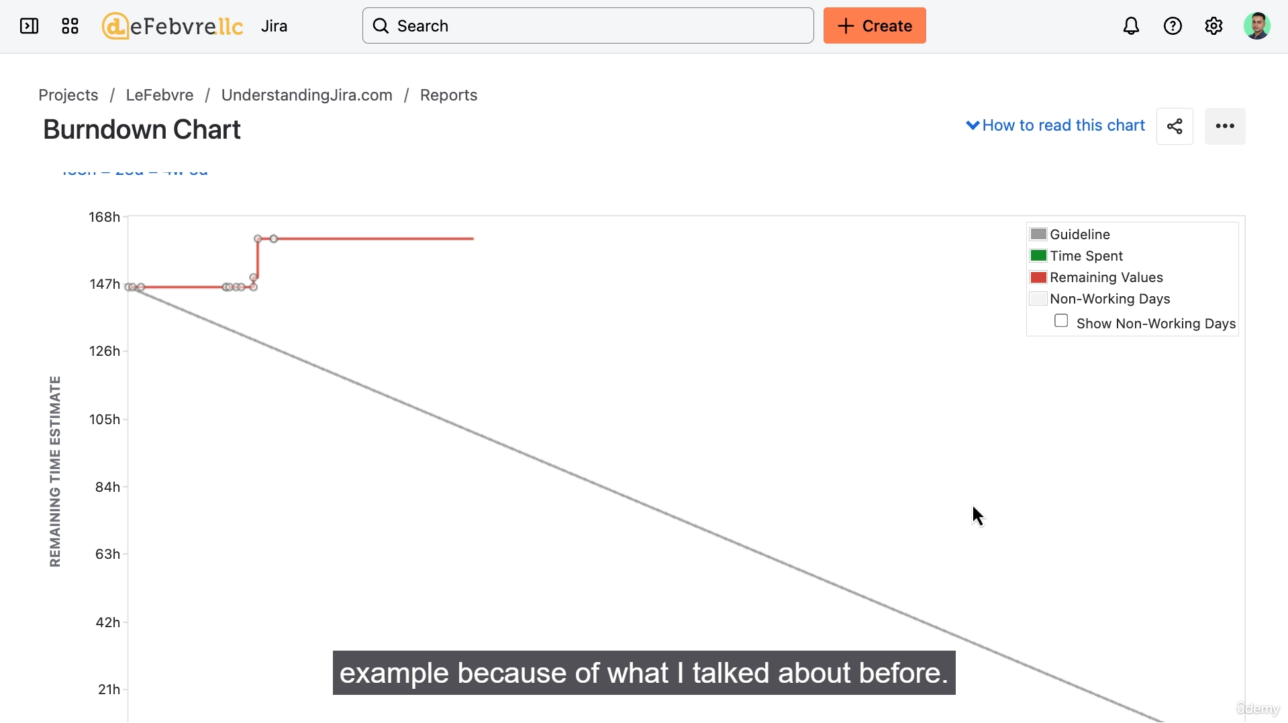

**Summary of Jira Reports**

The most crucial concept to understand about reports in Jira Company-Managed Projects is that they are **directly tied to the specific Agile Board** you are viewing.

**1. Board-Specific Reports**

The type of reports available is entirely dependent on whether the associated board is a **Kanban Board** or a **Scrum Board**.

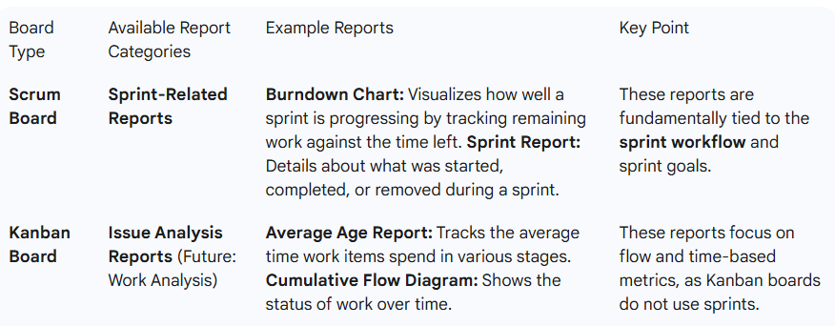

**2. Visibility and Limitations**

* **Filtering Affects Reports:** Reports are generated based on the work items that are currently **included on the specific Agile Board**. If the Jira Administrator has filtered the board to exclude certain work items from the project, those items will **not be reflected** in the reports.
* **Terminology Note:** Jira still uses the older terminology like **"Issue Analysis"** (referring to work items) in some places within the reports section.

**3. Alternative Reporting Location: Board Insights**

* Jira provides simple, quick reports directly on the Agile Board itself under **Board Insights** (e.g., in the form of simple charts or status indicators).
* **Permissions:** Some of these quick reports, such as the **Sprint Burndown** in the insights panel, may **not be available to a standard user** due to required admin permissions. If a report is missing, a user should contact their manager or Jira administrator.

**=======================================================================**

1. **Using Jira’s List view:**

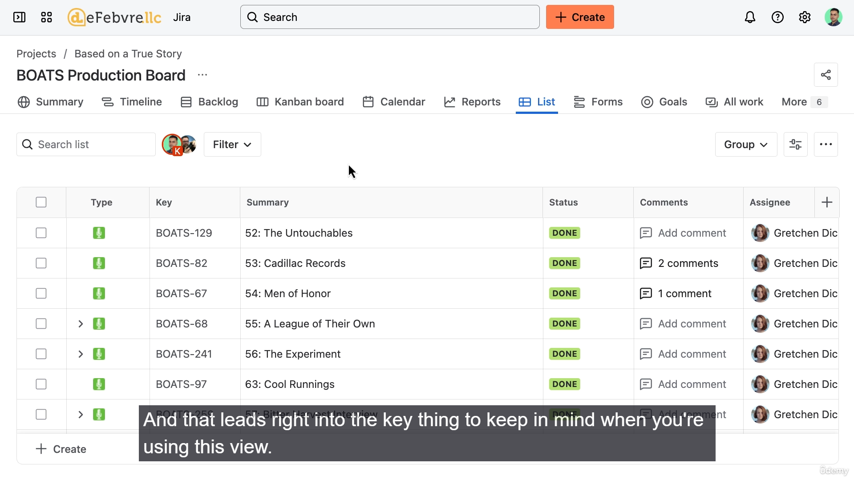

**Key Features of the List View**

**1. Scope and Visibility**

* **Project-Wide:** Unlike **Reports**, which are tied to a specific Agile Board, the List View shows **all work items** that exist within the current project, regardless of whether they appear on a Kanban or Scrum board.
* **Troubleshooting:** If you see work on a board but not in the List View, it's likely because the work is in a different project.

**2. Filtering and Organization**

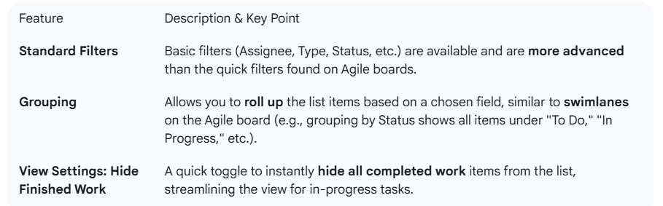

**3. Customization and Visualization**

The List View offers features for detailed customization and visual reporting.

* **Show/Hide Fields:** Users can **add or remove columns** (fields) from the list to see only the relevant data for their work items.
  + If a desired field is missing, it must be added to the project's work item type by a Jira Administrator.
* **Simple Charting:** The "View as Chart" option allows for **simple reporting** directly within the List View (e.g., viewing the status distribution as a donut chart). This is useful for creating quick, focused visualizations of the filtered data.
* **Format Rules (Conditional Formatting):** Users can apply **visual rules** to highlight specific work items, similar to conditional formatting in a spreadsheet.
  + **Rules are additive** (multiple rules can apply).
  + **Example:** Setting Epics (or "Issue Type") to display a specific color, or highlighting items with a **Due Date** in the next week.
  + **Persistence:** Jira **remembers** these formatting rules for the user's next visit.

**4. Integration and Export**

* **Quick Copy/Paste (to Excel):** Users can select work items and use the **"Copy to Clipboard"** option to quickly paste the visible data into external tools like Microsoft Excel.
  + **Note:** This is a quick copy, **not a true export**, and may not include all fields. For a more comprehensive export, the **All Work View** is required.

**=======================================================================**

1. **How to use goals with Jira:**

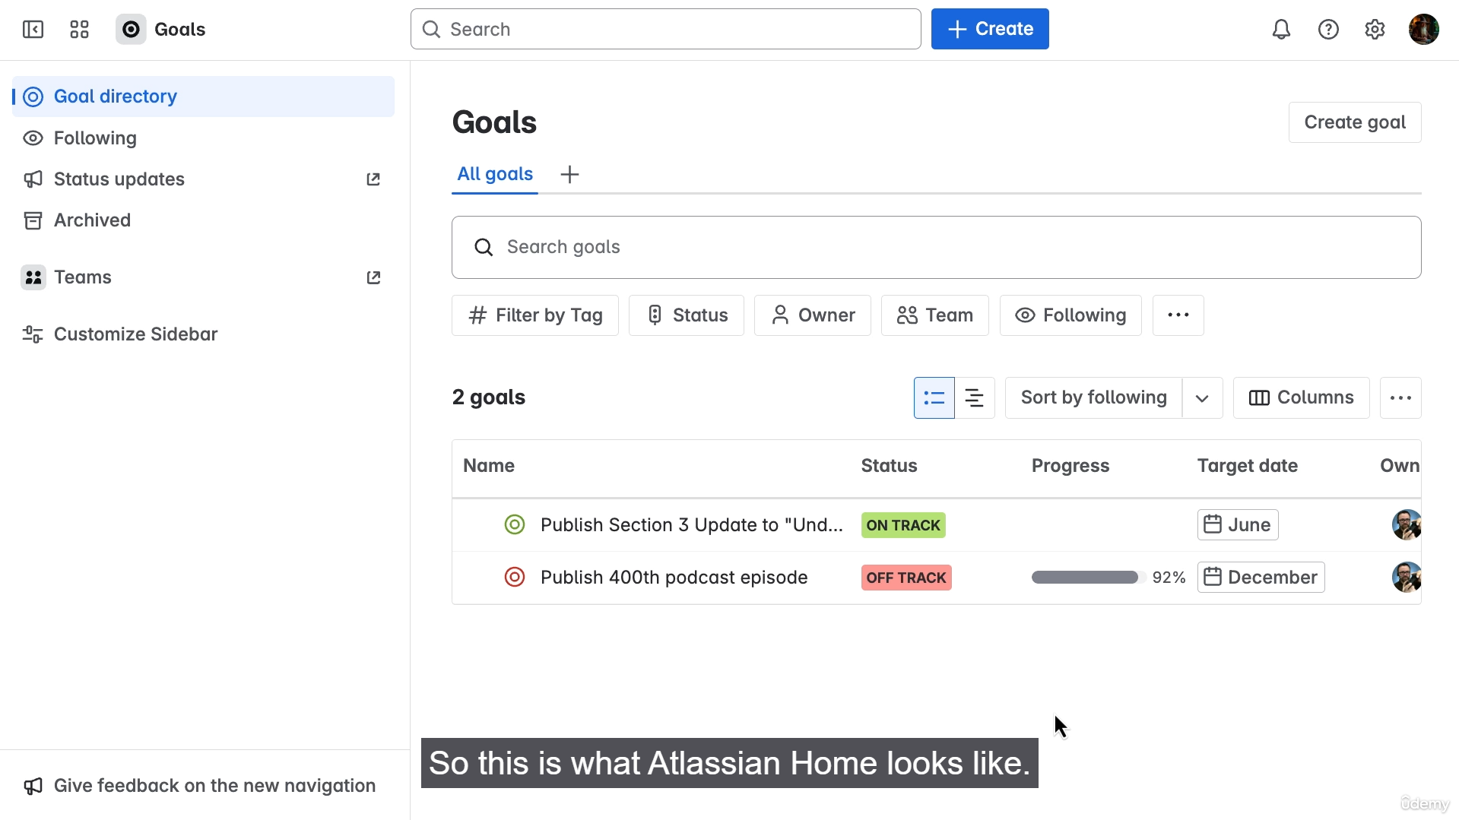

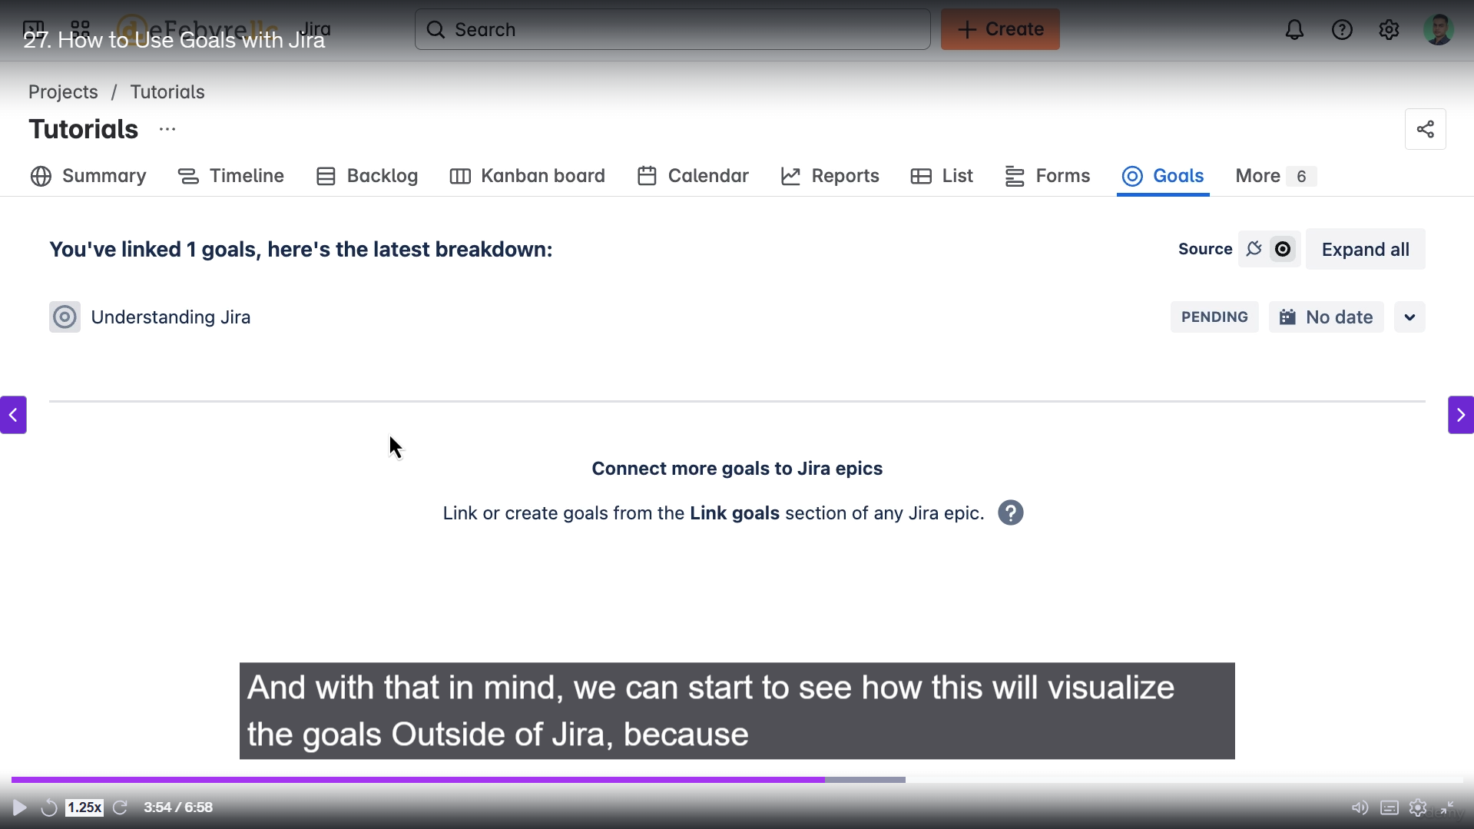

The key concept regarding **Goals** in Jira is that they do not reside within Jira itself; they are managed in the separate Atlassian application, **Atlassian Home** (or the dedicated Atlassian Goals app), and are then *linked* to Jira work items.

This separation provides a high-level, independent way to track progress and align work across multiple projects and teams.

**Key Concepts of Goals and Jira Integration**

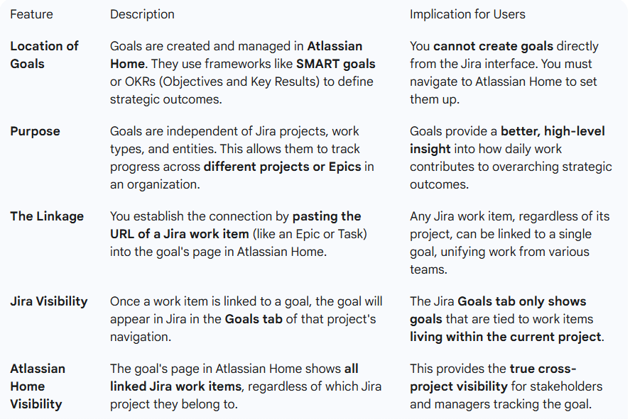

**Summary of Workflow**

1. **Create the Goal:** Navigate to **Atlassian Home** and create the new goal (e.g., "Understanding Jira").
2. **Copy Link:** In Jira, navigate to the work item (e.g., an Epic) you want to align with the goal and **copy its URL**.
3. **Link in Home:** Go back to Atlassian Home and paste the work item URL into the goal's linking section.
4. **View in Jira:** The linked goal will then appear under the **"Goals"** tab in the Jira project navigation for the project containing that work item.

**=======================================================================**

1. **Searching and Finding work in all work view:**

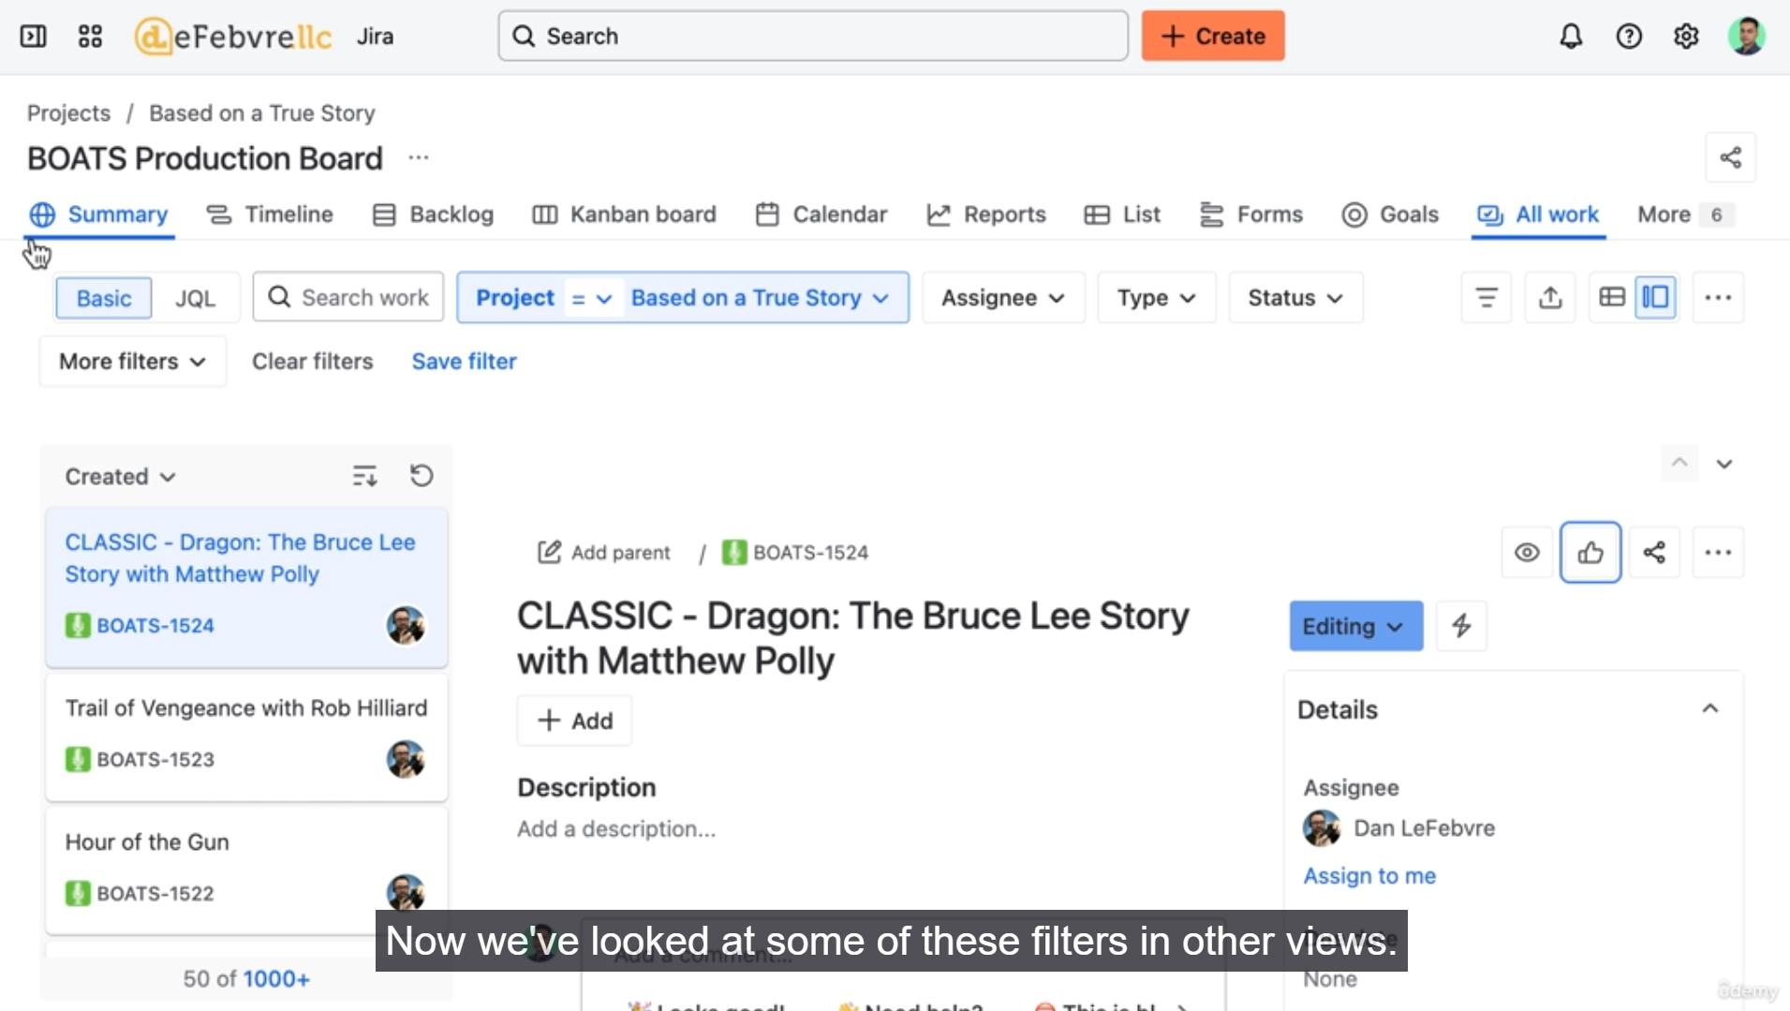

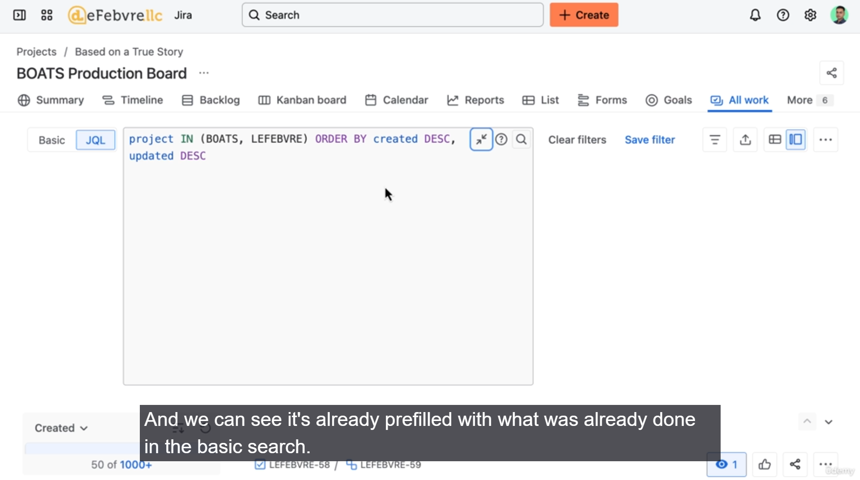

• **Purpose:** The "All Work" view is the primary place to find and search for all work items across a project or multiple projects.

• **Historical Context:** In older versions of Jira, this view was called "Issues" or "All Issues." The functionality is similar but the name and interface have been updated to reflect Jira's use of the term "Work" instead of "Issue."

• **Key Advantage:** Unlike views like the Calendar (which requires a date), the All Work view shows **everything**, regardless of what fields are associated with the work item.

• **Default Display:** Work items are listed on the left, often showing only a fraction (e.g., 50 of 1000+) of the total.

• **Sorting:**

* Work can be sorted by various criteria, such as **Created** (newest first, which also displays items in sequential order by project key and number) or **Updated** (most recently updated at the top).

• **Filtering Options:** Work items can be filtered using the controls at the top of the view.

* **Basic View (Dropdowns):** This is the default interface where you can use dropdown menus to select filters (e.g., by project, status, assignee).
  + The basic view is now powerful enough to handle advanced filters, such as **"Status does not equal Done,"** which previously required the advanced search.
* **JQL (Jira Query Language):** This is the advanced search mode where you build a query using code-like syntax (e.g., project in ("Project A", "Project B") AND status != Done).
  + JQL allows for even more complex searches that may not be possible in the basic view, such as finding work in **closed sprints**.

• **Example Search Walkthrough:** The video's objective was to **"Find all work from the last sprint that wasn't completed."**

1. Start in Basic View, filtering by the desired **Project**.
2. Add a filter for **Status does not equal Done**.
3. Switch to **JQL** to add the advanced condition: AND sprints in closedSprints.
4. *Optional Refinement:* Switch back to Basic View and add an Updated filter (e.g., "within the last two weeks") to narrow the list further.

• **Outcome:** The search helps identify work items that were not completed by the end of a sprint, allowing the team to discuss why and decide on next steps (e.g., move the work to the current sprint).

**=======================================================================**

1. **Working faster with filters:**

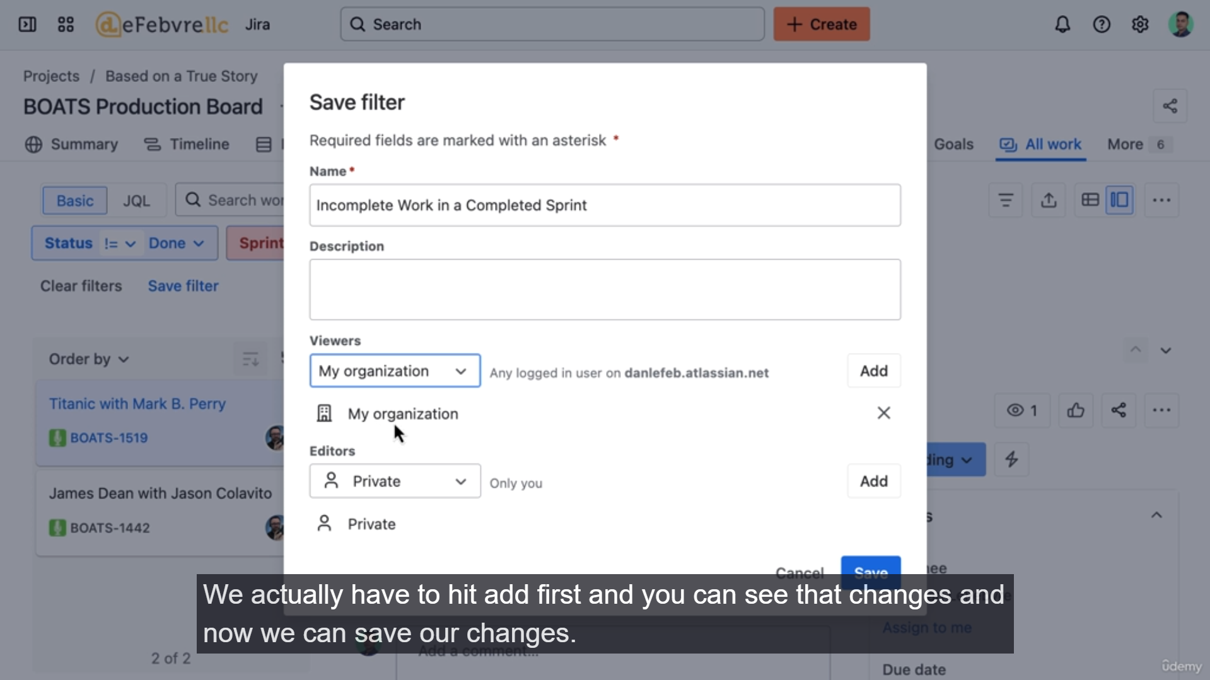

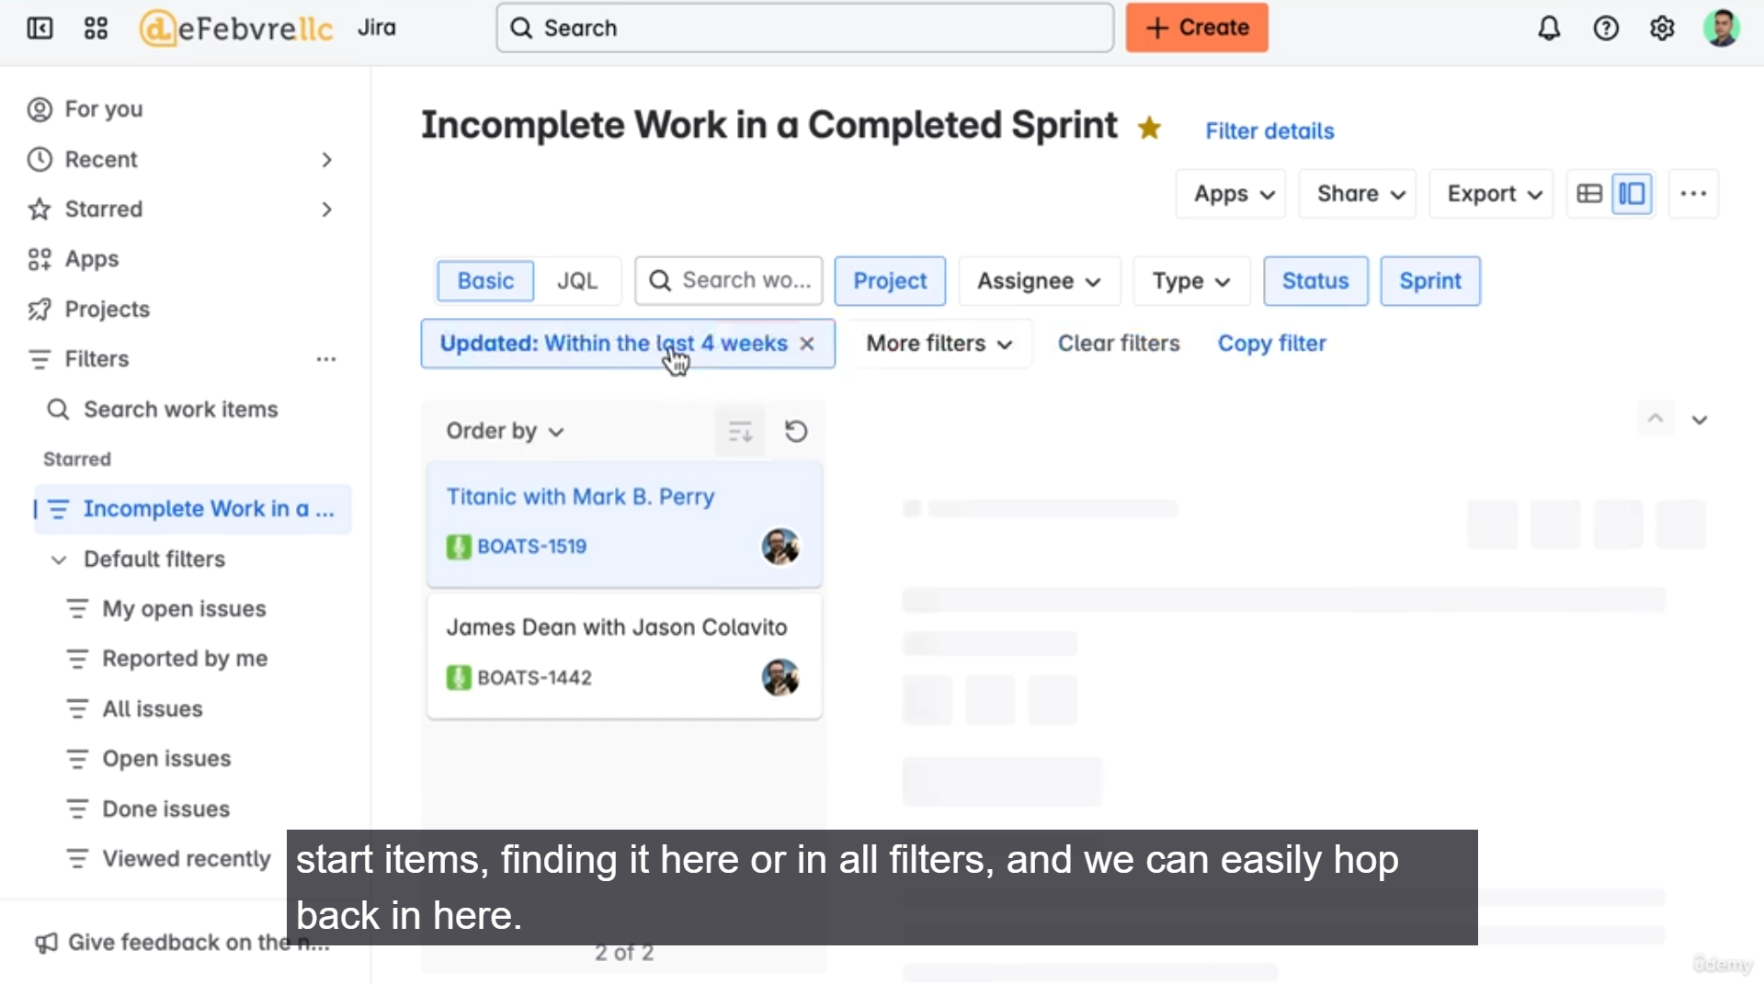

**Summary: Working Faster with Saved Filters in Jira**

* **Saving a Filter:**
  1. After performing a successful search in the "All Work" view, click the **"Save filter"** link.
  2. Provide a **descriptive name** (e.g., "Incomplete Work in a Completed Sprint").
* **Setting Permissions (Sharing):**
  1. **View Permission:** Set this to determine who can see the filter. By default, it's private. The speaker recommends setting it to **"Everyone in my organization"** to allow others to use it without encountering a broken link or permission error.
  2. **Edit Permission:** Set this to determine who can make changes to the filter. The speaker recommends keeping this as **private** so that only the creator can modify it.
  3. **Jira Administrator Exception:** Regardless of the permissions set, the global Jira administrator can typically view all filters.
  4. **Crucial Step:** You must click **"Add"** after setting the permissions (the box will change from "private" to the selected group) before finally clicking **"Save"**.
* **Accessing Saved Filters:**
  1. **Starred Items:** By default, new filters are **starred** and appear in the sidebar for quick access.
  2. **Filters Menu:** If a filter is unstarred, it can be found under the **"Filters"** section in the main navigation, either in **"Recent filters"** or by clicking **"View all filters"** and searching for it.
* **Updating a Saved Filter:**
  1. Load the existing saved filter.
  2. Make the necessary changes to the search query (e.g., changing the update time from two weeks to four weeks).
  3. Click the **"Save"** button to overwrite the existing filter.
  4. *Alternative:* Use the dropdown to select **"Save as a copy"** if you want to create a new filter instead of overwriting the original.
  5. Filter details (name and permissions) can be changed anytime under **"Filter details."**
* **Importance for Managers/Admins:** Filters are essential tools that control the data displayed in other powerful Jira features, including:
  1. The **work items shown on Agile boards**.
  2. The data that populates **dashboards**.
  3. Configuring these deeper features requires elevated permissions, which will be covered in the later manager/administrator sections of the course.

**=======================================================================**

1. **Exporting work from Jira to Excel:**

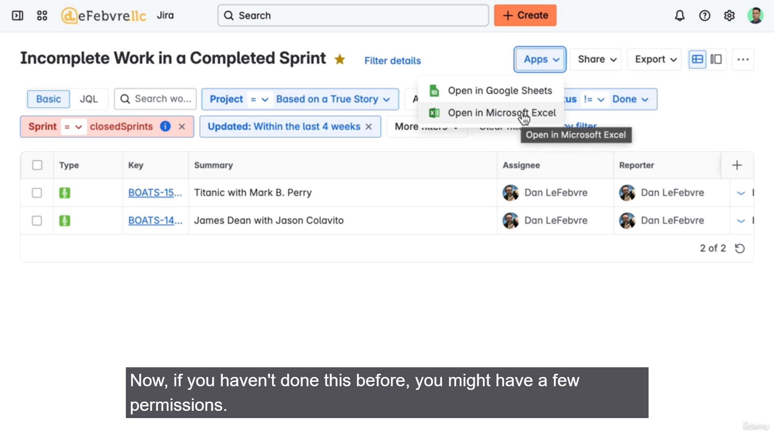

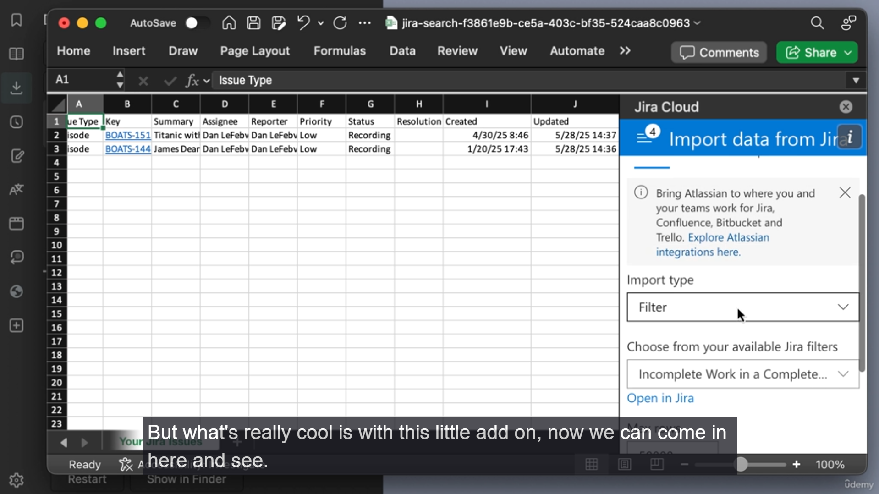

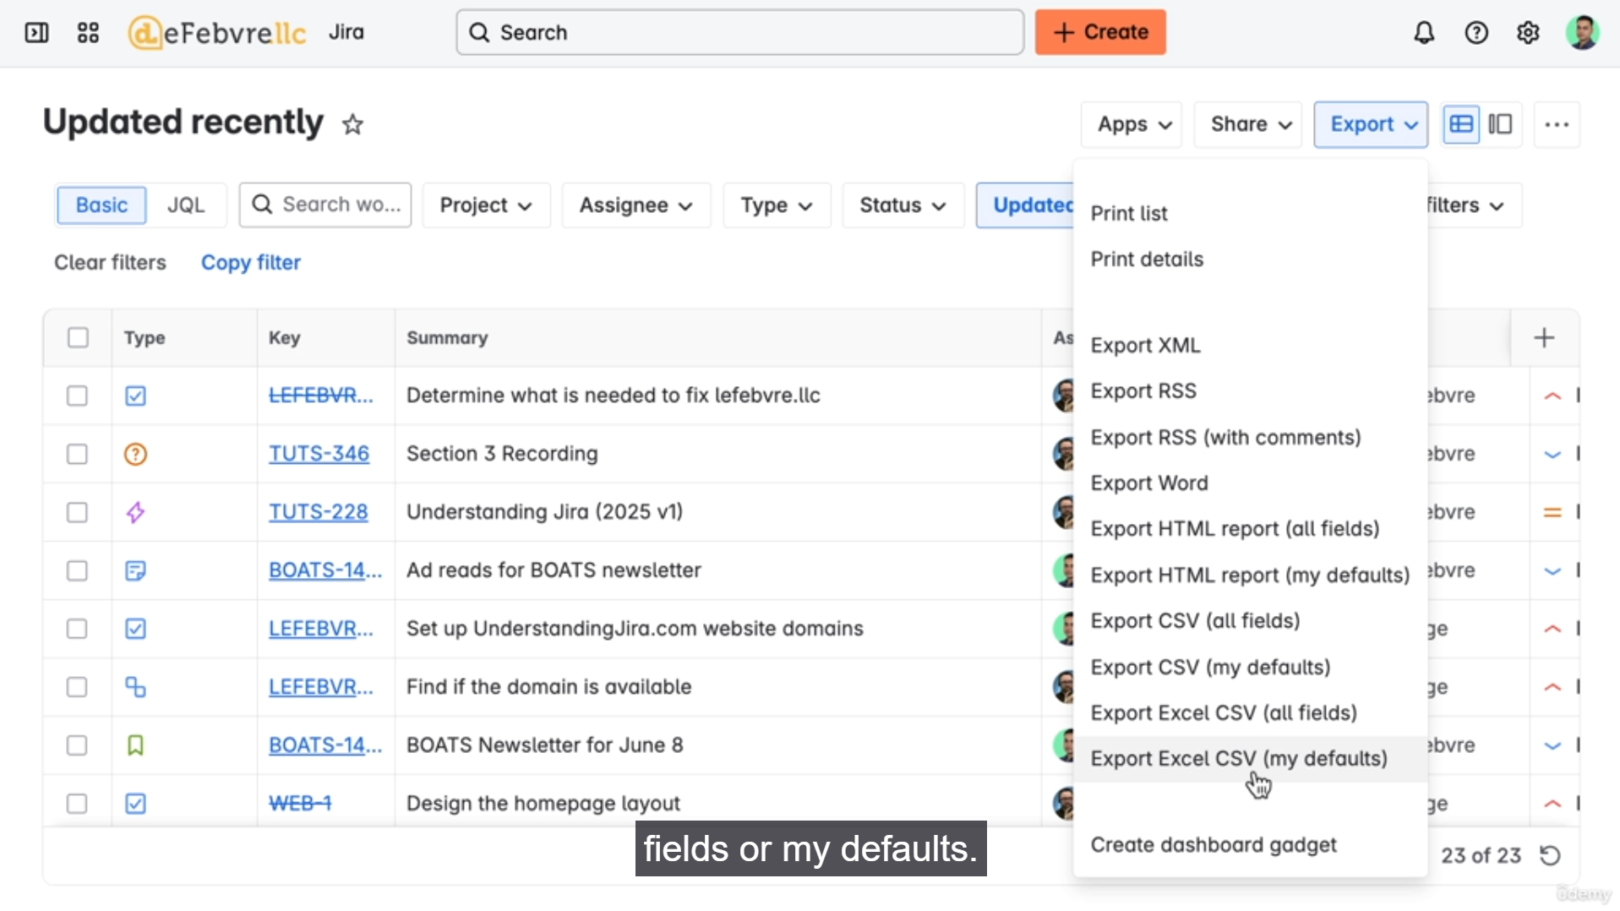

**Summary: Exporting Jira Work Items to Excel**

The video outlines two main methods for exporting Jira work items, emphasizing that the first step for both is to **filter the work** in the "All Work" section to select the data you want.

**1. Direct Export using the Jira Cloud-to-Excel App**

This method is the easiest and recommended for a quick, live connection.

* **Process:**
  1. Filter or load a **saved filter** in the "All Work" section.
  2. Switch to the **List View** for easier visualization before export.
  3. Go to **Apps** in the top navigation bar.
  4. Select **"Open in Microsoft Excel."**
* **Initial Setup:** The first time this is done, Jira will install a free add-on in the background to connect Jira Cloud to Excel. You will need to grant permission/acceptance.
* **Key Feature:** Once the data is in Excel, the add-on allows you to **change the filter directly inside Excel** (e.g., switch from "Incomplete Work" to "My Open Issues") and **refresh the data** instantly.

**2. Exporting as a CSV File (For Maximum Control)**

This method is best when you need to select specific fields to export or are using an application other than Excel or Google Sheets.

* **Process:**
  1. Filter or load the work items you want to export.
  2. Ensure you are in the **List View** in the "All Work" section, as this displays the fields that will be exported by default.
  3. Use the **Export icon** (usually three dots or a small export icon) near the top of the work list.
  4. Choose one of two options:
     + **"CSV (all fields)":** Exports every available field for the selected work items.
     + **"CSV (my defaults)":** Exports only the fields currently visible in the List View.
* **Customizing the Defaults (Fields):**
  1. You can customize which fields are considered "my defaults" by clicking the **"Columns"** icon (or similar configuration option) and adding or removing fields (e.g., remove Reporter or Priority, add Status).
  2. The customized field list determines what is included when selecting "CSV (my defaults)."
* **Result:** A CSV file is downloaded to your computer, which can then be opened in any spreadsheet application (Excel, Google Sheets, Numbers, etc.) for advanced reporting or data manipulation.

**Summary of Control**

Both methods, especially when combined with powerful JQL filtering and saved filters, give users a ton of control over **which work items** and **which fields** are pulled out of Jira for external analysis or reporting.

**=======================================================================**

1. **Road mapping work in the Timeline view:**

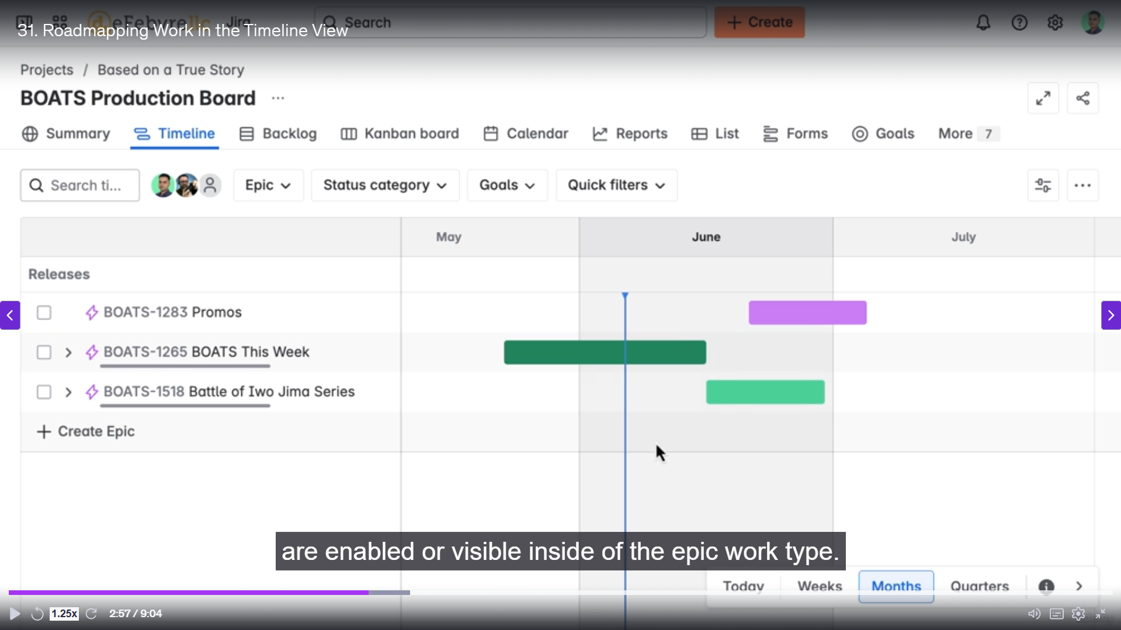

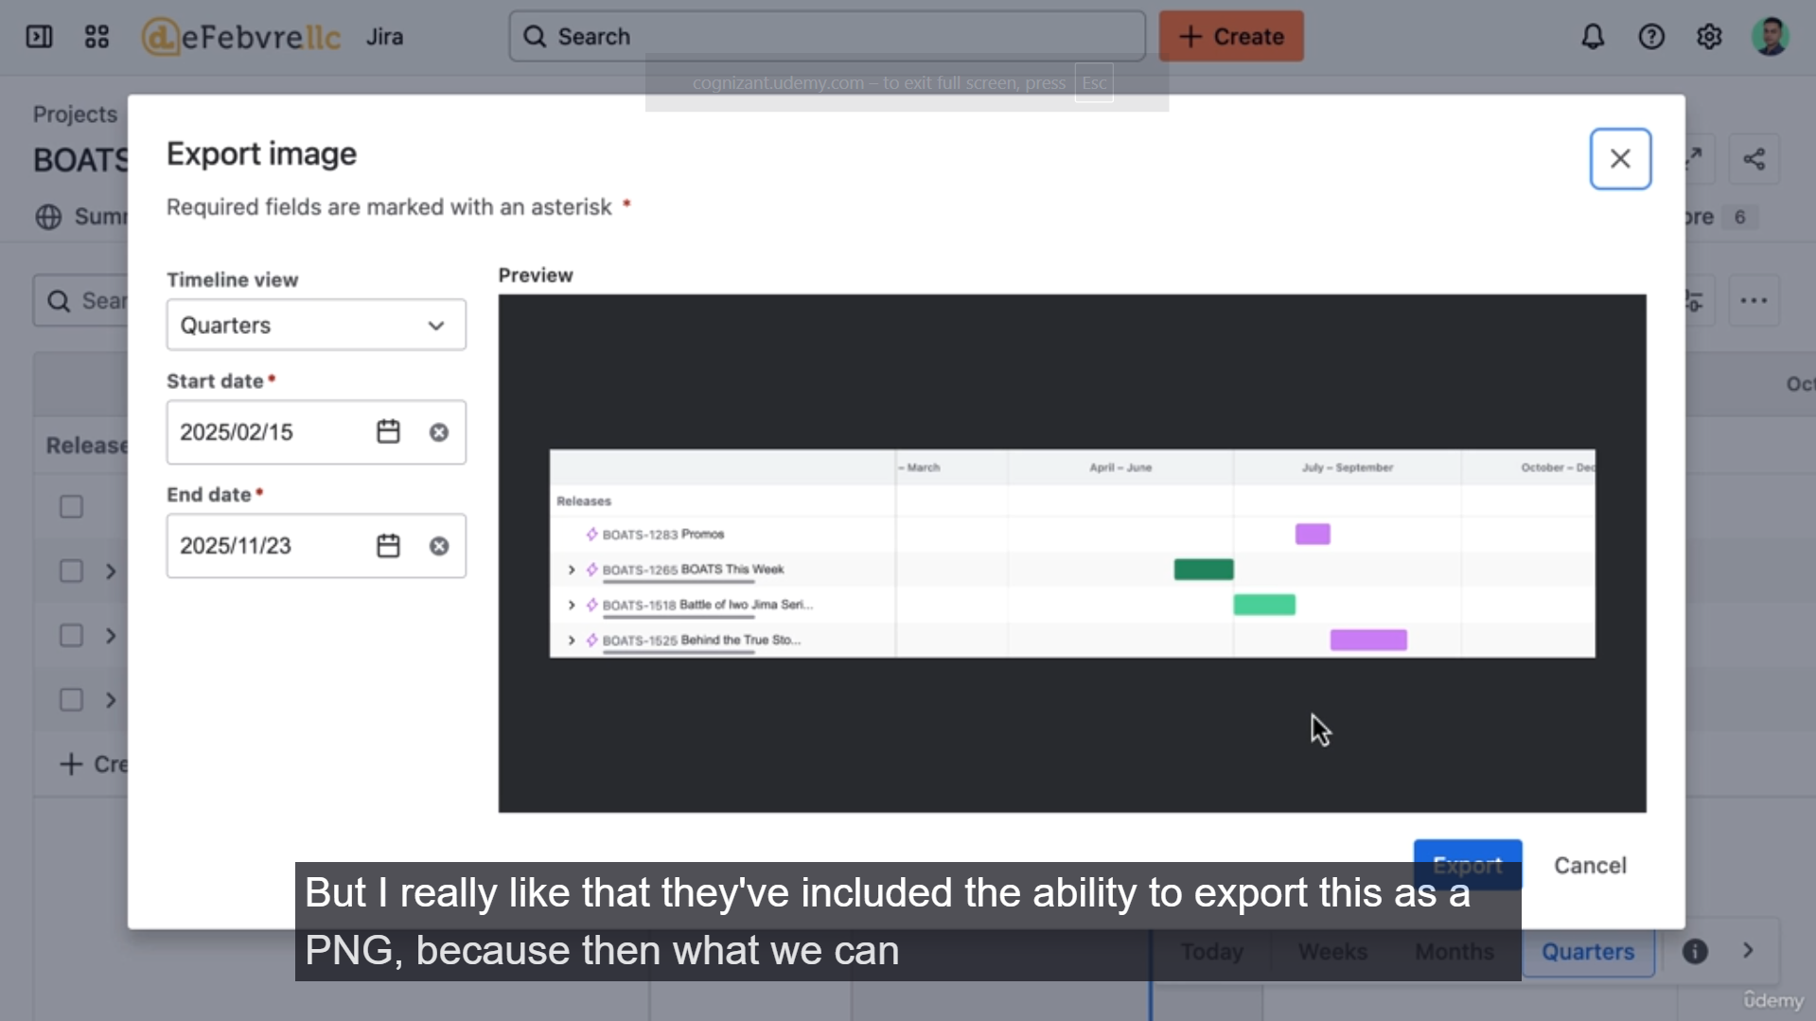

**Summary: The Timeline View in Jira**

* **New Name for Roadmap:** The Timeline view is the current name for what was previously called the "Roadmap" (or "Advanced Roadmap" in certain license tiers).
* **License Requirement:**
  + **Jira Standard (Used in Course):** Can view the timeline only for work items belonging to a **single project**. This is controlled by the Agile Board's filter.
  + **Jira Premium (Advanced Roadmap):** Required to view work from **multiple projects** on one timeline.
* **Core Purpose:** The Timeline view is designed specifically to track and visualize **epics** (and their child issues) in a **Gantt chart-style** interface.
* **Date Management:**
  + Planning is done by clicking and dragging the epic bars on the timeline.
  + This action automatically populates the **Start Date** and **Due Date** fields on the epic work item itself.
  + If these fields are not visible on the epic's detail screen, a Jira administrator needs to enable them.
* **Key Actions in the Timeline:**
  + **Planning:** Visually plan the duration of epics by dragging the start and end of their bars.
  + **Creating Epics:** Quickly add new epics directly from the view by typing a summary; the rest of the details can be filled in later.
  + **Adding Child Issues:** Create or link child issues to an epic directly within the timeline hierarchy.
* **Filtering and Customization:**
  + **Standard Filters:** You can filter the timeline by text (summary), assignee, or other standard Jira fields.
  + **Quick Filters:** The Quick Filters displayed here are the **exact same** as the ones configured on the corresponding Agile Board. To customize these, you must configure the board's settings.
  + **Goals Filter (Unique):** A specific filter allows you to narrow the view to only show work items (epics) that are linked to specific **Goals** (which live in Atlassian Home).
  + **View Settings:** Offers quick controls to:
    - **Expand or Collapse all epics** at once.
    - Turn off/on specific items to **clean up the visual display**.
* **Exporting the Timeline:**
  + **CSV:** Exports the data similar to the "All Work" export.
  + **PNG (Recommended):** Exports the visualized timeline as an image file. This is useful for sharing the roadmap with external stakeholders or anyone not using Jira, allowing them to see the overall plan.
* **Administrator Relevance:** The entire view is driven by the Agile Board's filter, which requires elevated (manager/administrator) permissions to configure.

**=======================================================================**

1. **Using the project summary:**

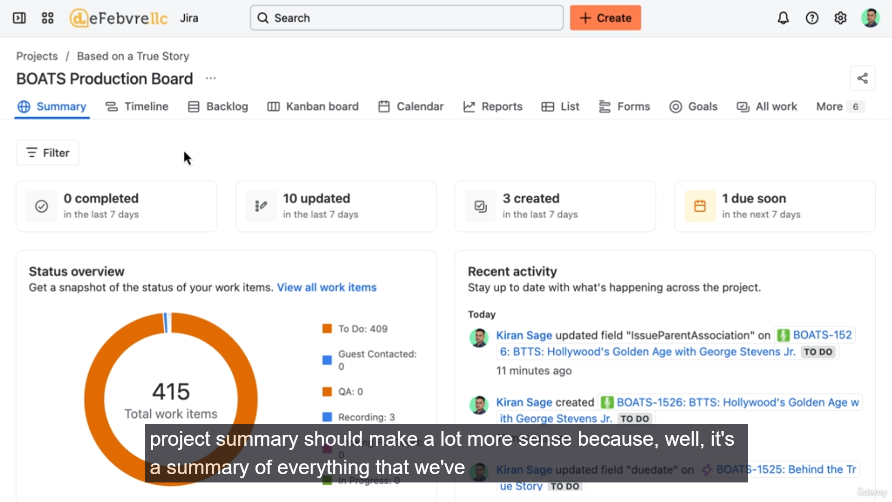

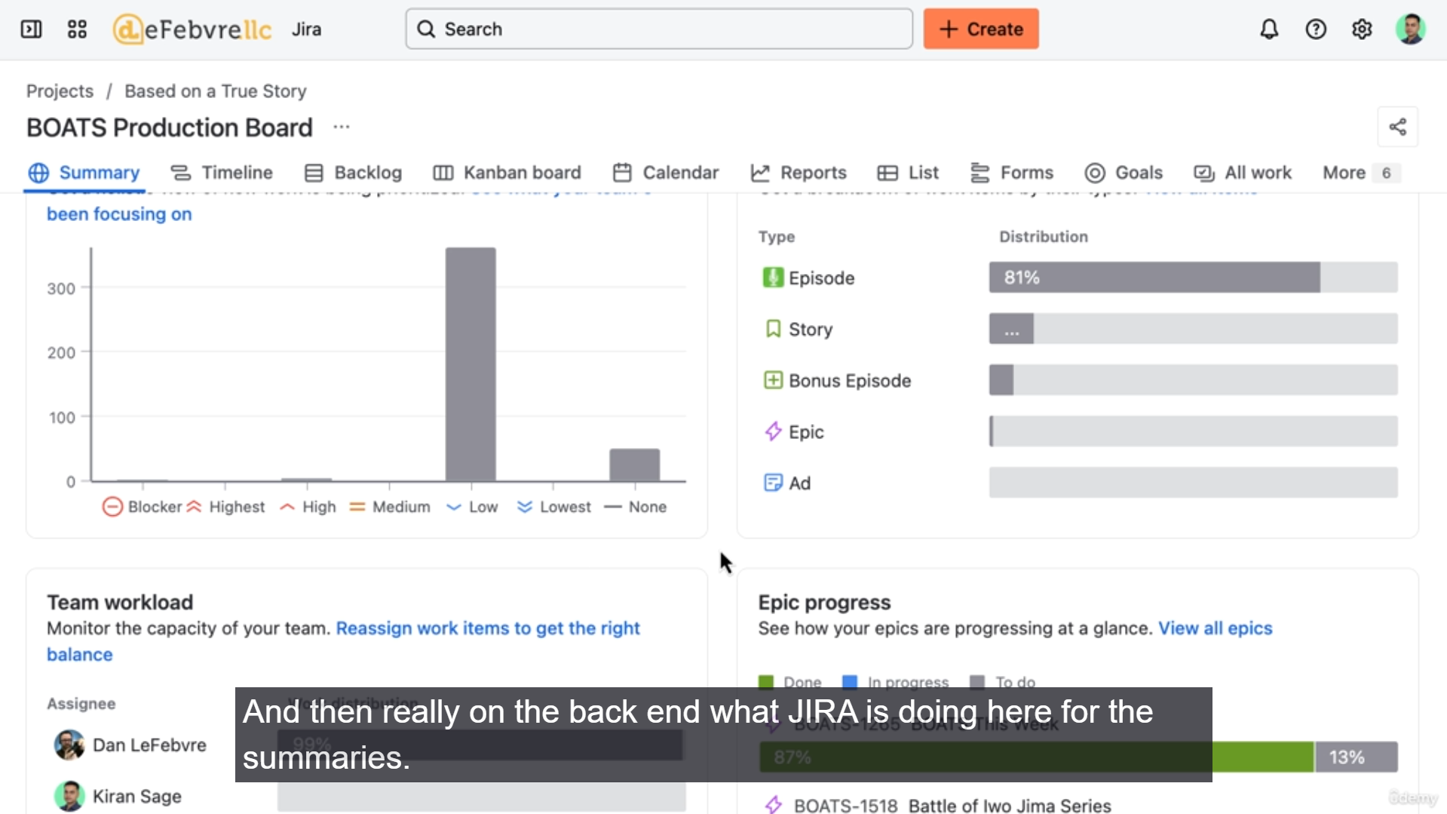

**Summary: The Project Summary in Jira**

* **Purpose:** The Project Summary provides an overview and consolidation of all the information and features covered in the project navigation section (board, calendar, timeline, etc.).
* **Content Source:** The summary largely consists of pre-built, visual reports that pull data directly from the **fields** on the project's work items (issues).

**Key Components of the Summary:**

* **Header (Recent Updates/Due Dates):**
  + Shows an overview of recent work updates, creations, and items with impending due dates (e.g., within the next 7 days).
  + Clicking these links applies a temporary filter, taking the user to a list view of those specific work items.
* **Recent Activity:**
  + A chronological log showing every change made within the project (e.g., epic creation, due date updates, issue unlinking).
  + It demonstrates how user actions in other views (like the Timeline) update the fields and are tracked here.
* **Status Overview:**
  + A chart showing the distribution of work items across various **statuses** (e.g., To Do, In Progress, Done).
  + This is similar to the status insights seen on the Agile Board or in simple list reports.
* **Priority Breakdown:**
  + A chart visualizing the distribution of work items based on their **Priority field** (e.g., Low, Medium, Blocker).
  + Changing the priority on a single work item will immediately update this report.
  + The report acts as a quick filter, allowing users to click and view all items of a specific priority.
* **Types of Work (Issue Type Breakdown):**
  + Shows the count and distribution of different work types (Epics, Stories, Episodes, etc.).
  + **Tip for Admins:** If one work type is overwhelmingly dominant, it might indicate a need for new, custom work types to better categorize and organize the project's tasks.
* **Team Workload (Assignee Breakdown):**
  + Shows the distribution of assigned work among team members.
  + Helpful for identifying team members who may be overloaded or have capacity for more work.
* **Epic Progress:**
  + Visualizes the completion status of individual epics.
  + The percentage complete is calculated based on the **status of the child work items** linked to that epic (e.g., 53 "Done" items and 8 "To Do" items equals 87% complete).

**Personalizing the Summary View**

* **"Assigned To" Filter:** The most important filter in the summary view is at the top right, allowing users to filter all the charts and data by assignee.
  + Users can select **"Current User"** (assigned to them) to transform the Project Summary into a personalized, custom overview of all the work they are responsible for within the project.

**Conclusion and Next Steps**

* This video concludes the section on core Jira features for regular users.
* The next section will focus on features requiring **elevated permissions** (Project Administrator/Manager), such as configuring the Agile board, its filters, and custom fields. Users are encouraged to continue watching to gain insight into the backend controls available to their administrators.

******************************************************************************************************************************************************************************************************************************************************************************************